Miracle Advance Technologies

PetMatrix

Application User Manual 5
1. General Information 6
2. System Menu 9
2.1. Dashboard 9
2.2. User Activities 16
2.3. Whiteboard 21
So the cycle is: 21
Whiteboard features: 24
2.4. Main Menu 26
3. Understanding the Features 27
3.1. Global Search 28
3.2. Owner/Client Dashboard 30
■ Pet Patient Actions 31
3.3. Pet Patient Dashboard 33
4. Using the System (OPD) 36
4.1. Registering a Pet Patient 36
Owner profile creation 37
4.2. Pet Patient Arrival 40
4.3. Pet Patient Consultation 45
● Physical Examination tab 49
● Problem and Diagnosis tab 51
● Vaccine 53
● Prognosis and Education tab 55
● Treatment Plan and Service tab 63
1.1. 67
4.4 Making an Appointment 68
Whiteboard: 71
Reservation List. 76
5. In Patient Department (IPD) 77
5.1. Reservation Worklist 78
5.2. IPD Worklist / My Pet Patient (Doctor Wise Worklist) 82
5.3. Admitted Pet Patients 85
Extend 87
Discharge 88
Return Items 91
Bed Transfer 94
Monitoring 95
Monitoring takes you to the Patient Care tab without having to go to a consultation for it. You can see the following pop-up once you click on the Monitoring icon- 96
5.4. Discharging a Pet Patient 96
5.5. Bed Cleaning Worklist 99
6. Surgeries 100
6.1. Surgery Appointments 100
6.2. Requested Surgery Worklist 104
6.3. Confirmed Surgery Worklist 104
7. Payments and Invoice Reports 105
Whiteboard: 105
7.1. Invoice Reports 109
7.2. Veterinarian Fees Report 109
8. Laboratory Information System 112
8.1. The Laboratory Worklist 112
8.2. The Panel List 118
9. Radiology Information System (RIS) 122
9.1. Radiologist Worklist 122
TEMPLATES: 128
9.2. Technologist Worklist 134
10. Pharmaceuticals and Return Items 134
10.1. Dispense Worklist 134
11. Exceptional Features 145
11.1. Tools 145
11.2. Counter Sales 146
11.3. Notifications 147
12. Adminstration 148
12.1 Add User 148
12.2. Due payment list 148
12.3. Dead Patients 150
12.4. Clinic Type 150
12.5. Package Setup 152
12.6. Package List 152
12.7. Role Mapping 153
12.8. Cancelled Consultations 154
12.9. Consumable Item History 154
12.10. Antibiotic Item usage history 154
12.11. Import Setup Data 155
12.12. Add Template 156
12.13. Owner List 157
12.14. Patient List 157

Document Version No- 1.1.1

Last update Datetime- 05/01/2022

Last update by-Wasiur Rahman

Application User Manual

1. General Information

1.1. Organization of the Manual

The manual is patterned to familiarize you with the frequent aspects of the application first - dashboards and search features, for instance. While doing so, the most common elements are explained so you can later relate to the erms as you look deeper into the application’s features and functionalities. Items inside the Main Menu will vary depending on user roles, but the full menu is explored as the manual proceeds, and user roles are explained beforehand, so the menu options that each user role sees can be made sense of. The OPD section (Using the System) contains the most basic and necessary outpatient tasks that are carried out by the vets. Best attempts were made so the functionalities are written in a manner which follows a chronology used by most user roles in the system. In Patient Department or IPD section is a large chapter dedicated to inpatient facility management. This section explores in detail the numerous operations and management related to inpatients of the hospital. For this section, the manual advances according to the submenu inside the PetMatrix application. The following sections after that will emphasize on the additional tools and features inside the application which you may find more beneficial once you have learned your way using PetMatrix.

1.2. Additional Help

Common terms are emboldened throughout the user manual to acquaint the reader with the terms used in the application. Section numbers are indexed (numbered) and/or linked next to common keywords and task phrases (adding allergies, making an appointment, etc.), so the reader can go directly to the section to find more information on it when necessary. For easier navigation, keywords in blue are linked so you can refer back to the section where you can find details on keywords/phrases.

1.3. System Requirements

HARDWARE REQUIREMENTS:

- Processor (CPU) with 2 gigahertz (GHz) frequency or above
- A minimum of 2 GB of RAM
- Monitor Resolution 1024 X 768 or higher
- A minimum of 20 GB of available space on the hard disk
- Internet Connection Broadband (high-speed) Internet connection with a speed of 4 Mbps or higher
- Keyboard and mouse or compatible pointing device
Webcam SOFTWARE REQUIREMENTS:

Browsers:

- Chrome* 36+
- Edge* 20+
- Mozilla Firefox 31+
- Internet Explorer 11+ (Windows only)
- Safari 6+ (MacOS only)

Operating System:

- Windows 7, Windows 8 or Windows 10
- Mac OSX 10.8, 10.9, 10.10 or 10.11

1.4. Getting Started

Before you can log in to PetMatrix, you will need to have your email registered by the System Administrator to be a user for the system. Go to http://app.petmatrix.vet/#/login and log in with your credentials. The login page should look like this

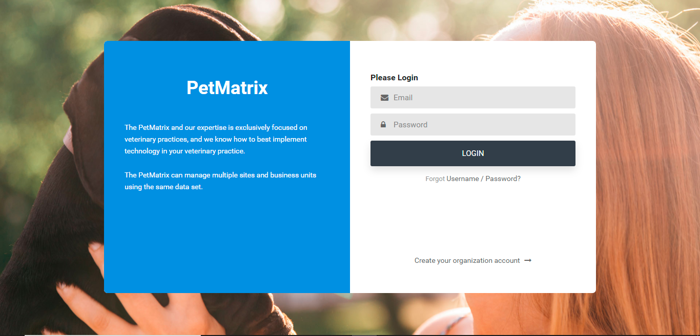

Once logged in, you should be viewing the Dashboard, but you can set any page to be your landing/home page by doing the following: Go to the page you want to set as the landing/home page that you want to see after you log in, and click on the orange arrow at the top-right end (corner) of the screen :

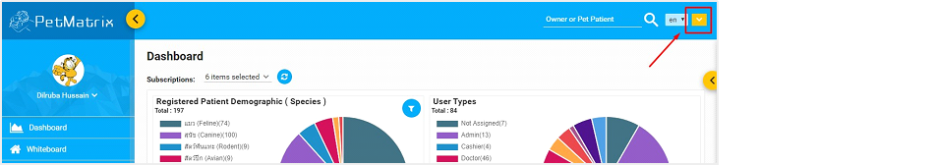

Select ‘Set as home’, and the current page you are on will be set as the default page.

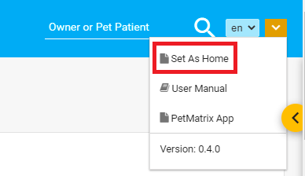

If you’re viewing this manual right now, you probably know where to find the ‘User Manual’ option already ;

2. System Menu

2.1. Dashboard

The Dashboard displays various graphic data presentation in one place:

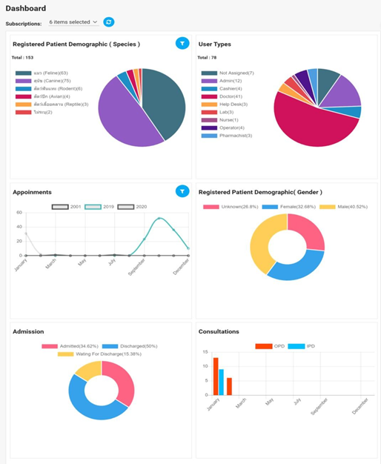

➢ For now, you can view the following analytics in the Dashboard:

- Registered Patient Demographic (Species) - showing the distribution of registered patients of various species.
- Registered Patient Demographic (Gender) - showing the composition of the number of males, females and other genders that make up the total registered number of patients.
- Appointments - shows, using a line graph, the number of appointments being created in each month.
- Admission - shows how many of the total number of admitted patients till now are on queue, admitted or discharged from the clinic
- Consultations - shows the total number of consultations (OPD and IPD) taken each month.
- User Types - shows the various user roles that are registered inside the application.

➢ You can select or deselect which subscriptions you want to see in the Dashboard-

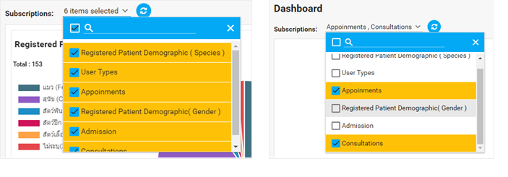
➢ Data representation is done using a number of styles including pie charts, docut charts, bar graphs, and line graphs.

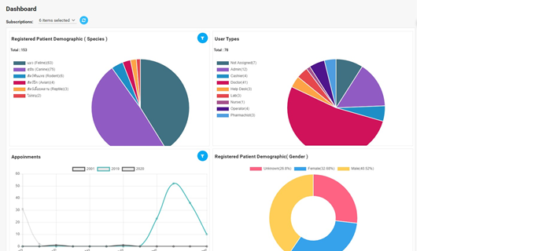

➢ Some features of the graphs are interactive-

a. You can drag and drop a card/graph and rearrange the Dashboard-
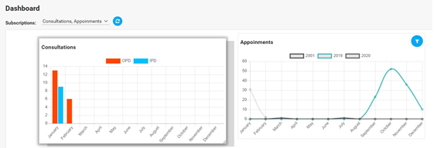
b. You can ‘click’ on an item to cut it off of the graph to see how the numbers reflect without the particular item.
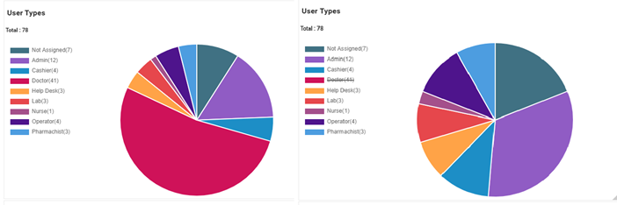
c. You can reset the graphics if you wish to. The Reset button is right next to the Subscriptions dropdown:-

Before Resetting-

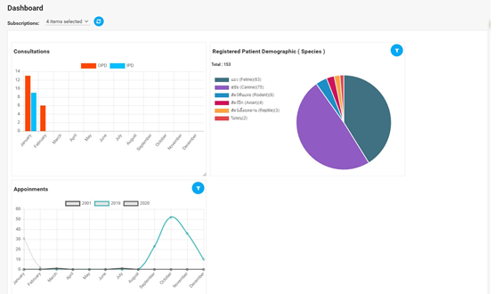
After resetting-

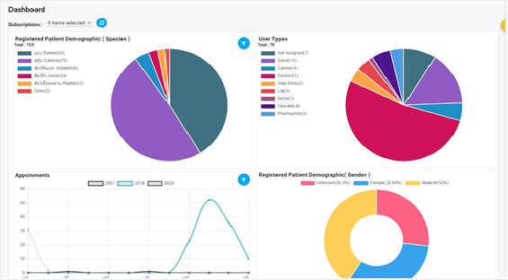
d. Hovering over a graph will show the details and information of the graph:

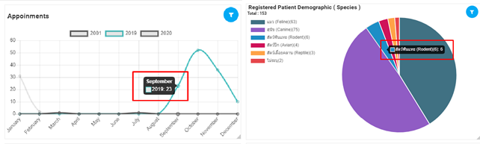

e. You can filter dates to select the date range for which you want to see the data:

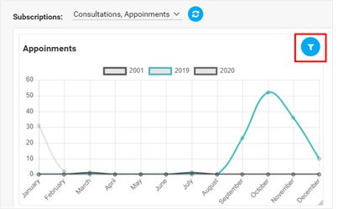

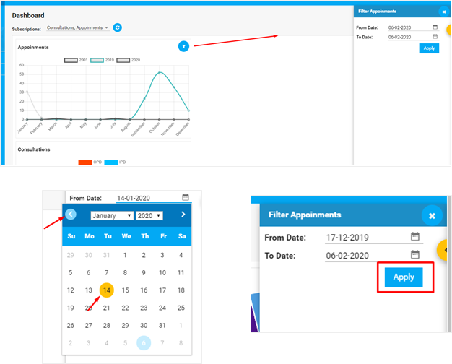

2.2. User Activities

You should be able to see a yellow button peeking from the very right of the screen. Clicking on the button opens up the User Activities panel on the right side of the screen.

Once the panel slides out, you should be able to see infographics and session-related information about your usage of the application as the user:
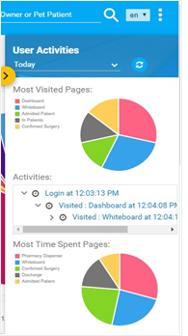
For example, you will immediately be able to see two pie charts about pages that you visit the most, and spend the most time on.
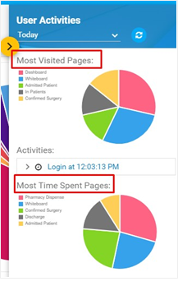
- Hovering over the pie sections shows the piece of information represented by the ‘slices’.

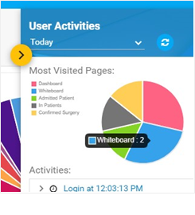
- You can view user activities for a collective number of days, e.g, 3 days/week/month.

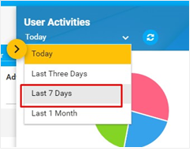
- You can see the key/legend at the left, and the session activities for each login by the user:
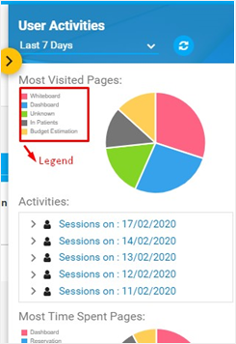

- Clicking on a session will open a dropdown to show where the user has navigated to.

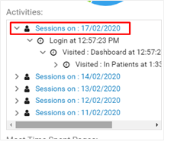
- The dropdown will continue until the ‘tree’ has covered all the pages that the user (that’s you, btw) has visited to:
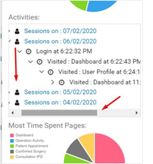

- Details of each session tells you about the page that the user visited, the exact time of visit, and how long the user has been on that page:

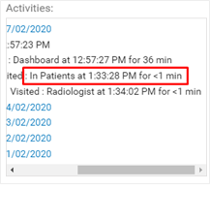
- You can hit refresh to see any updates on user activities while you are still using the application.
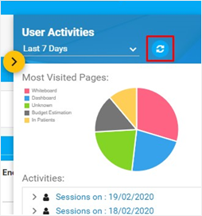

2.3. Whiteboard

The Whiteboard is where you can keep track of all the out-patients. If a patient had an appointment scheduled, it would show up in the Appointment Worklist. If a pet has walked in for a Consultation, it will have to be arrived first (to take in Vitals and record Problems and History), and then be taken to Consultation.

So the cycle is:

Whiteboard is organized with tabs that will carry a patient record from one tab to the next until the client has completed the payments.

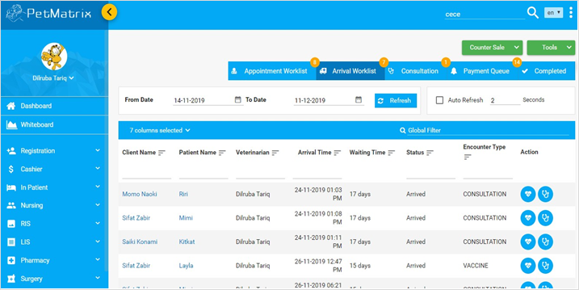
Whiteboard Overview

You should be seeing the Whiteboard with the Arrival Worklist tab if you have marked it as the default home page.
● The Arrival Worklist shows the list of pet patients who have registered already, and are marked for arrival for that day.


● You can view the other worklists (Appointments, Consultations)
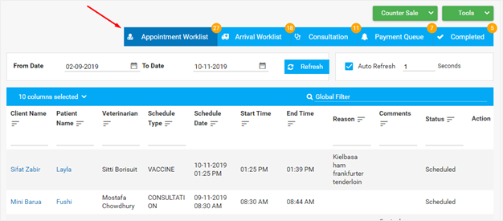
Appointment Worklist inside Whiteboard

● You can see your pet patient Arrival Worklist for any set of dates you wish to use from the date setting calendar (date picker).
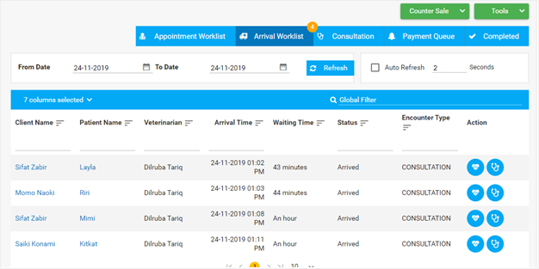

Whiteboard features:

- Auto-refresh: the minimum seconds for auto-refresh is 1 second. You can see the yellow number icon flicker as the Whiteboard refreshes the worklist:

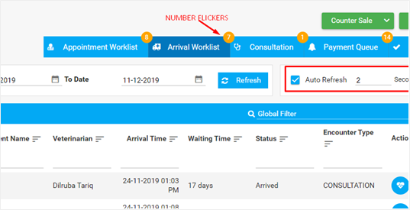
Mouse right-click options: you can transfer a pet patient to another veterinarian from the Arrival Worklist. Right-click anywhere inside a row and you can see the option:
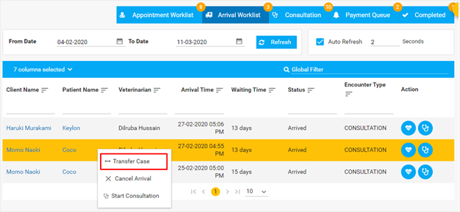
Once you select transfer, you will be asked for a confirmation, followed by the veterinarian you want to transfer the case to:
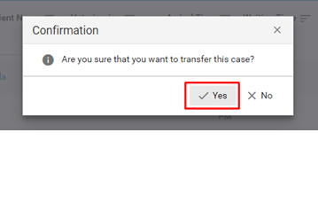
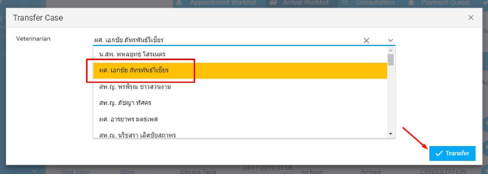
Once you have clicked on Transfer, a notification will show up at the top with a confirmation:
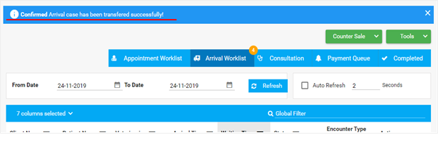
You can also start a Consultation from here directly, or click on the Consultation icon from inside the Arrival Worklist. You can find the full details in the OPD section of the manual as you progress. You can cancel an arrival from here, too.

2.4. Main Menu
To the left of the Dashboard is the Main Menu. The Main Menu lets you register new pet patients, manage in-patient worklists, view laboratory, and radiology reports and carry out administrative tasks. The number of options you can view in the menu depends on the user access level you are granted.
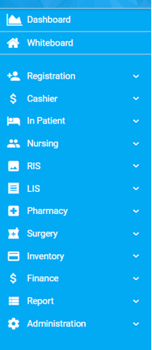
Main Menu to the left

3. Understanding the Features
Before you can start to use PetMatrix, it is imperative that you learn about the small features that are incorporated throughout the application for ease of use, convenience and better user experience.
The default features you will find in almost any tabulated information list is the Column Settings option. Here’s how you see it:
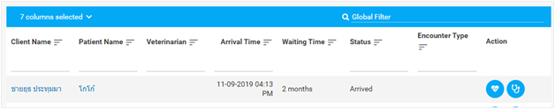
This is taken from an Arrival Worklist, but you can also see it on any other table that represents information. The Column Settings allow you to do 4 things:
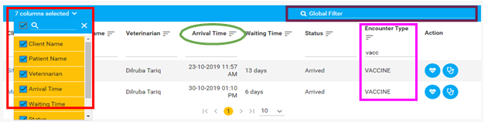
a. Select which columns to display - you can select/deselect which column you want to display in the table. For the image above, all the columns are selected. There is even a search field inside at the top of the list so you can directly type to search for a field!
b. Searching for a specific information in a column - You can filter your search by typing in any keyword you want. This makes the search more narrow and faster.
c. Sorting the results in a column - Clicking on the little icon beside the column name, which looks like a ‘list’, alphabetically sorts your search results by the column order.
d. The Global Filter - this search can help filter all the information related to the search word you enter, and works for that table only. In other words, it searches the entire table with any keyword you enter. We can now move on to the rest of the features!

3.1. Global Search

The global search at the top right corner lets you look up a pet patient using the pet
patient’s name or the owner’s name.

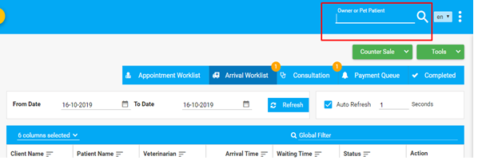
Global Search
For a more advanced search, you can use the Advanced Search option from Registration option on the Main Menu:
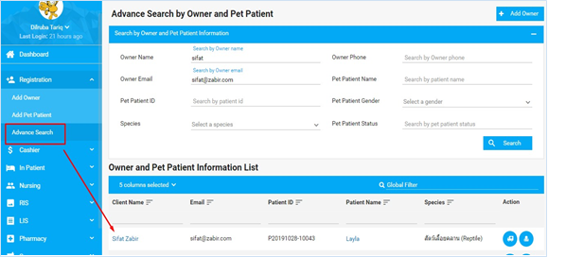
Advanced Search

■ Results for the Advanced Search can show all the information regarding the patient you are searching for, such as Arrivals or Appointments.
■ You can always do an Advanced Search before you register a new client/pet patient. If you find no records, you can always add a client from the Add Owner option inside the Advanced Search.

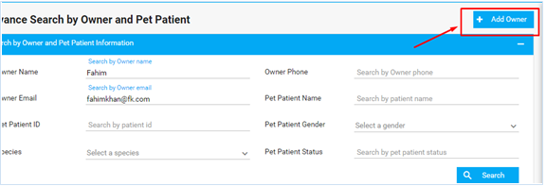
Add Owner - Advanced Search

3.2. Owner/Client Dashboard

■ Before a pet patient can be registered, the owner of the pet has to be registered first.

■ You can go to an Owner’s Dashboard by looking up the pet or the owner using the
Global Search option.
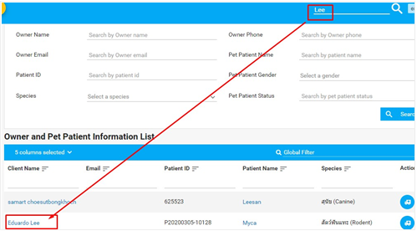
■ An owner can have more than one pet patient. A pet patient can be transferred to a different owner using the Change Owner option, which will be described in details inside Tools section.

CLIENT/OWNER DASHBOARD:
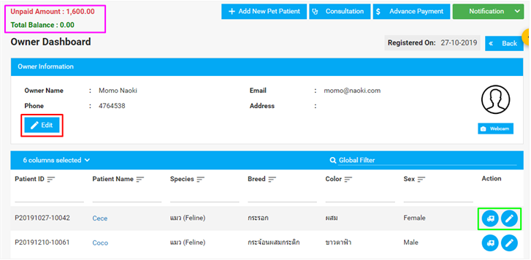
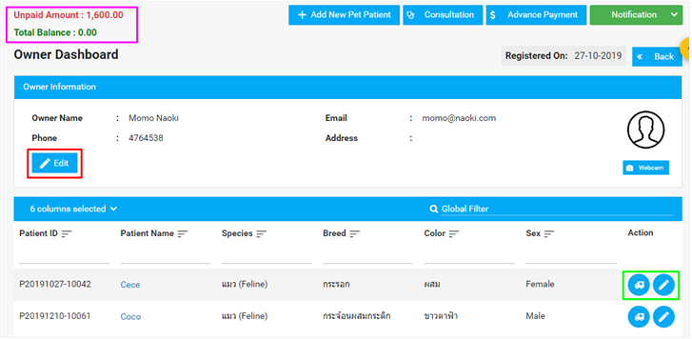

Inside Client Dashboard

■ Pet Patient Actions

- MARK ARRIVAL - For a pet patient, you can choose to mark its arrival using the Mark Arrival icon , which takes you to the Mark as Arrived page.
- UPDATE PET PROFILE - Takes you to Pet Patient’s profile. You can add allergies from here and make changes to a pet profile from the Owner Dashboard. The changes can be saved and will reflect on the Pet Patient Dashboard.
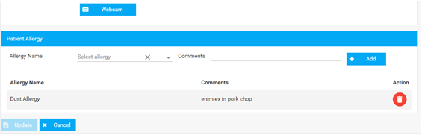
■ Edit - A client’s information can be changed from the Dashboard. Clicking on Edit takes
you to the following page:
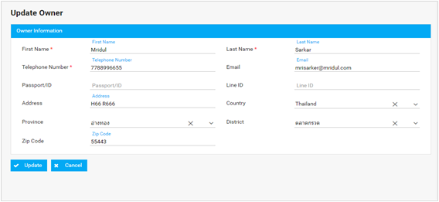
Updating Client Information

■ Account Balance - displays the status in the amount due and paid.

■ Any pets owned by the client will display in the Owner Dashboard, including details about the pet patient. You can choose to view the details in the row by selecting the dropdown in the search field dropdown.
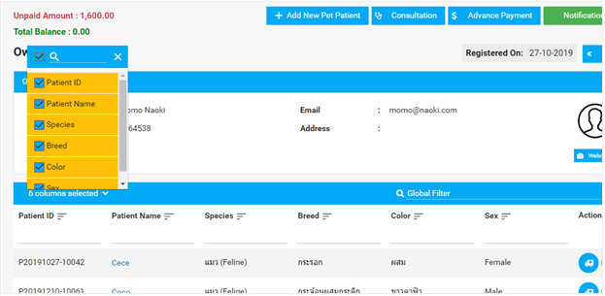
Pet Patient Column Options

3.3. Pet Patient Dashboard

To go to a pet patient’s Dashboard, you can look up a pet using the Global Search and click
on the pet name, or click on a pet’s name from the Owner Dashboard.

You can expect to find the following information inside the Pet Patient Dashboard:

- Owner and Pet Patient basic information
- Pet Patient details
- Allergy information
- Past visits and Consultations
- Upcoming/Scheduling Appointments
- Vaccines (more on Vaccines)

PET PATIENT DASHBOARD:

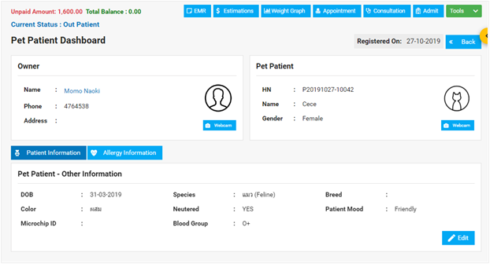
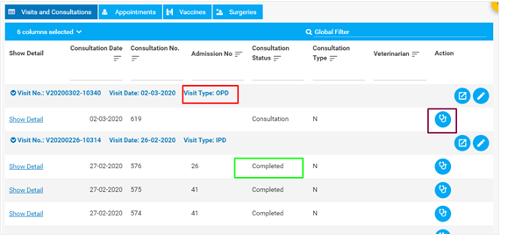
■ You can edit Pet Patient info and enter new Allergy Information from this dashboard.
■ To add a patient allergy, you click on the Allergy Information tab, and select the allergies, if any:
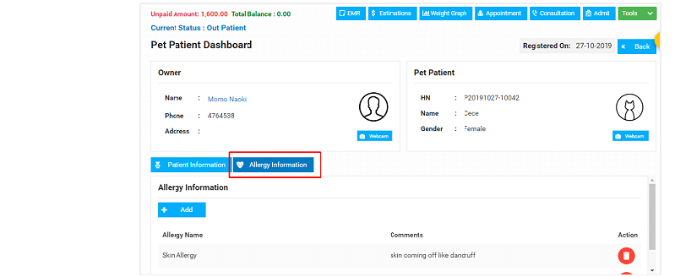
■ Visits and Consultations show any past visits or consultations the pet patient had with any/all veterinarians so far.
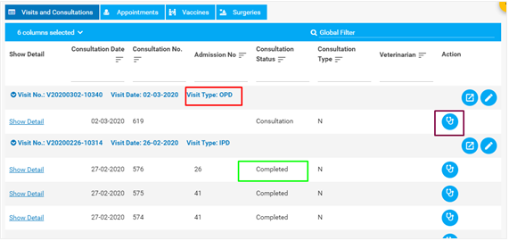
If you open a visit using the little arrow button beside it , you would be able to see details from that visit - the number of consultations, details of the consultations, and even go to a consultation in case the consultation was not completed.
Once you open the dropdown, you can see the type of visit that was made, the status of the consultation, and open a consultation if it needs to be completed.
■ You can view the pet’s vaccine history from the Vaccine tab, or any upcoming appointments (with any/all veterinarians) from the Appointments tab.
You can even view the details of the consultation

4. Using the System (OPD)

4.1. Registering a Pet Patient

If a pet/owner does not already exist, you will have to register the owner first, prior pet patient registration. We can go to Registration from the Main Menu and start filling in the details. Here’s how to register a new pet patient and a new client:
STEP 1: Go to Registration from the Main Menu on the left.
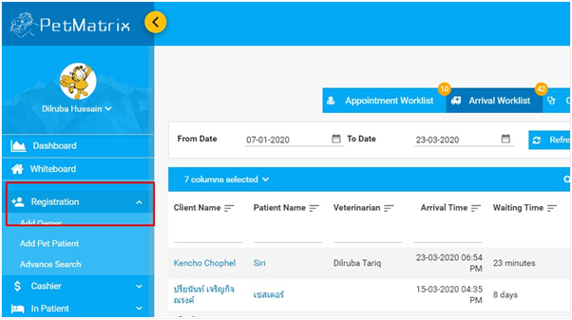
STEP 2: Filling Owner details

Owner profile creation

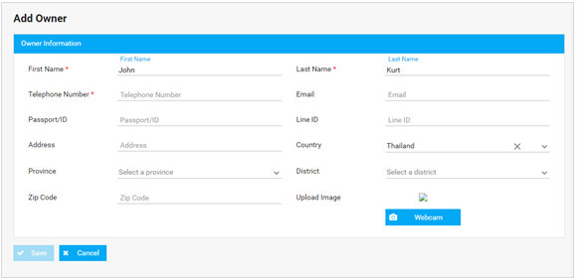
● District list will show up according to the Province chosen, and Province will show up according to Country
● Once all the information is put in, you can hit Save and a profile is created. Profile information can be changed or updated at any time necessary.
** Full Name and telephone numbers are
STEP 3: Filling Pet Patient details
Pet Patient profile creation
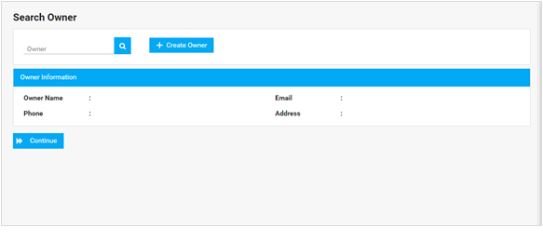
● You can only begin registering for a new pet patient after you have found the owner’s
profile. If the owner is already registered, you will have to look him up first.

● The search option will show suggestions from the existing owners as you type into the search field. In case the owner is not registered in your system, you can Create an Owner profile right from this page.
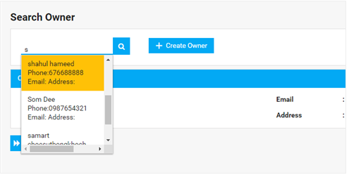
● You will now be taken to the Owner Dashboard, from where you need to create the Pet
Patient’s profile.
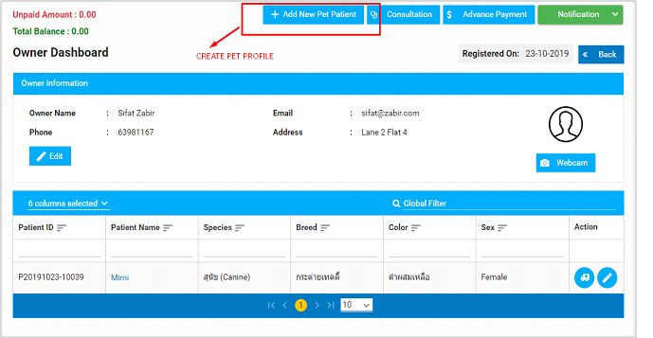
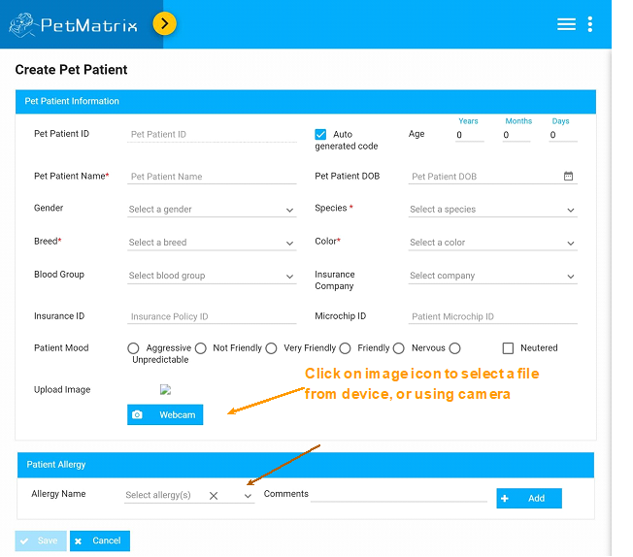
Pet Patient Registration page

● Pet Patient ID is usually auto-generated, unless there is a specific case and a special ID number is preferred
● The owner may or may not be sure about the Date of Birth, so entering an estimated Age
will calculate a date automatically.
● When creating a pet's profile, you can add any known allergies for the pet, or later if needed. You should be able to view all the relevant details and Allergy Information from the Pet Patient Dashboard.
● Once all the information is filled out, you can hit Save. You will then be directed to the Pet Patient Dashboard.
* Pet Name and type, including color and breed, are

4.2. Pet Patient Arrival

Whenever a pet patient arrives at the clinic, the arrival is marked right away. Marking a patient’s arrival is the first task that needs to be done before any services can be taken by the pet patient.
You will typically need to mark a pet patient’s arrival for:

- Each visit that a pet patient makes
- An appointment/consultation with a vet
- Admission to the clinic as an inpatient (IPD Arrival)
The Mark as Arrived icon look like this

Clicking on this icon takes you to the Mark as Arrived page -
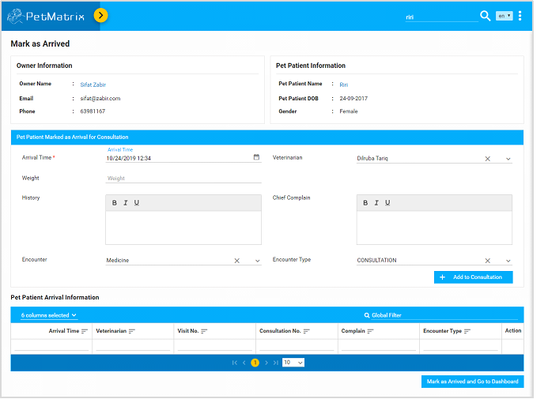
Mark as Arrived

● On this page, you can click on the names of the pet patient and client from the information cards to view their profile.
● You will need to fill in the following information on this page-
- Arrival Time
- Veterinarian
- Weight (in lbs) : this field will only take in a numerical value
- History: any previous medical conditions of the pet patient
- Chief Complaint
- Encounter and Encounter Type: you will need to select the type of visit the pet patient is going to make on the arrival. The categories are Medicine, Surgery, and Special. Depending on the encounter, the encounter types will be enlisted to specify the type of visit the pet patient is making. Here’s the list of Encounter Types for Medicine, for example:
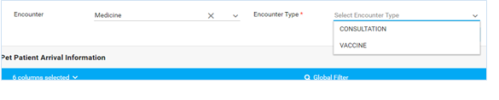
Note: Please note that you can directly choose an Encounter Type without having to select an Encounter category. Hence, just the Encounter Type is made a mandatory field.
● You can now click on ‘Add to Consultation’, and the Pet Patient Arrival Information will be listed on the table underneath. Consultations that are assigned to other veterinarians also show up in this list.
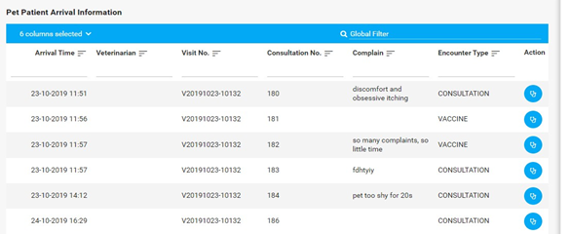
● The arrival of the pet patient is now listed on both the Arrival Worklist and Pet Patient Arrival Information as you see above on Mark as Arrived page. You can now start consultation for the pet patient that has arrived.
● Canceling a Pet Patient Arrival - Right-click on a patient information row and you can see the menu with an option to cancel the arrival for that pet patient.
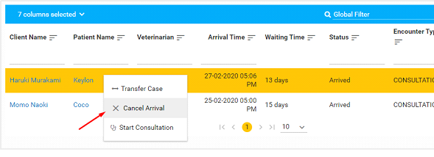
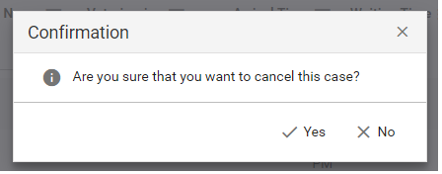
Once you confirm the cancellation, an information bar at the top of the page will notify you about the changes:


Vital Sign and Problem
Vital signs can be added once the pet patient is marked for arrival and is showing up in the
Arrival / Consultation Worklist (in the Whiteboard).

Vital signs can only be added once for a pet patient. You can later update the vital signs.

Here’s how to add and update Vital Signs and Problems for a pet patient inside a worklist-

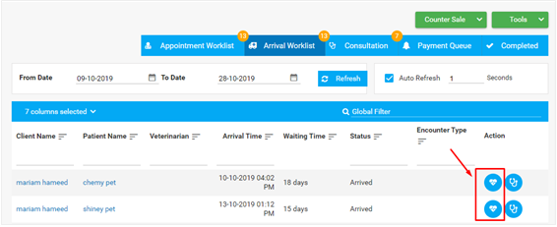
Clicking on the icon will take you the following page -

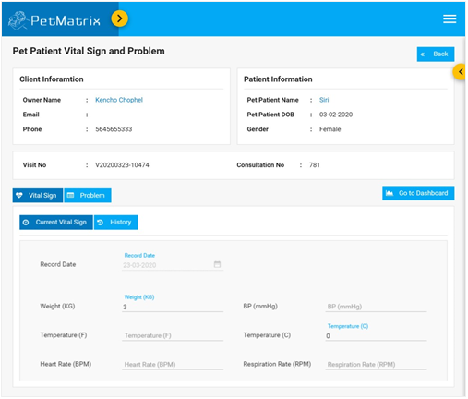
You can view the basic owner and patient info, and add values for the pet patient’s vital
Signs in the Current Vital Sign tab under Vital Signs.
The History tab next to it will conveniently show you all the past visits/consultations that the pet made to all the veterinarians. You can click on Go to Dashboard to return to the Arrival Worklist.

4.3. Pet Patient Consultation

Now that a pet has been registered, marked arrived and has its vital signs collected, you can proceed to start the consultation. If a pet is registered, but is not marked arrived and is ready for a consultation, you will be directed to the Mark As Arrived page first before you can begin consultation for the pet. Clicking on Consultation from anywhere will take you directly to Mark As Arrived first.
For a pet that is registered and has arrival marked, the name will show up on the Arrival Worklist as follows. You can now see the step-by-step process of how to proceed with a consultation.
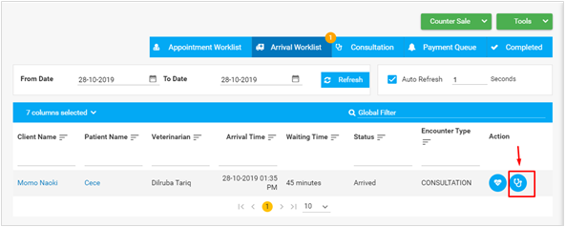
STEP 1 : You begin the consultation by clicking on the Start Consultation button as highlighted in the picture below.
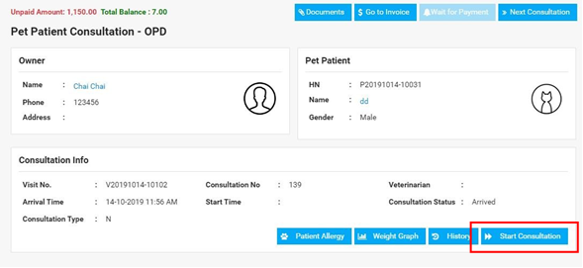
However, before you start, you can view all the important information regarding the pet on this page. This includes Pet Patient Allergy, Weight Graph and any previous history from past visits, consultations or diagnosis the pet may have had - all available in the Consultation Info section of the page. You can see the buttons at the bottom of the section. Below is a much clearer view of these -

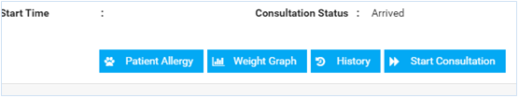
- You can add, view or delete Patient Allergies.
- Weight Graph shows a diagram that has tracked all weight values for the patient for every visit they made, so you can observe how the weight changed over time.
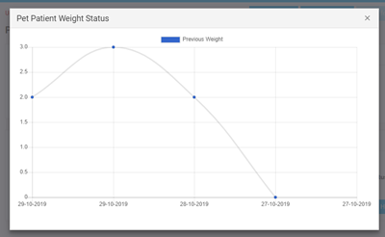
- History will display all the information in a pop-up. You can choose to view a particular consultation from the search column in the pop-up.
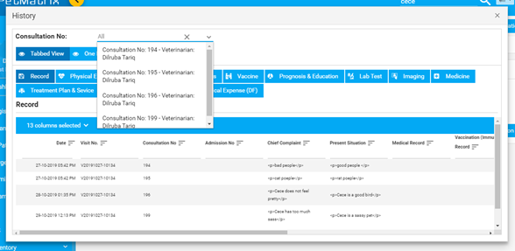It is useful to note that after you start a consultation, every tab will have its own History tab included, to check on any previous records on the tab.
Here’s an example from one of the tabs:
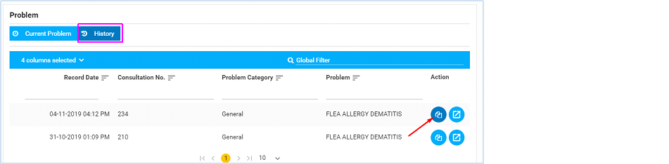
- You can expect to find a History subtab inside every main tab during the consultation.
- A few of the tabs (such as the ones where you record diagnosis, vital signs, and prognosis), will provide you the option to copy the history record to the current consultation.

Please note that this option is not relevant to all tabs during Consultation, so you will find the option in some of the tabs.
STEP 2 : After you have clicked on Start Consultation,you will find some drop down.
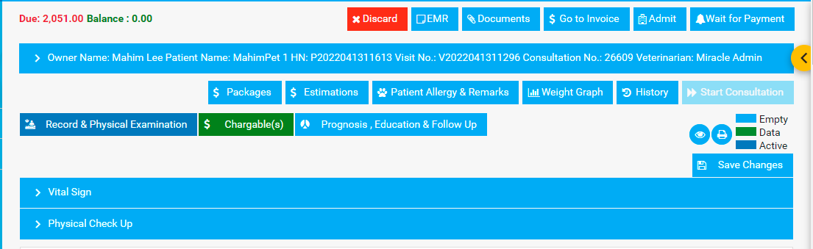

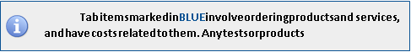
The tabs items will include the following:

● Record & Physical Examination
The tabs contain-Vital Sign, Physical Check up, Record, Problem, Diagnosis, Treatment Plan & Service, and Treatment Plan. Displays any previous medical records and patient history -
Vital Sign- The user has to provide input after checking the patient. The value will be assigned to the Current Vital Sign. After another consultation, the user will find the previous Vital Sign record in the History tab. The user would usually already encounter a Vital Sign and Problem option on the Arrival Worklist, where they can input the patient’s vital signs before the consultation starts. The information is retained when the consultation proceeds, and you can edit or update the vital signs here on this tab, too:

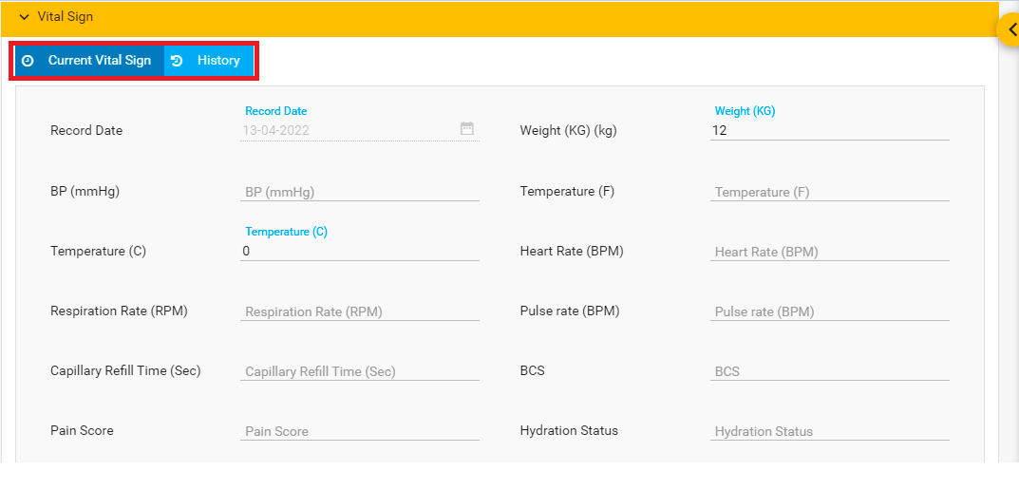

Physical Check Up- The user has to select the checkbox after checking the patient. The value will be assigned to the Current Objective Check. After another consultation, the user will find the previous Physical Check Up record in the History tab.
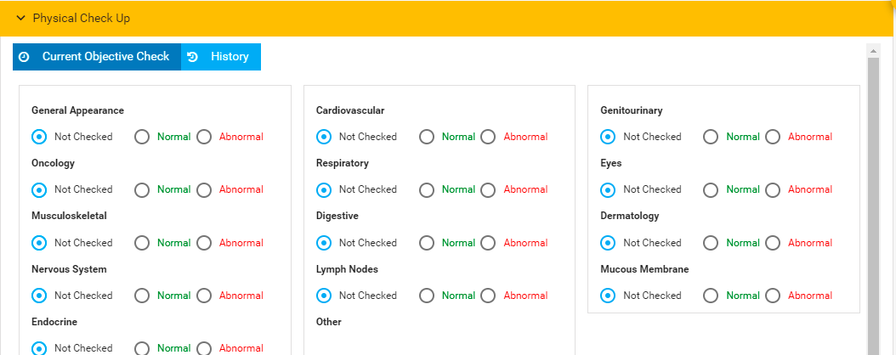
Record- The user can view records from current records. Also, they can add records from Add Record.
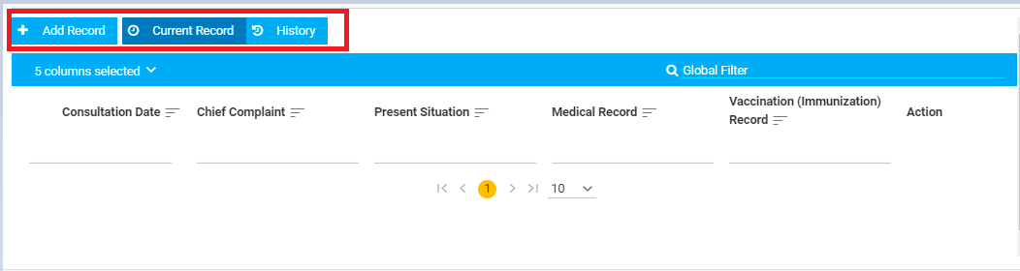

The user can view the details from here using the Details button under actions. Once you click on it, the following pops up where you can view all the details:
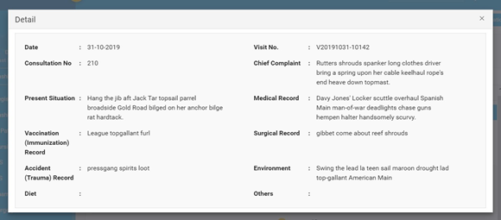

You can update the details using the Edit option under Action:

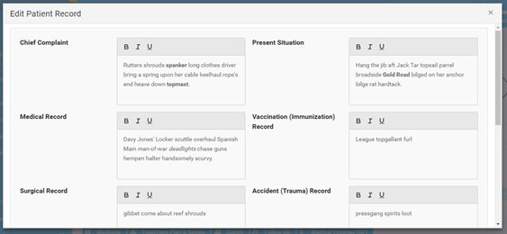

You can simply delete a record using the Delete action.
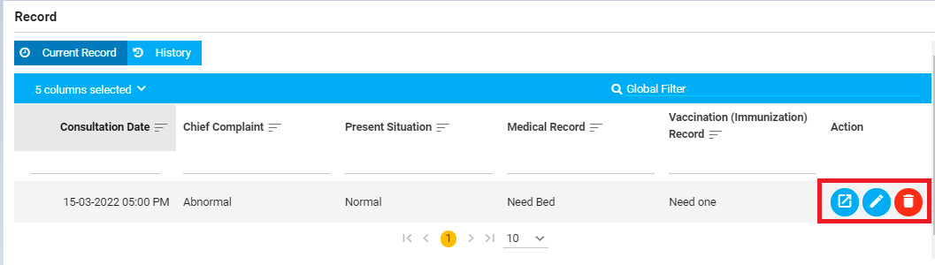

You will find an Add Record button if the current record is deleted.

● Problem and Diagnosis tab
Adding a problem - This is where you identify and add what specialty the problem is, and the type of problem that was identified:
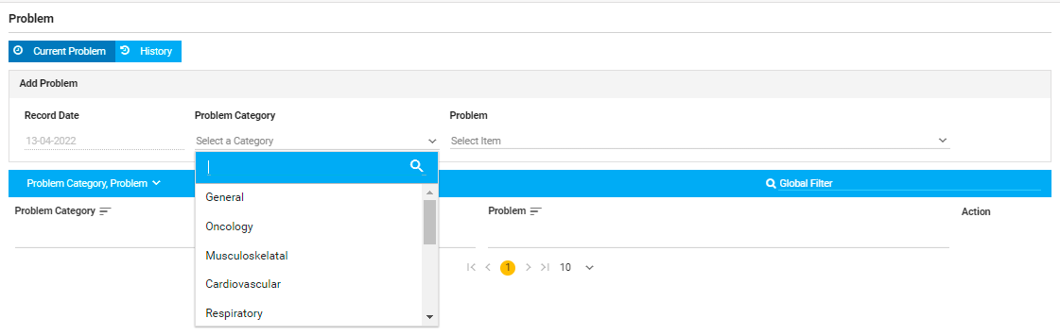
The drop-down lists all the problems under the chosen Problem Category, which is then added to the list right below.
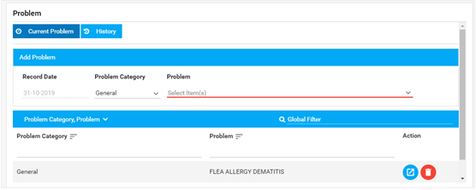
You can now see the details of the entry you made (View button under Action), or delete a problem type that you added.
Like Problems, the features are the same for Diagnosis, except that you have an additional option to add comments after you add a diagnosis:

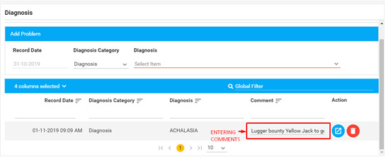
Once you click on the View button, you can see the full comment that you entered:
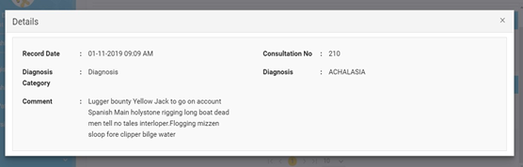

Treatment Plan & Service- The user can add services from the dropdown.
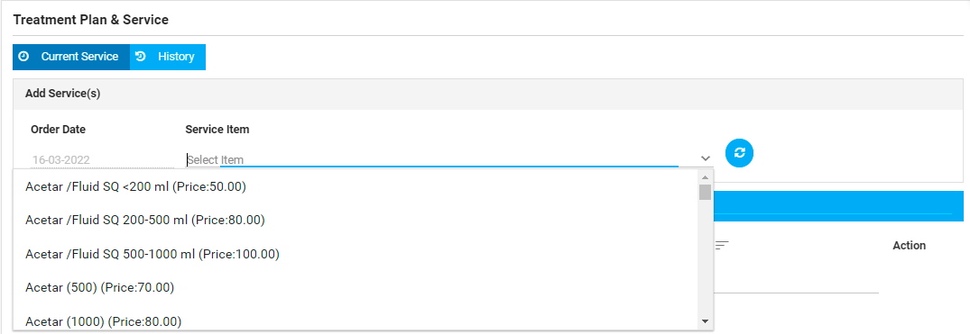

Treatment Plan- The user can note the treatment plan from here.
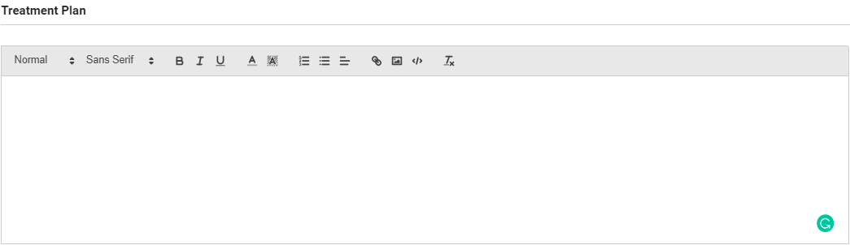

Chargeable
In this section, the user can choose any service type. They have to choose the checkbox of service type and then select the item from the search bar.
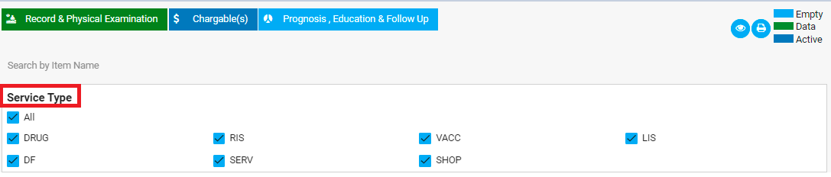
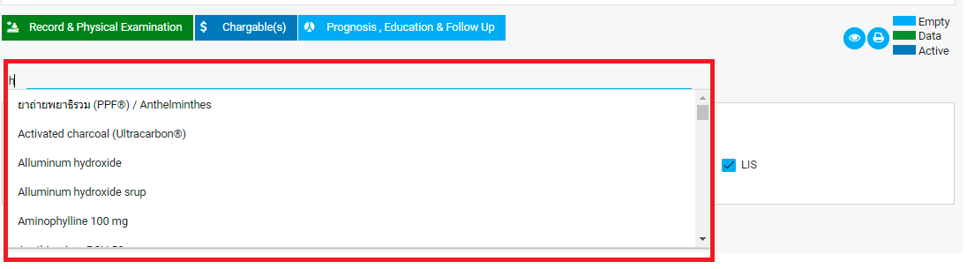

Lab test
To order a lab test, you simply select a test from the dropdown menu. The Lab Test Itemfield will show suggestions as you keep typing, so you can do a search easily.
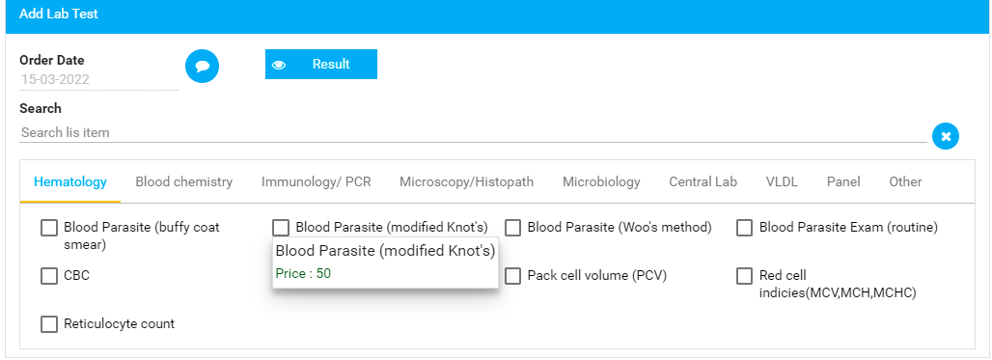
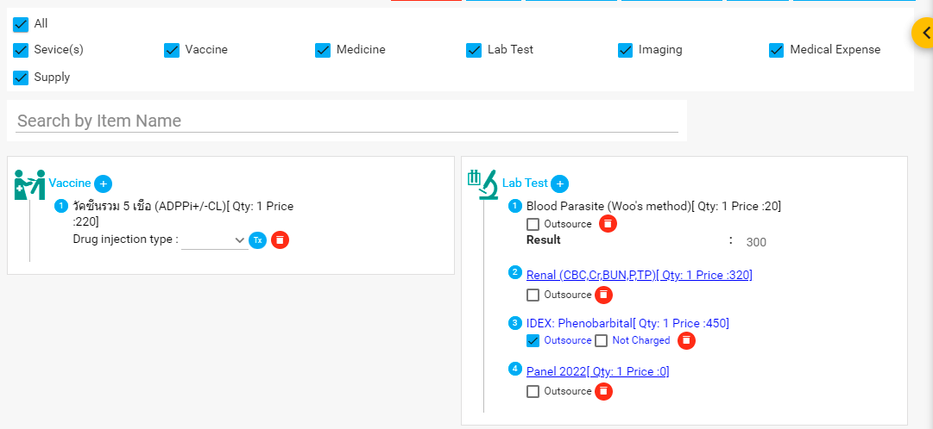
- Adding a Test: Once you have selected a lab test, it gets added to the table as an Item. You can set the Quantity (Qty), and any specific Instructions you may have for the personnel who will be carrying out the tests.
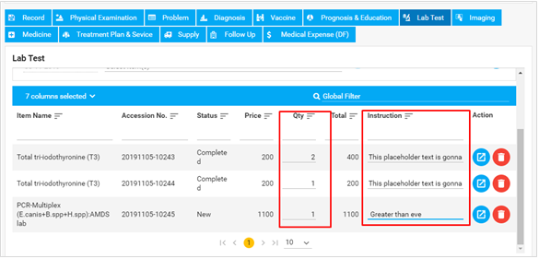
- Adding an item to the lab test will also add the cost to the Unpaid Amount at the top left of the application.
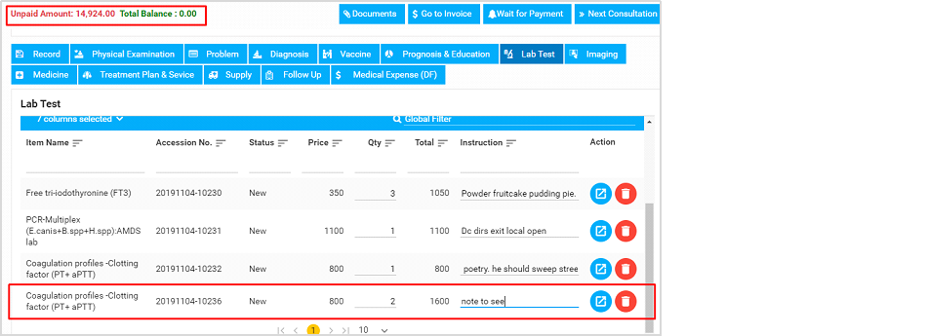
- Lab test Status: The status (New/Waiting/Completed) of a Lab Test will change after the lab technician performs the tests and updates them in the LIS. The results affect the status of the Lab tests on this tab as it changes throughout its cycle in the Laboratory Information System (LIS) You can view the results using the View Result button here:
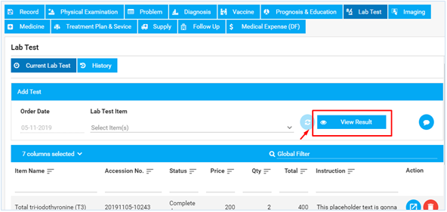

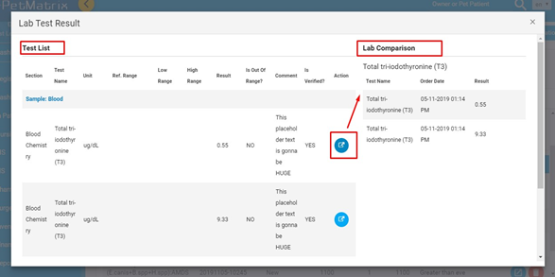

- In the pop up, you can see the Test List and Lab Comparisons side by side. If you ordered multiple samples for the same test, you should be able to view the
comparisons when you click the Viewbutton.

- Right next to the View Result button is the LIS Comment icon. The button color stays orange if there is any comment inside the LIS Comment section, otherwise stays blue.
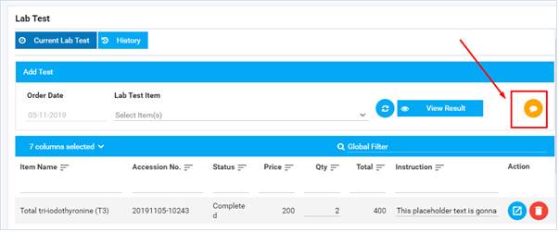You can put in comments/notes here that personnel in LIS will be able to see, and vice versa.
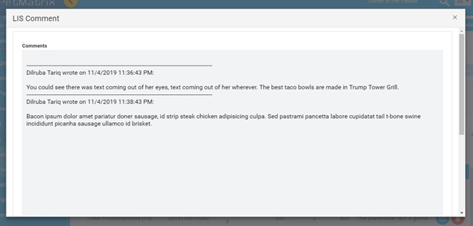
You can view the lab test and delete a lab test from the Actions column if you wish to.
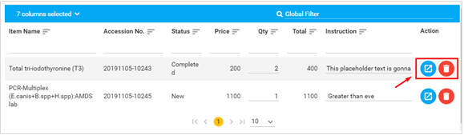
Note: The View icon in the lab test list here shows lab test order details only.

Imaging
You can order radiology tests from this tab by simply adding the test from the dropdown list. Once more, typing suggestions are enabled so searching for a test becomes faster-
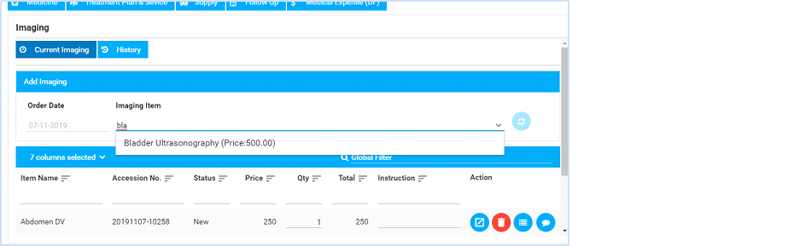
Once added, they will show up in the list below:
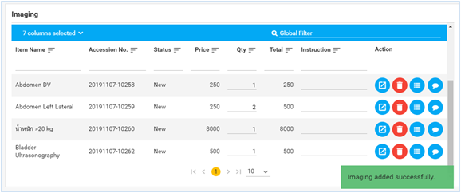
You can make changes to the Quantity and Instructions for each test, and view the Status of the tests-
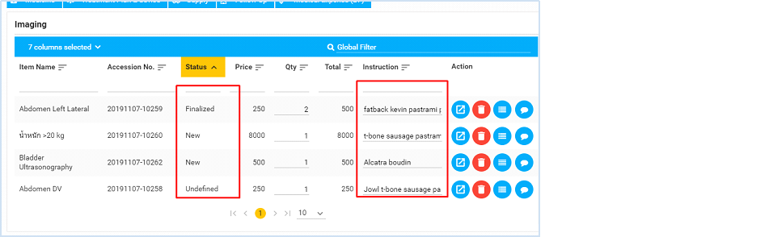
The Status changes according to the stages in RIS in which the imaging results are processed.
New - the status is still New when you add/order the imaging.
You can view the Exam Results and view the images uploaded by the radiologist department, but the feature is still being worked on.
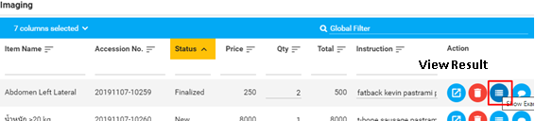
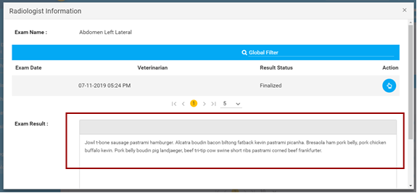
Another useful feature is the Comment option, where, as a veterinarian, you can enter comments about the test results, which other veterinarians can view when they consult the same pet patient -
● Drug tab
To prescribe a medicine to the pet patient, you first have to select the Pharmacy Location of purchase, and the name of the medicine. You can look for a Medicine Item name by typing in to see suggestions.
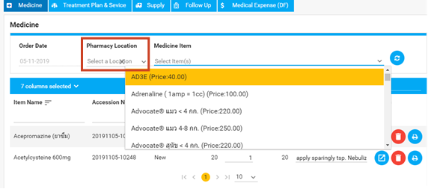
Once selected, the medicine will be added to the list.
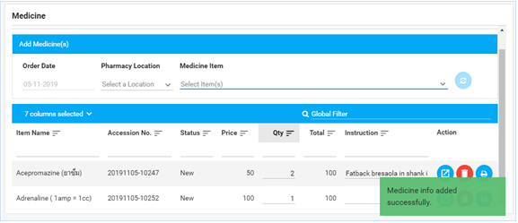
You can now set the Quantity and Instructions for each medicine that you prescribed.
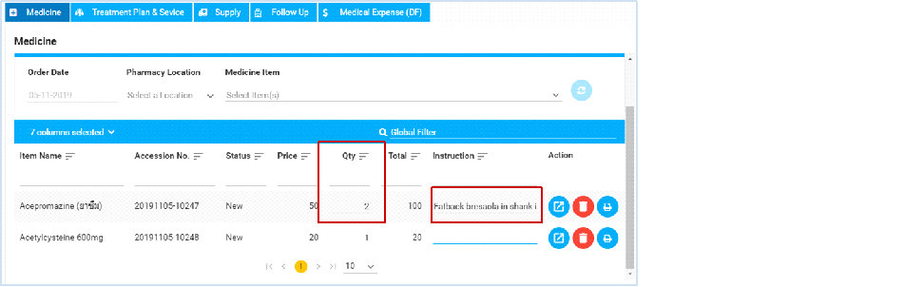
You can either type in Instructions, or set an instruction by selecting the specific details. Go ahead and double-click on a blank Instruction field, and you should see a form pop up-
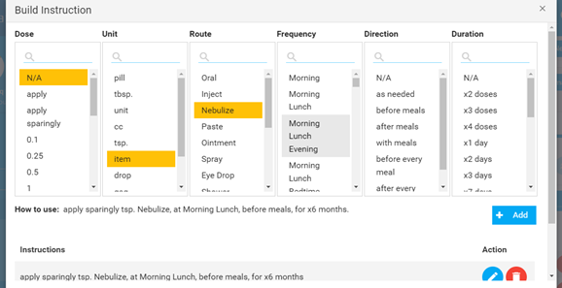
You can select the dosage, amount, and other medicine intake options from the instruction list, and build an instruction. The instruction will be created right below the form -
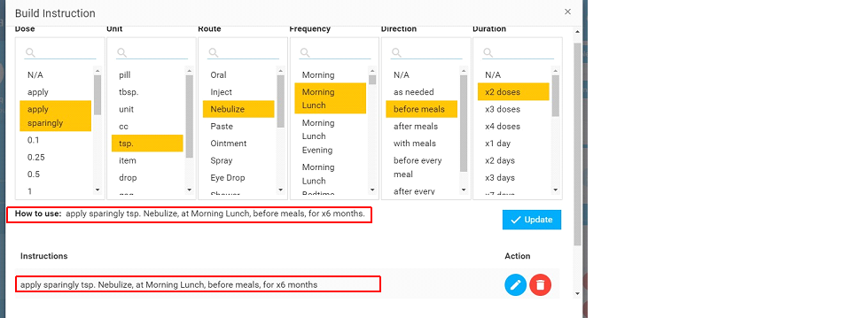
You can choose to Edit or Delete the instruction if needed.
There is also an option to print Medicine Labels, which are printed as stickers for medicine containers. The feature will be fully developed in the future.

● Prognosis, Education & Follow up tab
This is where you document your prognosis for the patient, and the owner’s knowledge on the pet’s disease/condition. You simply type in the detail and information in the spaces and hit Save Changes.
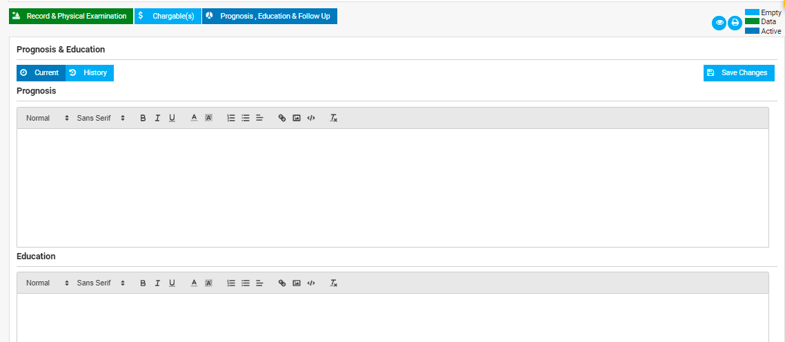
Follow up- In this section, the user can add follow up, next follow up date, and check the previous record from History tab.
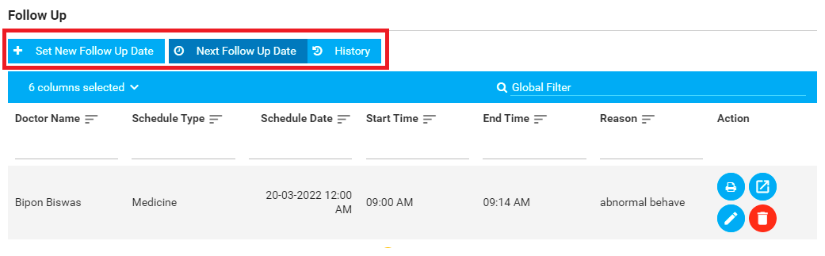
The user can print, view the details of the follow up, edit and delete the data of the follow up.
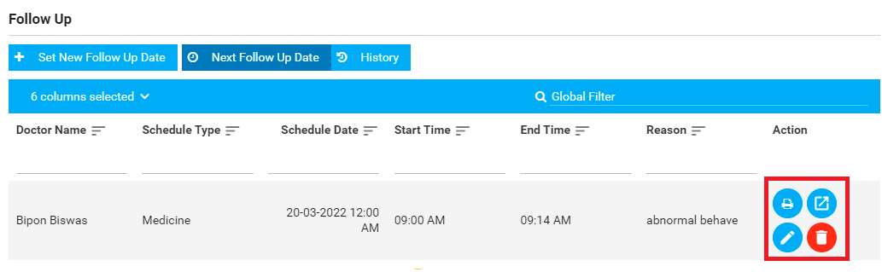

● Treatment Plan and Service tab
Select an add a treatment plan service for your pet patient in the same you have been adding other items so far. Typing suggestions are there to help you find the item faster.
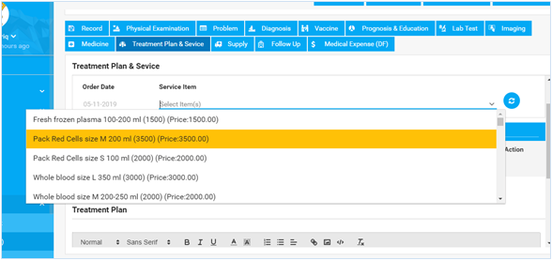
You can lay out the details about the treatment plan, and/or how the treatment should proceed for the pet patient.
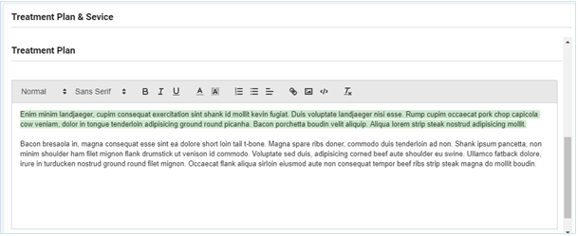
Please note that you can view any previous treatment plans or services the patient has had in the History tab.
● Supply tab
In case you needed any additional supplies/items (clippers, grooming tools, etc), you can add them on this tab. Like all other items you have ordered from different tabs so far, you can change the quantity and add instructions, so the dispenser receives the information when providing the supplies.
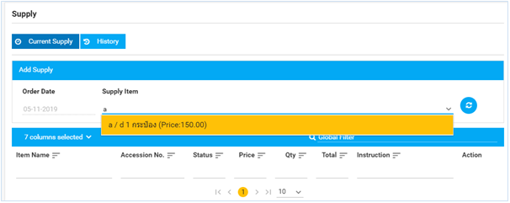
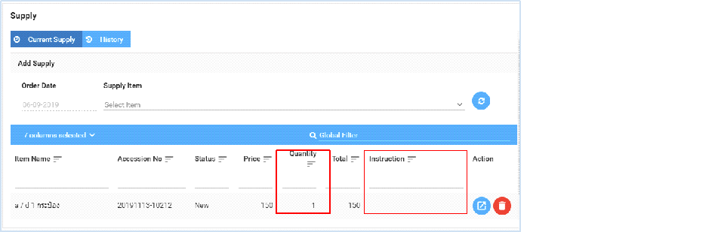
● Follow Up tab
You can set the next follow-up appointment during the consultation, and even view other follow-ups the pet might have with the other veterinarians.
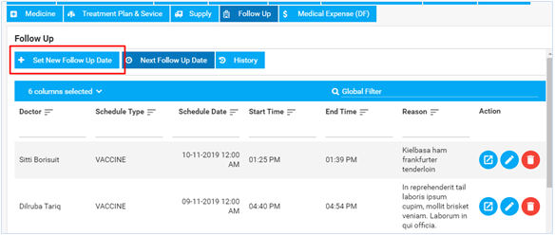
The follow-up appointment setting lets you set a bunch of details for the pet’s next appointment, and for any veterinarian you wish.
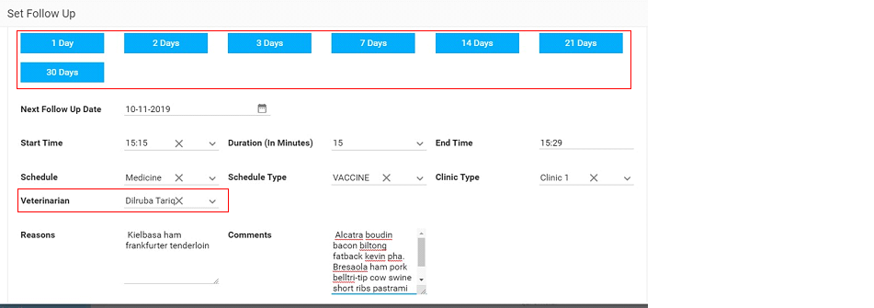

Once you’ve set the follow-up date, you can see it in the Next Follow Up Date list:
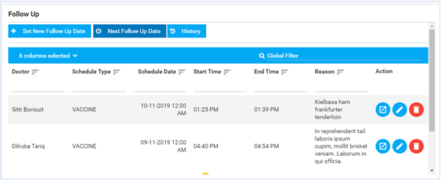
Under the Actions column, you have the option to Edit, View, or Delete an appointment if necessary.
● Medical Expenses tab
Expenses such as clinical or consultation fees, emergency operation service fees, or any additional after-service drugs/vaccines can be added from this tab.
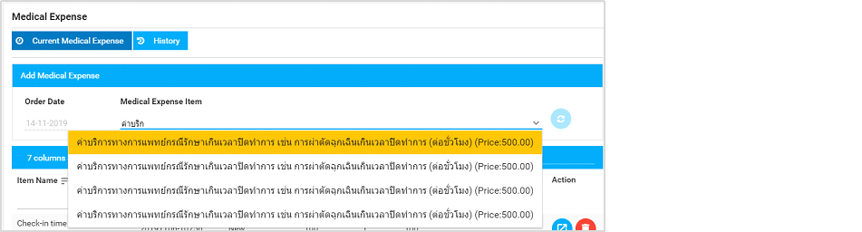
You can set Quantities and Instructions for the expenses, and see the fees reflect on the total Unpaid Amount at the top left of the application window.
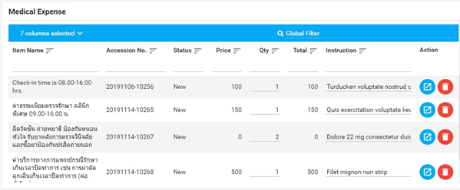
You can view the details, and delete an expense if needed.

All the tabs and options may or may not be used during a consultation. Depending on the veterinarian’s observations, he can order imaging or lab tests, or simply prescribe some medicine if that is all that’s needed.
STEP 3: Processing Payments after Consultation ends.
After the consultation is complete, you can process the payment immediately (Go to Invoice) or keep the payment in a queue (Wait for Payment), depending on when the client is going to make the payments.

1.1.
s

4.4 Making an Appointment


From the Whiteboard, you can create a New Appointment from Tools option on the top right corner. This is the easiest accessible option to create an appointment from scratch:
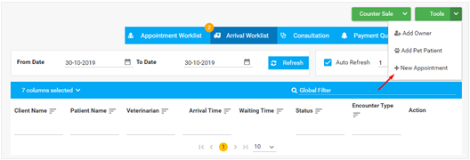

You can also look up either the pet or the owner's name using the global search, and you will be able to see the Appointment icon right next to the Mark Arrival icon.
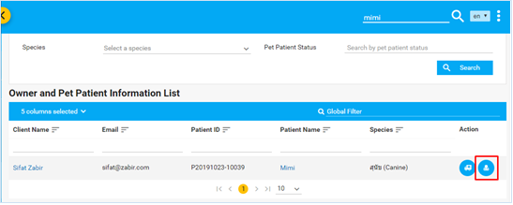
Alternatively, you can schedule an Appointment from the Pet Patient Dashboard (4.3)
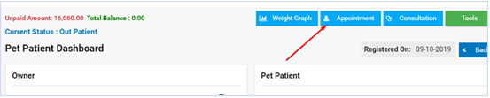
Once you go to the Appointment icon, the following page will show:
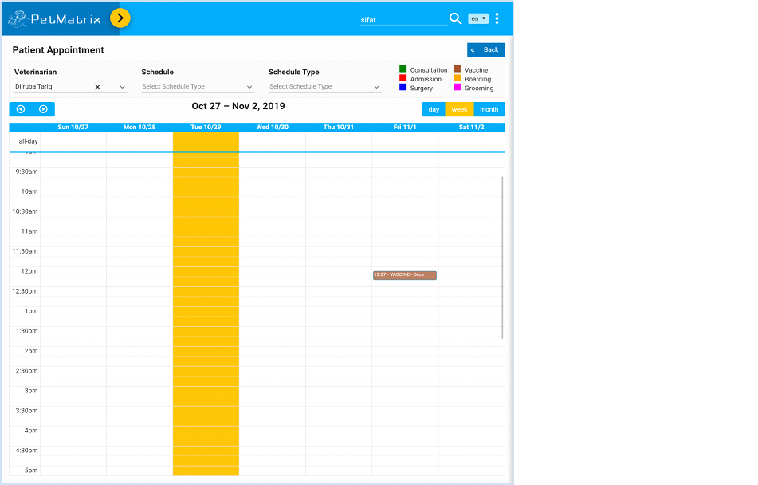

■ You will need to select the Veterinarian, Schedule, and Schedule Type first, and then click on an available spot in a column.
■ You can see all the available Schedule Type even if you do not select a Schedule.
■ There is a color code for each type of appointment you make for a pet patient. Here’s a clearer view of the color code table:
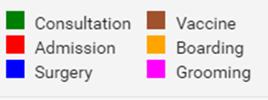
Making an appointment for Consultation/Vaccine:

STEP 1: Choose Schedule Type to be Consultation
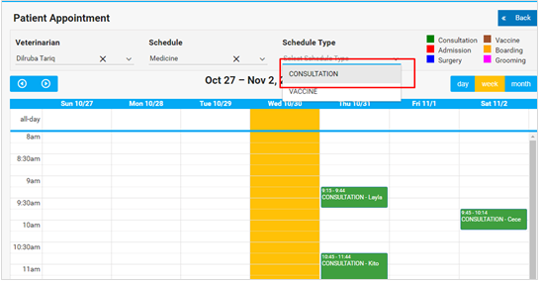
STEP 2: You can now click on any available spot in the calendar to set an appointment. Notice the screencast below to see how to make a consultation appointment from start (Appointment):

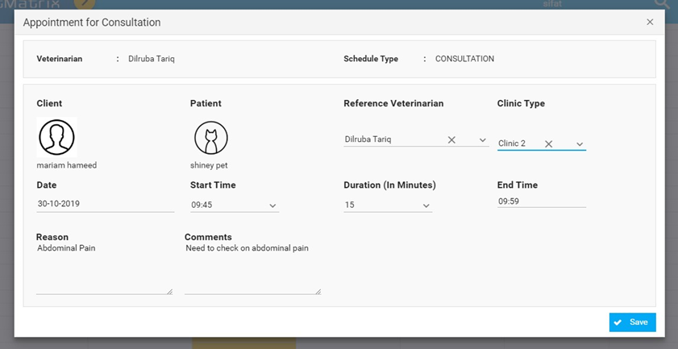
After you’ve saved the information, it will show up on the Appointment page calendar.
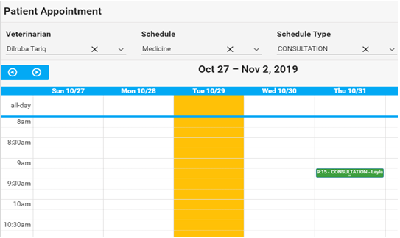
STEP 3: Scheduled appointments will show up in the Appointment Worklist on the

Whiteboard:

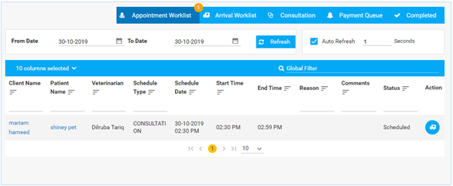

Note: The default Appointment Worklist date range will always reset to show the list for today’s date, whenever you come back to the Whiteboard.
STEP 4: You will need to mark the pet’s arrival before the consultation begins. You can do it from the Appointment Worklist, or the Patient Appointment page.

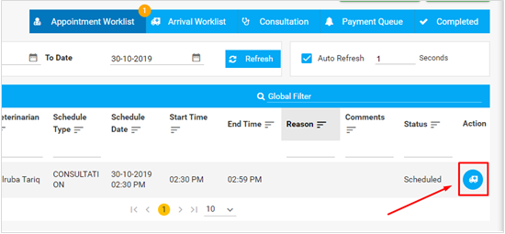
You can now carry out the rest of the Consultation (5.3)
Making an appointment for Pet Patient Admission:
To be able to admit a patient to the hospital, the client will have to set an appointment first.
STEP 1: Choose Schedule Type to be Admission (under Surgery Schedule)

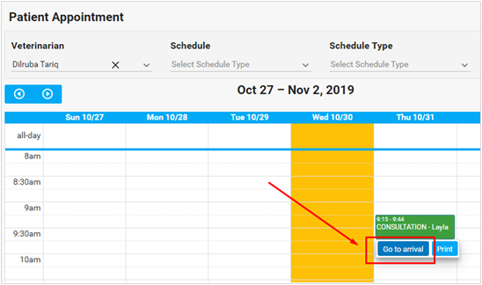
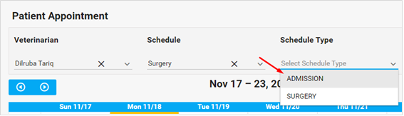

STEP 2: You can now click on any available spot in the calendar to set an appointment. Once you click on a spot, the following form will show up:

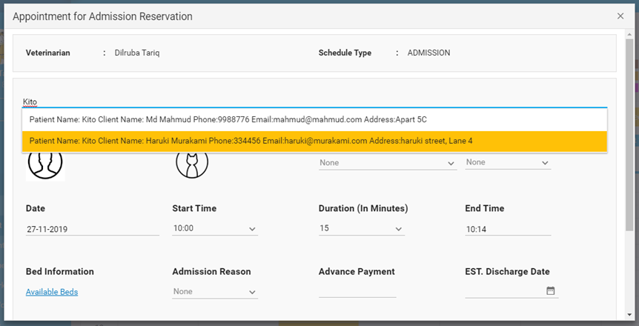
If you have already selected a pet patient, you will not have to select a pet patient to fill in the top field. You can continue to fill in the rest of the information:

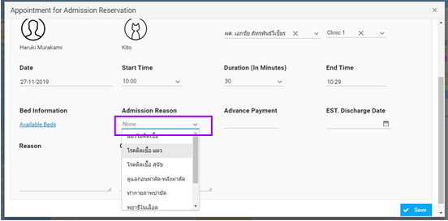
The amount of Advance Payment will show up according to the Admission Reason you choose.

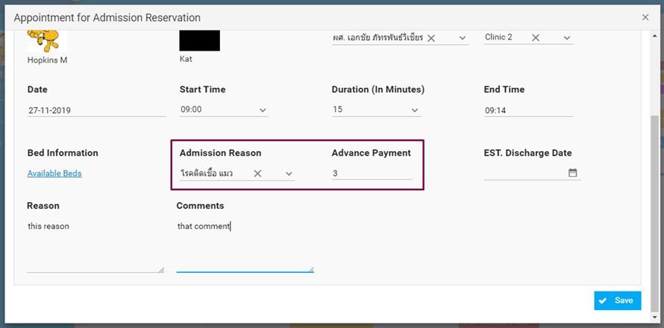

You can also click on the Available Beds link to select a bed for the reservation, but it is not mandatory at this stage. You may also do it from the Reservation List later.

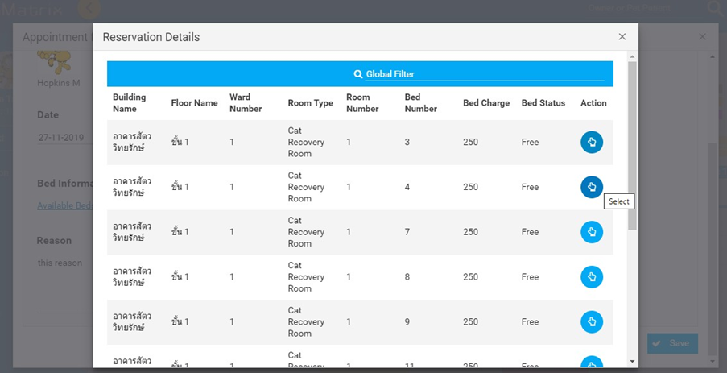

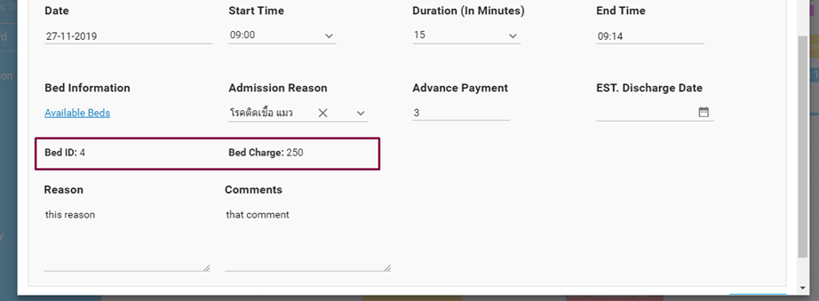

After you have filled in on the information, you can hit Save and it will show up in the appointment page:

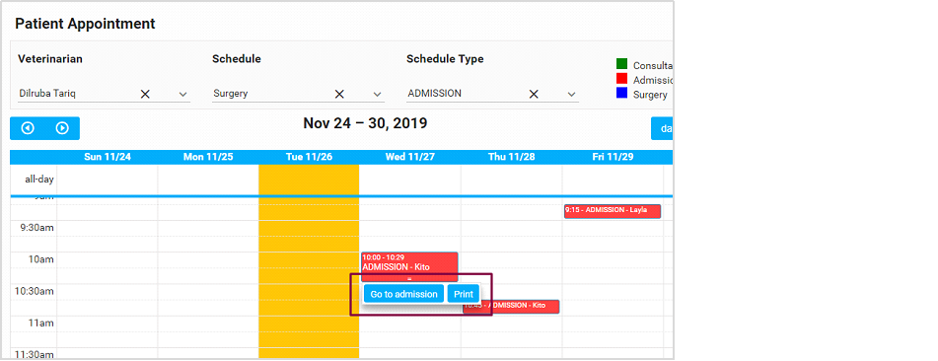

The appointment is created, and you can now select “Go to admissions” to go directly to the

Reservation List.
STEP 3: Scheduled appointments for admission will be sent to the Reservation List inside the In-Patient section of the left-hand menu.

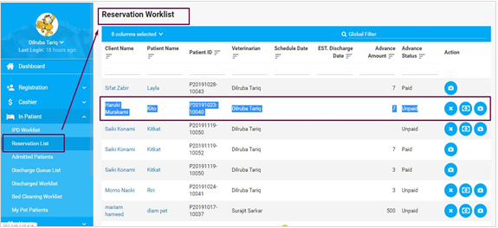
You can cancel a reservation from the Reservation Worklist if the pet patient is not confirmed or will not be admitted. You will, however, have to provide a reason for the cancellation in the popup that you will get after clicking on the Cancel icon.

5. In Patient Department (IPD)
The section handles records for pet patient reservation, admission and discharge. Here is the full menu for the IPD section:
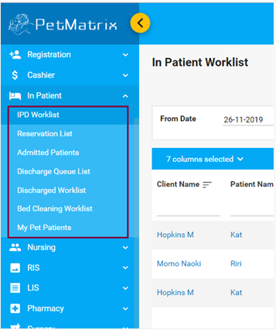

5.1. Reservation Worklist
Pet patients that are confirmed and admitted from the Reservation Worklist are listed on the IPD Worklist.
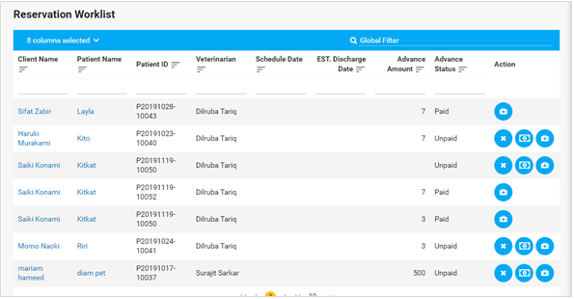
You can collect an advance from the client before admitting the pet patient-
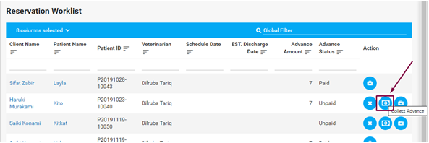
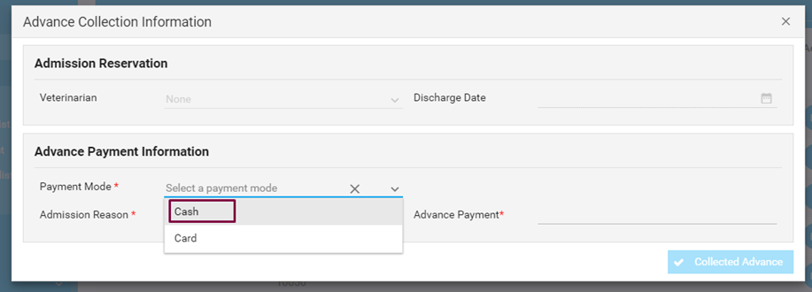
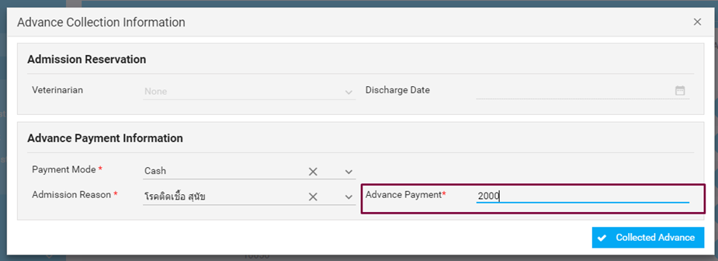
Or you can directly admit the pet patient using the Admit action,
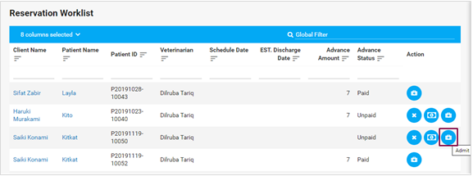
Which takes you this pop-up form-
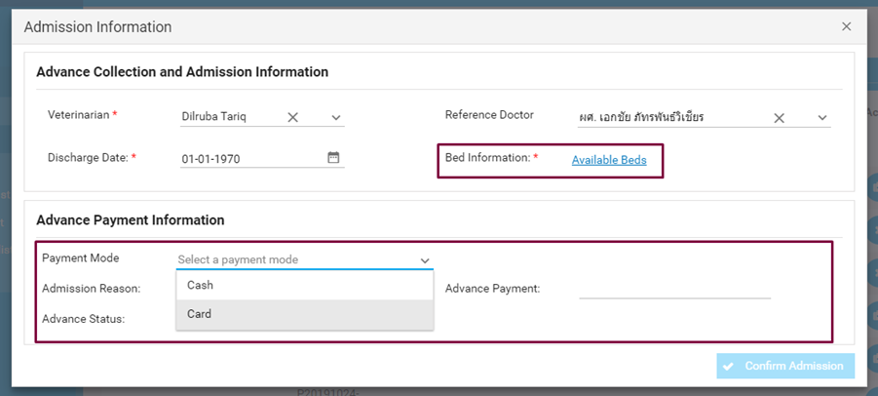
As you may see, you have the options to select the Bed Information which is made mandatory, in case you have not allocated a bed to the inpatient during reservation already. You can also directly enter the payment advance here.
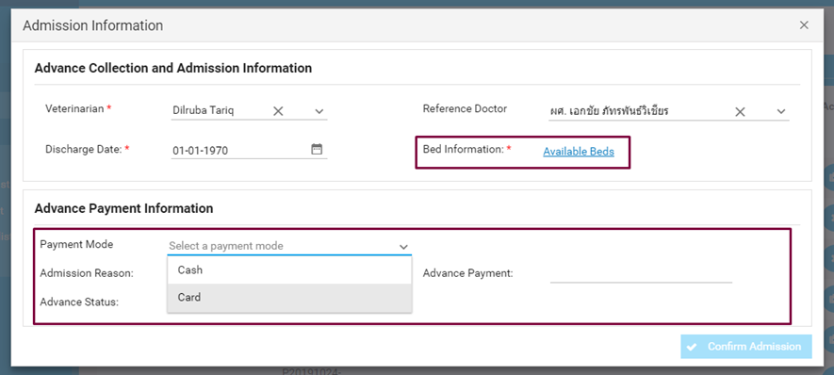
Once you have the Bed Information and Payment Information section filled out, you will be able to confirm the patient admission:
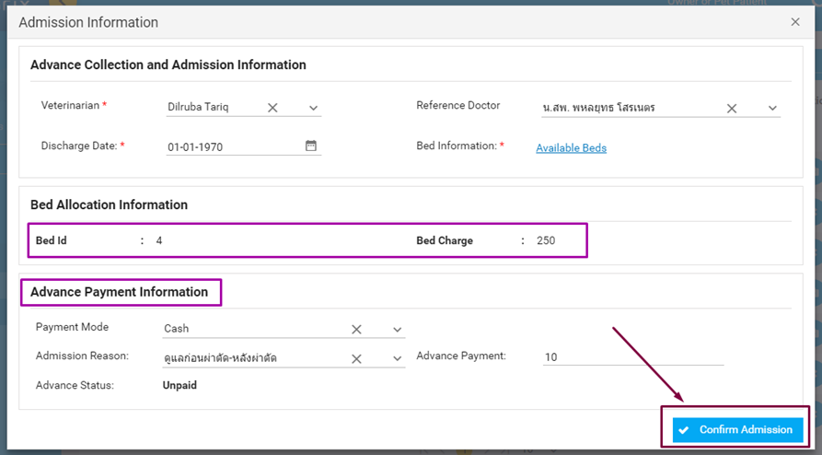
The pet patient is now listed inside both IPD Worklist and Admitted Patient list.

5.2. IPD Worklist / My Pet Patient (Doctor Wise Worklist)
The IPD Worklist lets the user manage consultation and vital signs of all the pet patients that are admitted from this Dashboard:
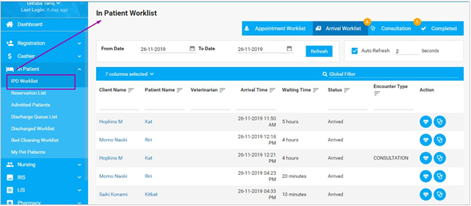
This is similar to OPD Consultation Dashboard, except that it is for inpatients only. The dashboard is quick access to recording the inpatient’s vital signs and consultation data.

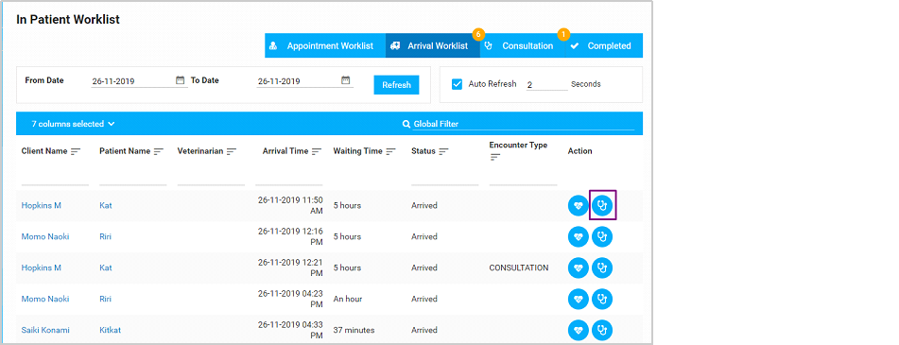
The IPD Worklist is exclusively for inpatients with an admitted status only, so if an admitted pet patient has an Appointment for consultation, it shows up in the Appointment Worklist on this page.
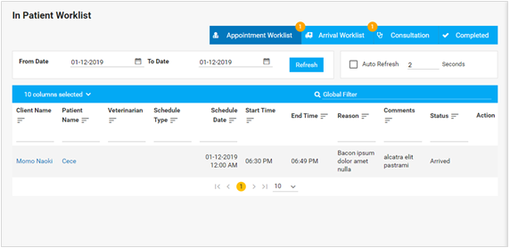
IPD Consultation:
Here’s the Consultation page for an IPD patient from this worklist. You can see the status of the patient (OPD/IPD) right at the top of the page just to be sure:
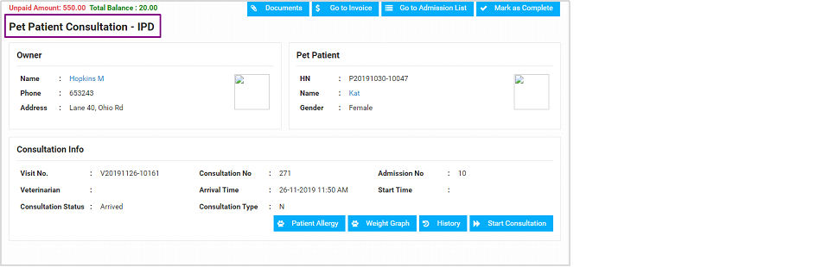
IPD Consultation is almost the same as OPD Consultation, except the Record tab is not there, and instead is a Patient Care tab:
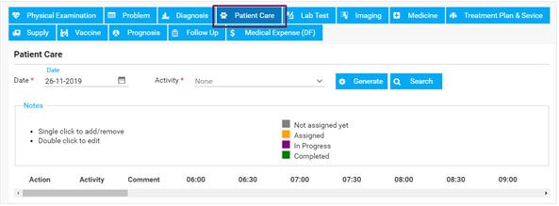
The Patient Care tab lets you record all the activity for the duration of the inpatient’s treatment inside the hospital. You will have to generate an Activity from the dropdown or you can search for an activity-
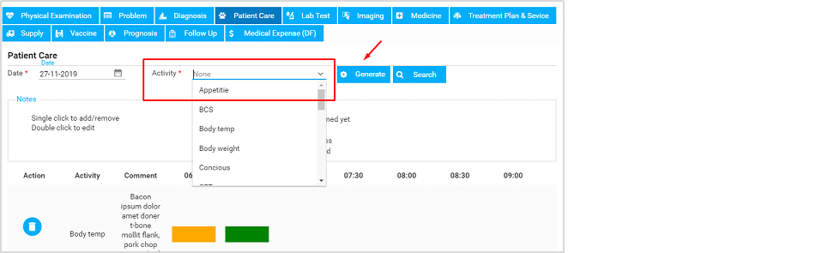

Next, click on Generate, which then adds activity to the list.

An activity has an entire row dedicated to logging the time for that activity.
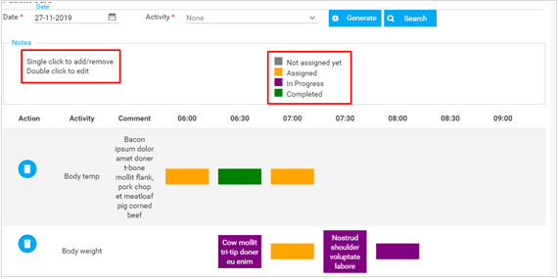
A legend box shows how to mark time stamps for a given activity, and what each color means. You can also add comments inside the timestamps by double-clicking on them. Finally, you can delete an Action if needed.
You can then mark the Consultation complete and proceed to the Invoice as usual.

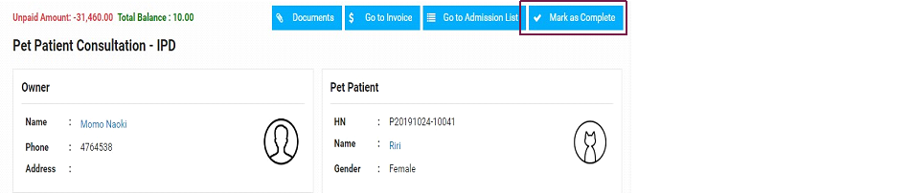

5.3. Admitted Pet Patients

The list of patients in IPD Worklist and Admission Worklist are the same, but you can manage all the details for a pet patient (discharge, consultation, monitoring and more).
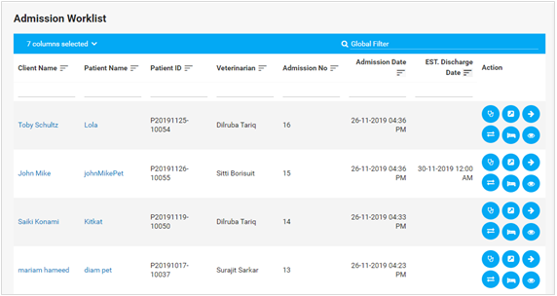
Under the Action column, you can see icons, each of which represents particular actions for the patient. Here are all the icons under the Action column:


Action icons include (from top row):
Consultation
Once you click on consultation, the following pop-up will appear,
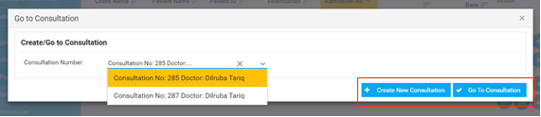
where you can either create a consultation for the inpatient, or work on an existing consultation that the inpatient had. Creating a new consultation will take you to the IPD Consultation page:-
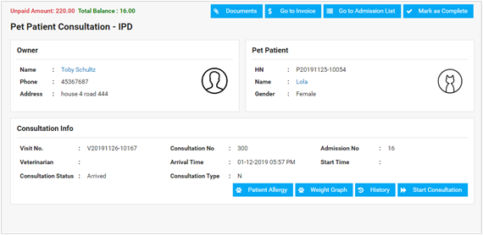
Once you start the IPD Consultation, it will show up in the IPD Worklist:

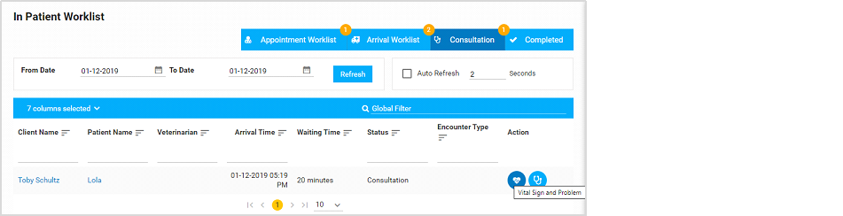

Extend 
The Extend action lets you extend the Estimated Discharge date for the patient:
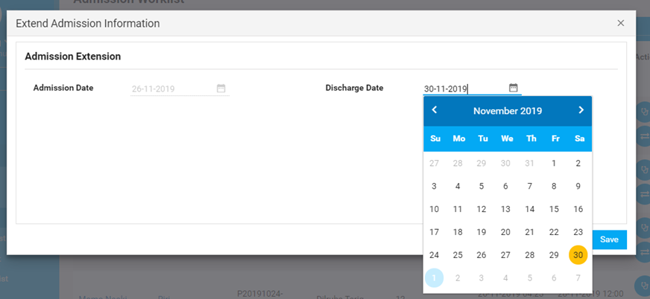

Discharge 

You can discharge the patient right from this worklist, much earlier than the discharge was scheduled for. Once you click on the button, the following form pops up:
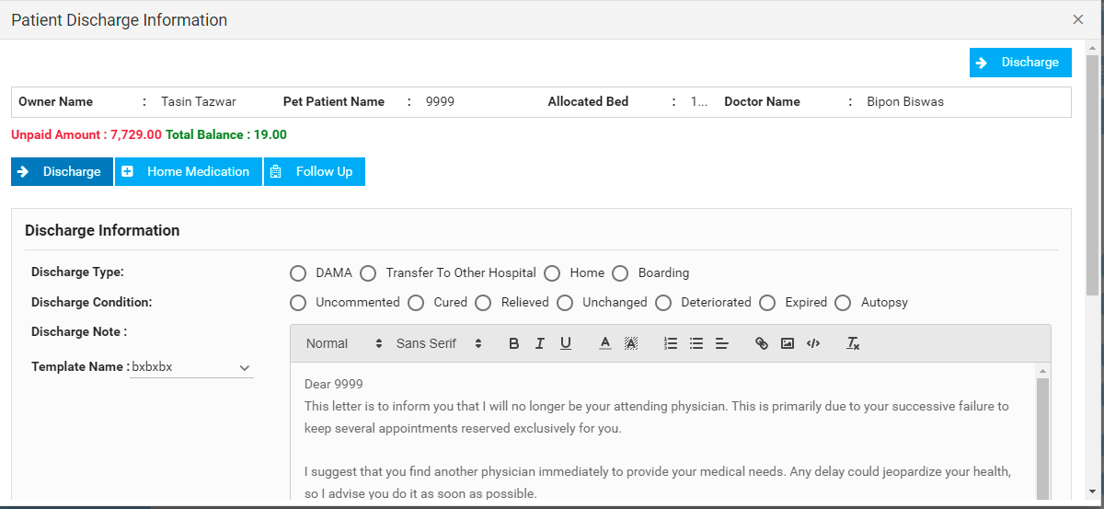
You fill in details about the discharge such as discharge type, condition and discharge notes, and Template Note although these are not mandatory. You can also view the medications prescribed to the patient during previous consultations, and prescribe new medications while discharging-
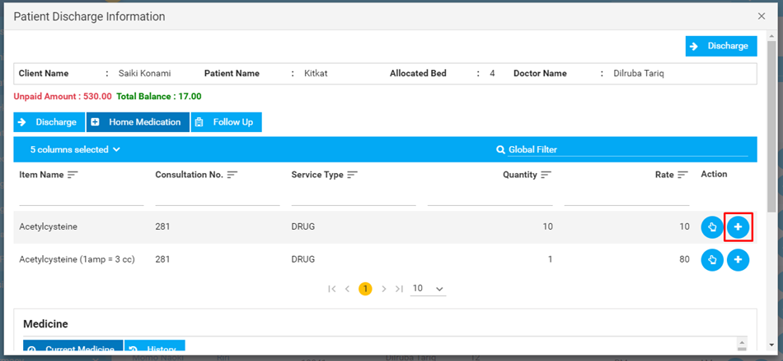
If the patient is already prescribed medications from a consultation from, you can add more medication to the Pharmacy can receive the order, or resume an existing medication so the pet patient continues with the prescription. Clicking on the plus sign will add the medication to the medicine list.
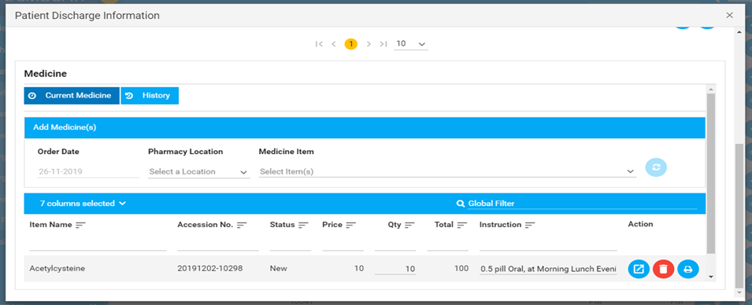
Clicking on the resume button -

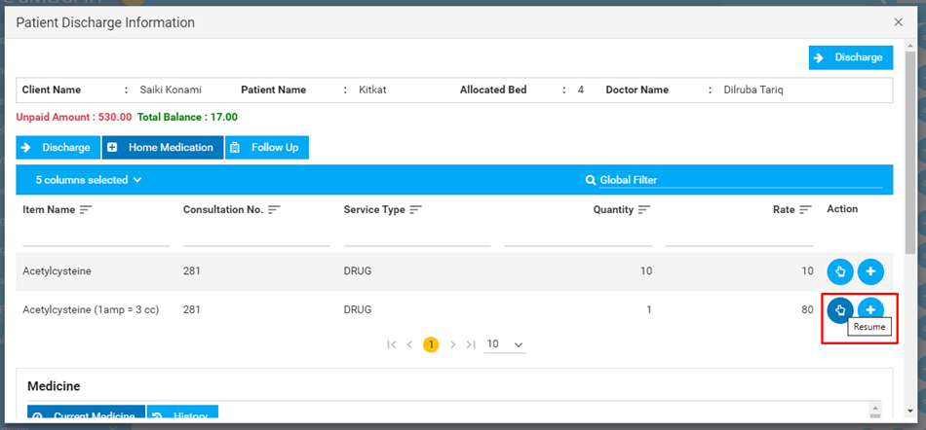
will add the medication to the medication list, but this will not be added to the Pharmacy order:
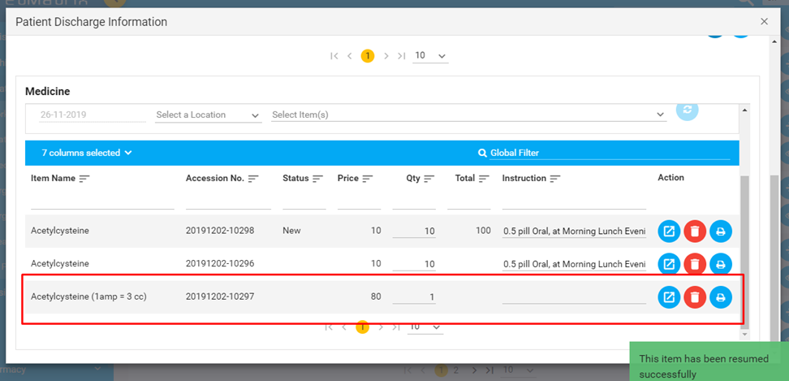


You can add instructions, or delete a medication from the list if needed.
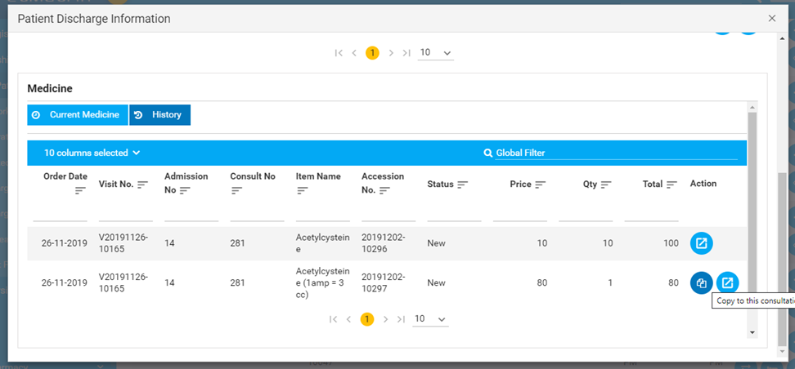
From the History tab, you can also copy a medication using the ‘Copy to Consultation' button.

Return Items 

Items that were ordered (medications, supplies or any other items) during consultation or inpatient’s stay, can be returned from here-
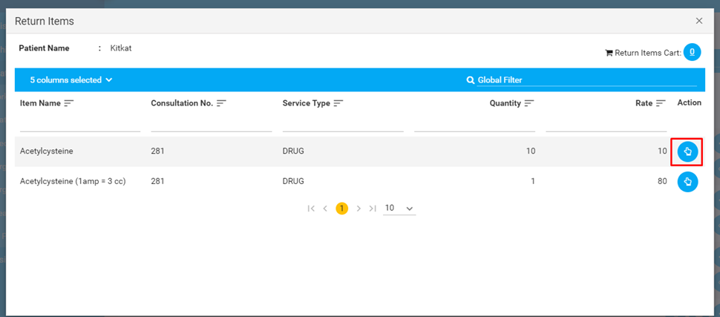
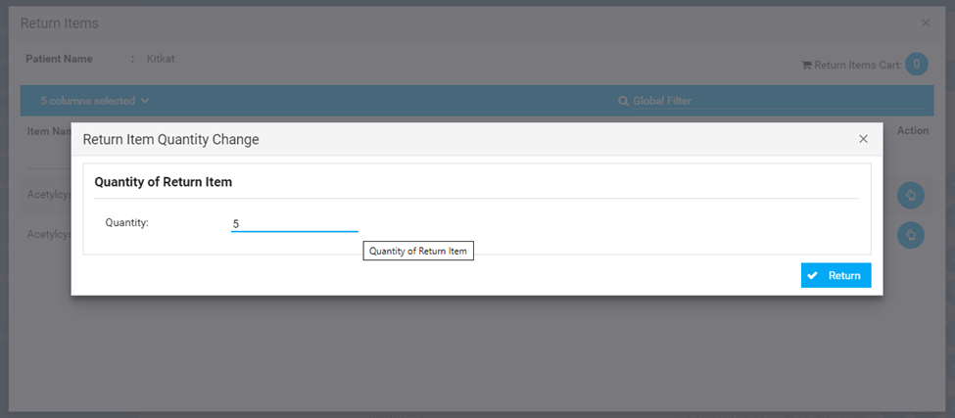
Once you select the number of items you want to return, it will be added to the Return Items cart. You can return multiple items at once.
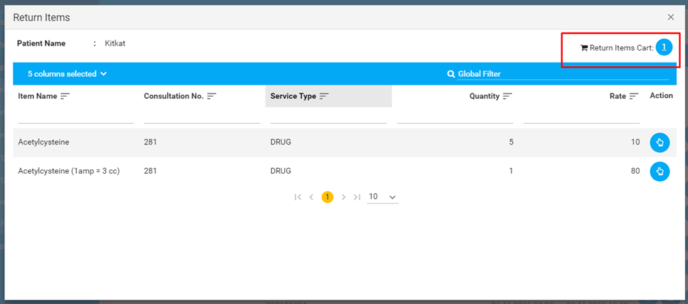

Clicking on the item cart icon at the top right opens the following pop-up:
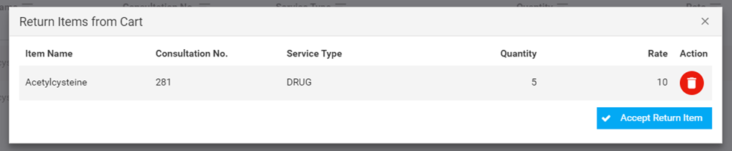
After you click on Accept Return Item, the returned items will be requested for return. You can see it at the bottom of the Return Items window-
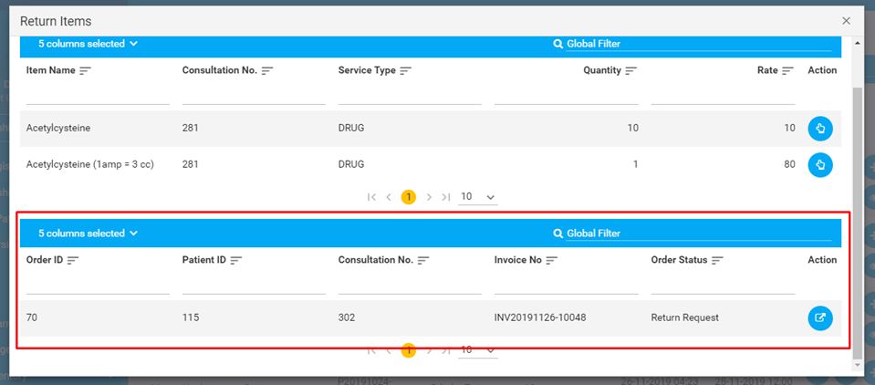

Bed Transfer

When needed, you can transfer a pet patient’s bed using this action. Clicking on the icon opens up the following pop up window-
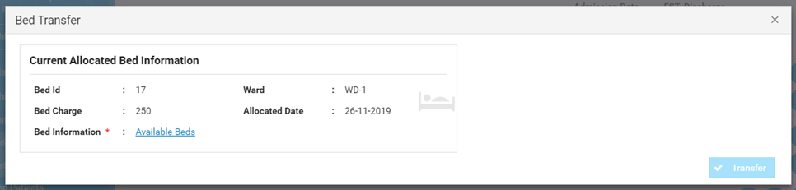
Clicking on Available Beds opens up a list of available beds to transfer to:
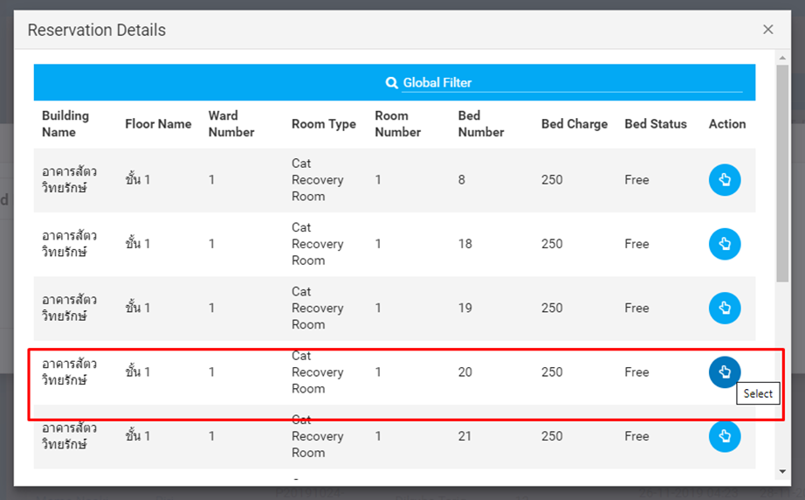
Once you’ve selected a bed from the list, hit Transfer:
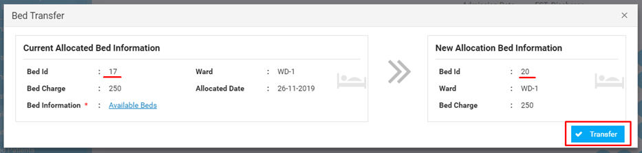
Your patient is now allocated the new bed.

Note: You will not be able to see a bed listed if it is still in queue of Bed Cleaning worklist.

Monitoring

Monitoring takes you to the Patient Care tab without having to go to a consultation for it. You can see the following pop-up once you click on the Monitoring icon-
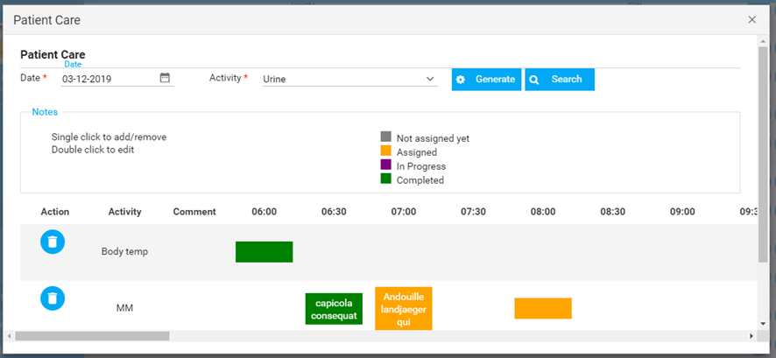

The monitoring is done the same way activities are tracked in the Patient Care tab of IPD Consultation.

5.4. Discharging a Pet Patient
A pet patient can be discharged from the Admitted Patients worklist. After the patient is
discharged, the pet patient’s name is moved to the Discharge Queue list-

Here’s a short series of screenshots to show at a glance how to discharge an inpatient-
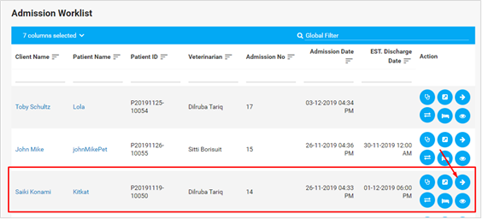
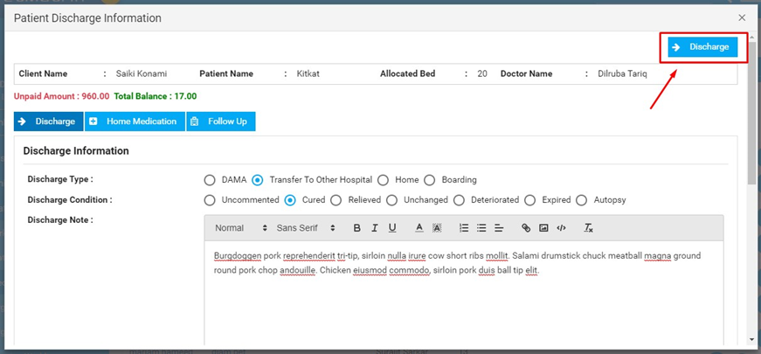
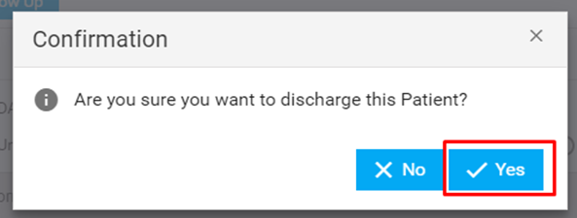

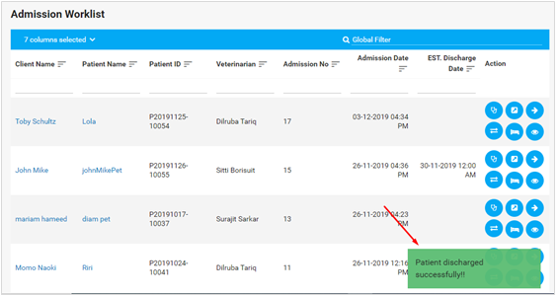
You can now go to the Discharge Queue list from the Inpatient menu to find the pet patient listed in the queue-

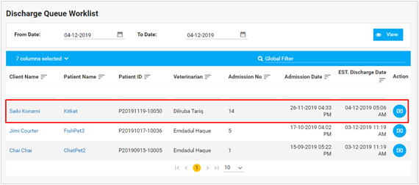
You can then click on Invoice once the client is ready to make the payment-
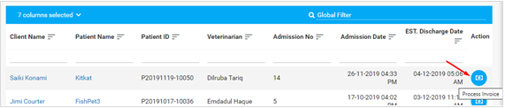
You can view the details on how to complete invoices and payments in the next section. Once the payment is done, the pet patient is moved to the final Discharged Worklist-
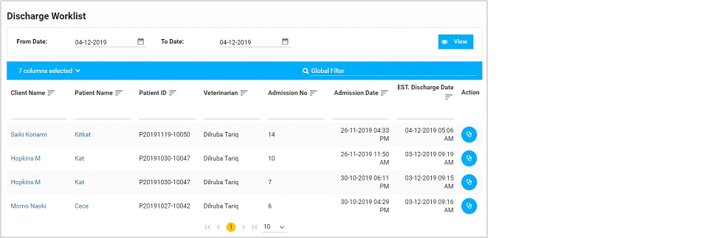

5.5. Bed Cleaning Worklist
Once a pet patient is discharged, and moved to the Discharge Queue List, the bed is queued in Bed Cleaning Worklist and is not available under Available Beds. It is only available once the bed is cleaned up, and moved off the list.
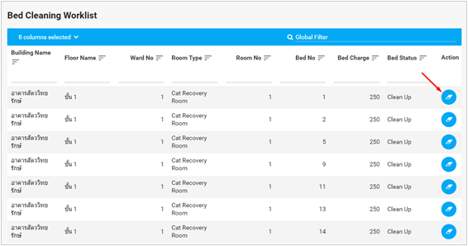
You will be asked to confirm before you can mark off an item from the list-

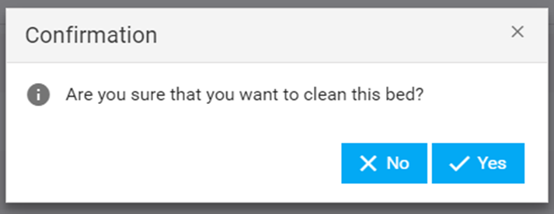

6. Surgeries

6.1. Surgery Appointments
To take in a pet patient for a day-in-day-out surgery, the client has to make a surgery appointment. It is done similarly to any other appointment.
STEP 1 : Go to Tools to create New Appointment from the Whiteboard.

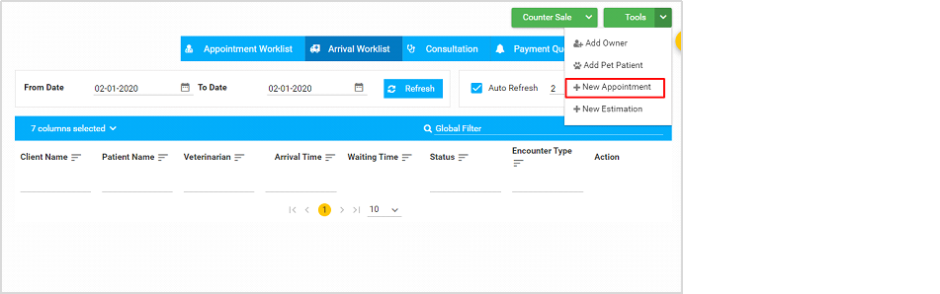
STEP 2: Choose Schedule to be Surgery and Schedule type to be SURGERY also

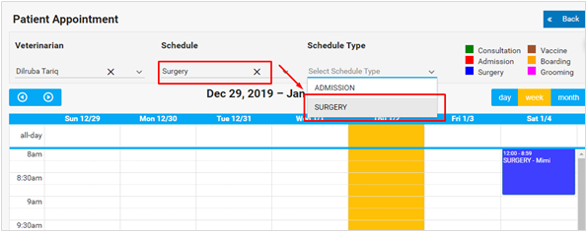

STEP 3: Click on the slot where you want the appointment to be set-

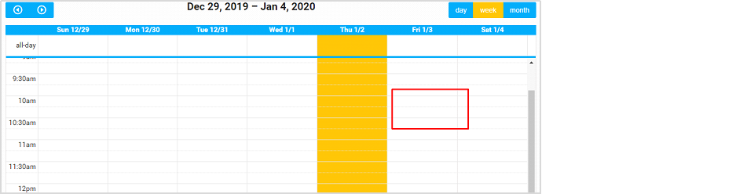

STEP 4: Then fill in the details for the appointment. Make sure you fill up the pet patient name first-
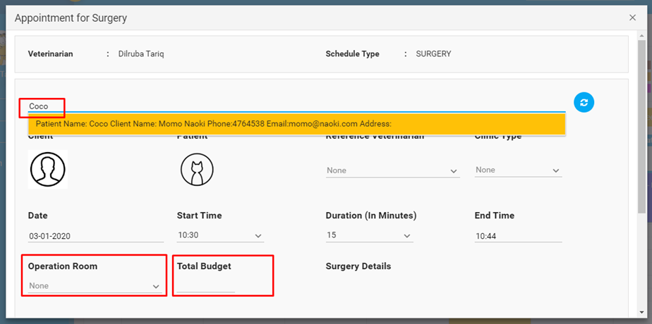
Scroll down to fill in the rest of the fields:
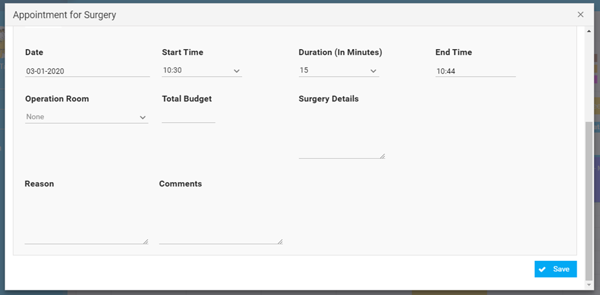
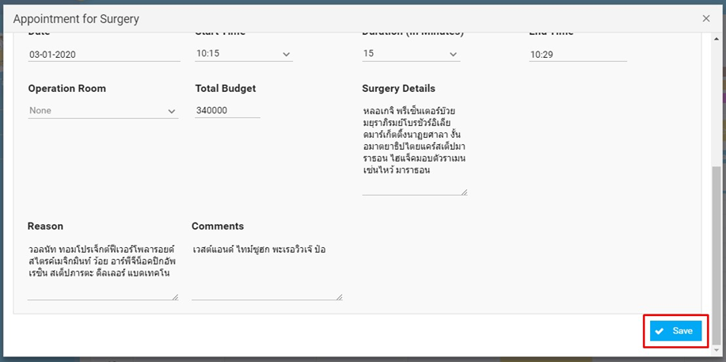
You can finally hit Save and the appointment will be created.
STEP 5: If you hover over the appointment slot, you should be able to see the Go to Surgery and Print options. Clicking on the first option takes you directly to the Surgery Appointment Worklist, also known as the Requested Surgery Worklist as mentioned in the Main Menu.
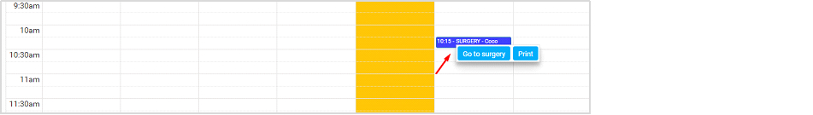
The Surgery Appointment Worklist is the same as the Requested Surgery Worklist from the main menu on the left:

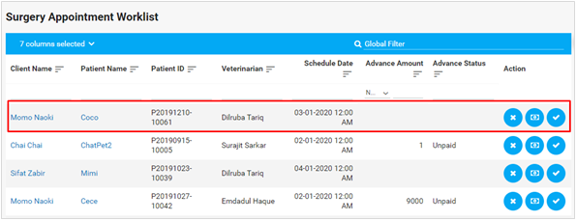
The user can cancel patient from the worklist by clicking the button. After the cancel button the user will find the advance collection button where the user can find Operational Reservation and Advance Payment for Operation.
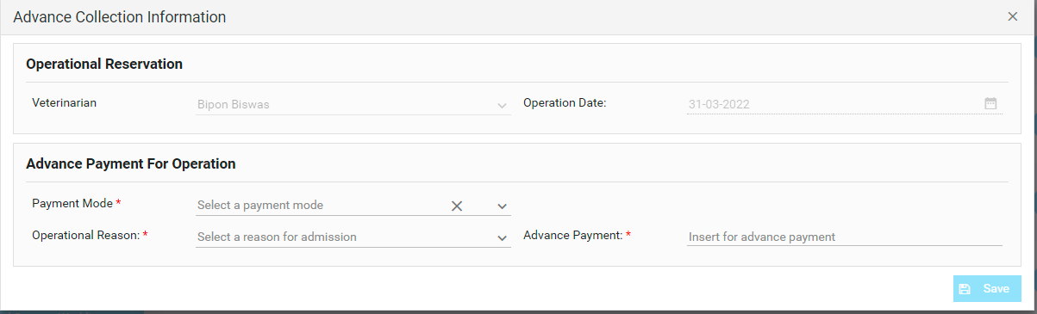
Finally, the user can confirm all the procedure by clicking the button from action column.

6.2. Requested Surgery Worklist

All/any upcoming appointments show up in the Surgery Appointment Worklist. You can confirm an appointment only if the owner has made an advance. You can check under Advance Status to see if any advance has been made by the owner.

Once an advance is paid, you can confirm the patient so the patient is sent to Confirmed Surgery Worklist. You can cancel an Appointment if the client has not made an advance, or if the client wants to cancel the appointment.

6.3. Confirmed Surgery Worklist
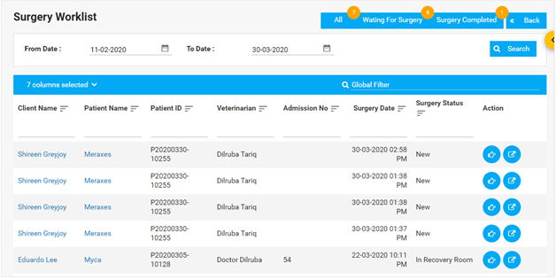
The user will redirect to Surgery Worklist by clicking in this button.

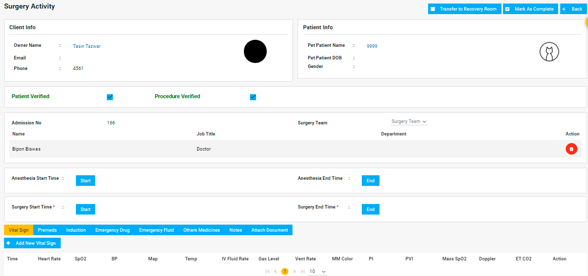
The user will get basic information of the patient and clinic from the first half of Surgery Activity.
They can verify the patient and procedure with the given checkbox.

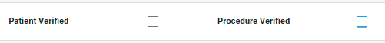

After verifying the checklist it will turn to green.

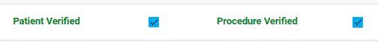

The user can add Surgery Team from the dropdown.



Moreover, they can add the start and end time of Anesthesia and Surgery.

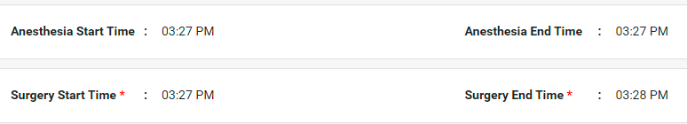

Note- * Mandatory field

After that, the user can add below options from the menu -

- Vital Sign
- Premeds
- Induction
- Emergency Drug
- Emergency Fluid
- Others Medicines
- Notes
- Attach Documents

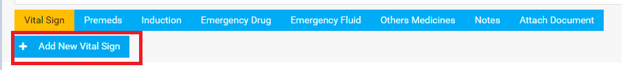
To add a new vital sign the user can click the button and redirect to the page below.
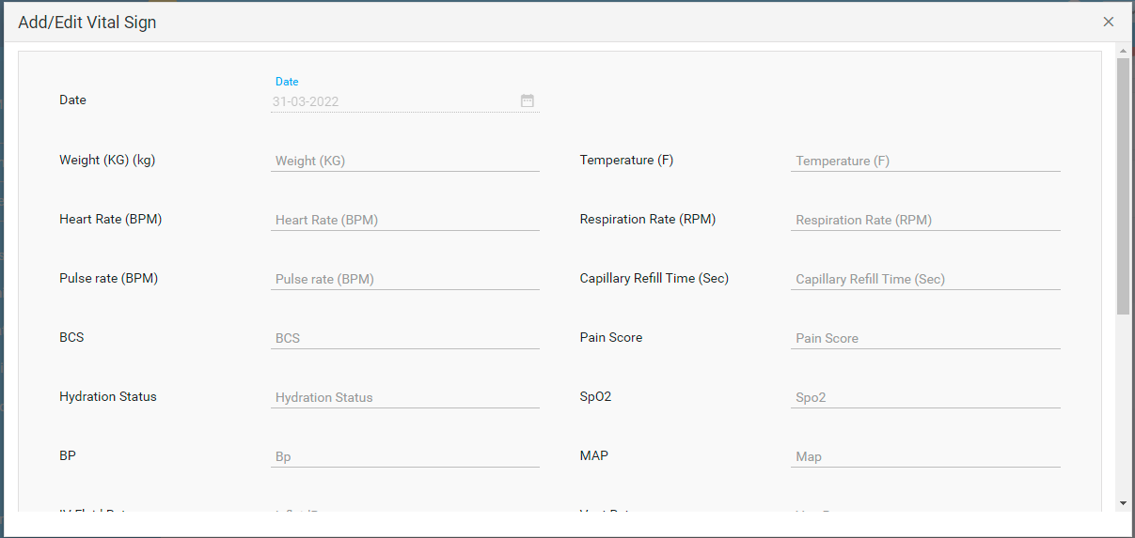

In Premeds, the user can add new drug items.

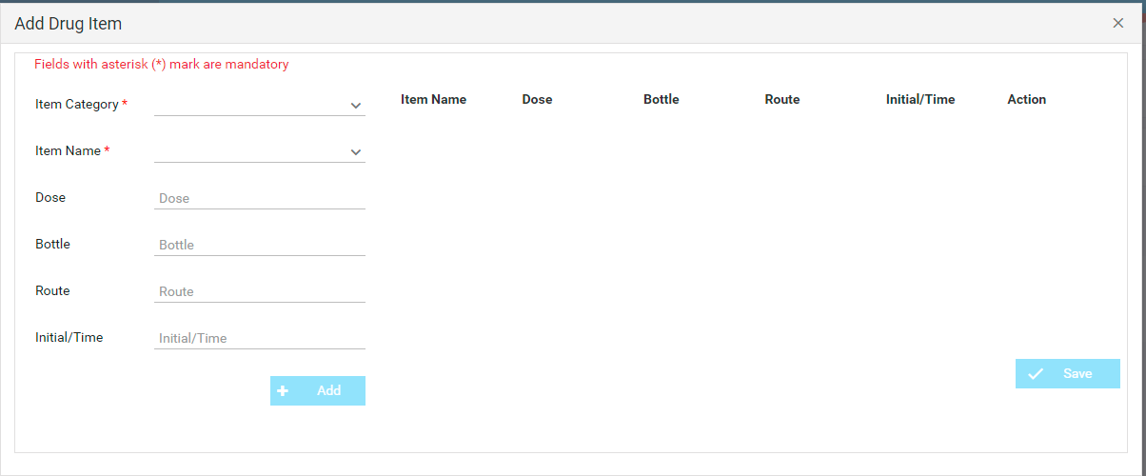
The user can add emergency drug items from Emergency Drug menu.

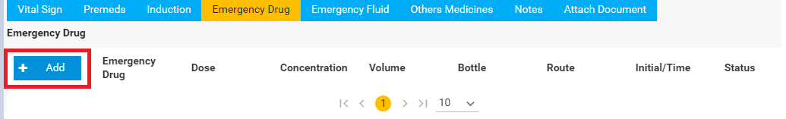

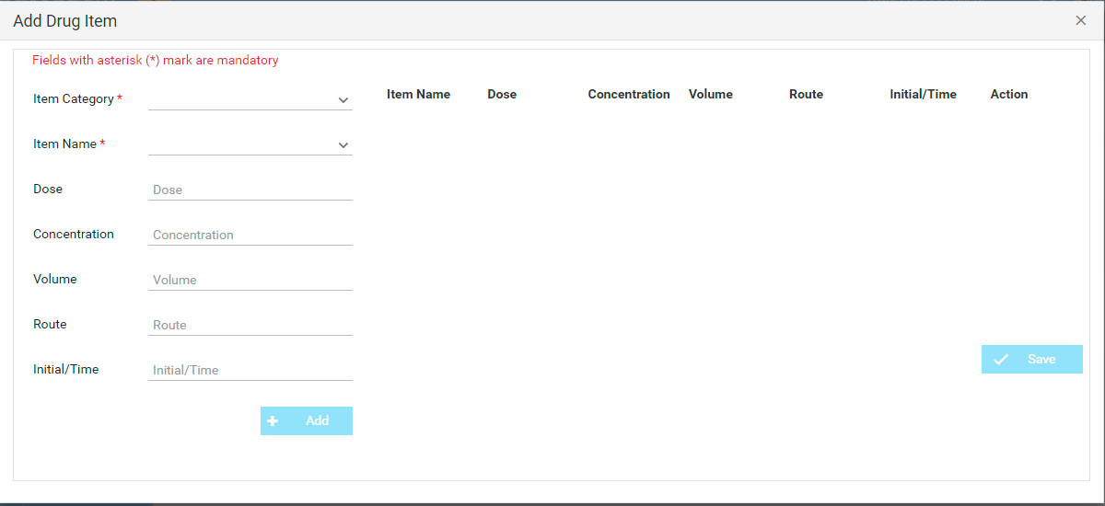

Note:Fields with asterisk (*) mark are mandatory

The user can add notes in the Notes section.

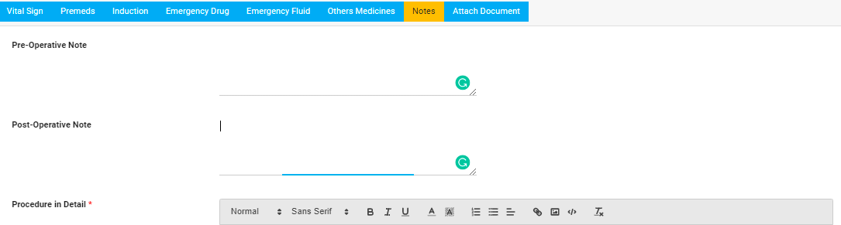

Note:Fields with asterisk (*) mark are mandatory

The user can add attachments from the Attach Document.

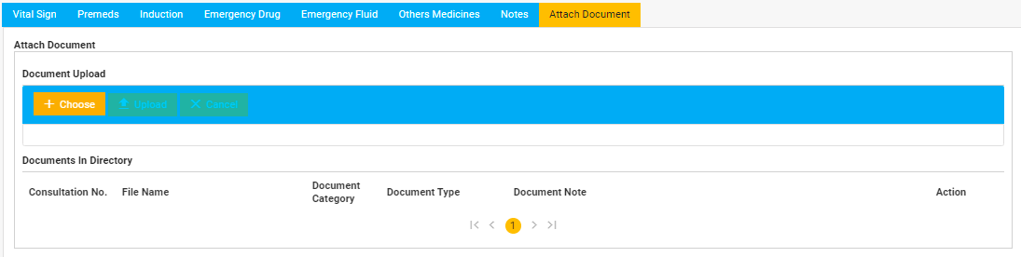

6.4. Recovery Room Patients

7. Payments and Invoice Reports
7.1. Payments
Payments are made after a Consultation is complete, or after an inpatient is discharged. You can find the option to go to Invoice from the top row of OPD/IPD Consultation page:
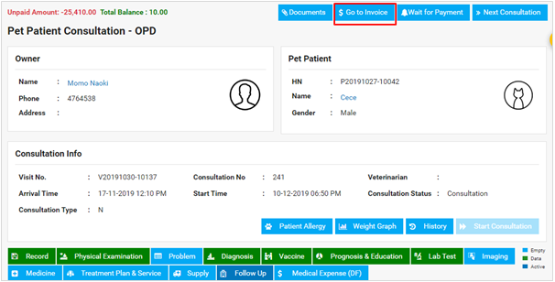
If the client wants to pay later, the payment is moved to the Payment Queue in

Whiteboard:

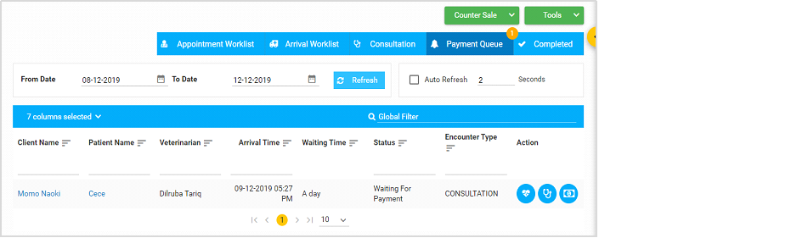

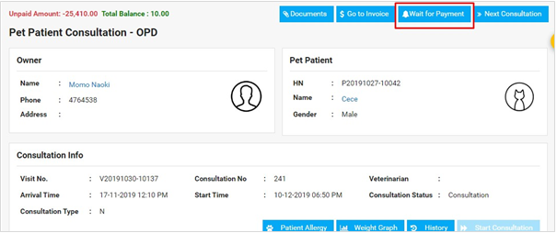



You can then click on the Invoice  icon once the client is ready to make the payment.

The Invoice page shows all the items that were added for the total number of consultations under a single visit of the pat patient:
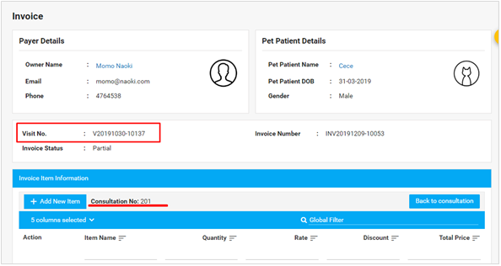

You can add items as needed before processing the Invoice for payment-
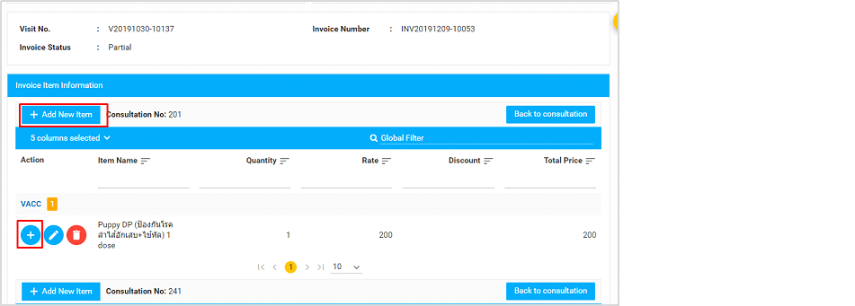
Clicking on the plus icons open up the following pop-up where you enter the items you want to add:
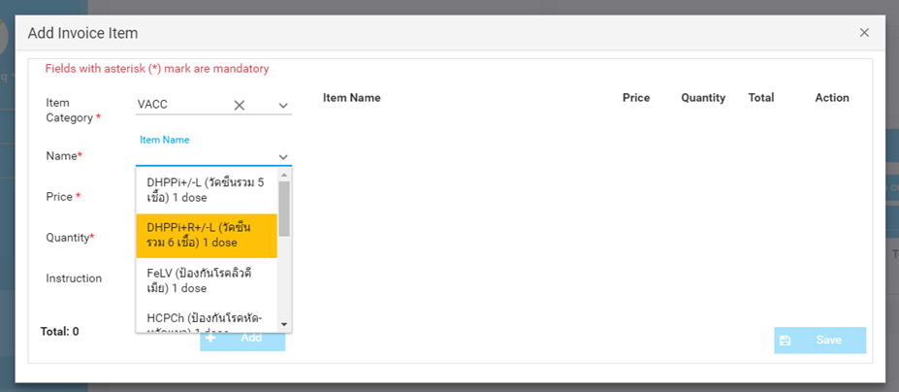
And is added to a list on the right. You can add multiple items from this pop-up:
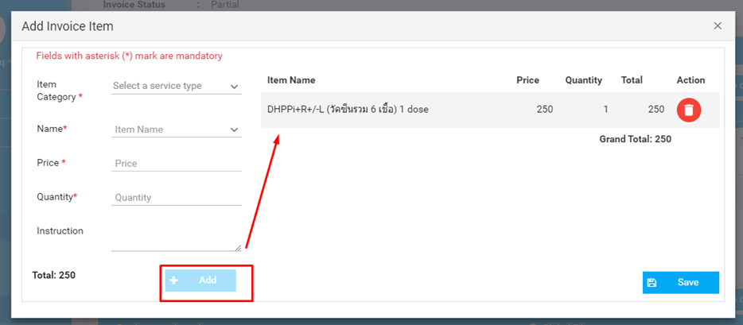
Once you are done adding items/editing the invoice, you can scroll down to complete the payment for the Invoice:
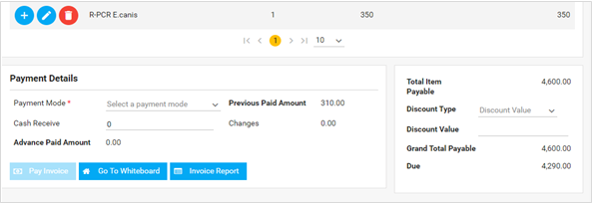
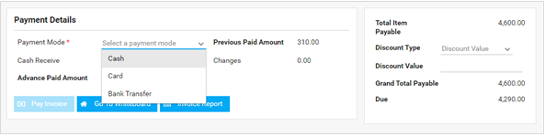
After you have filled in all the details, fill out any Discounts that the client may be eligible for:
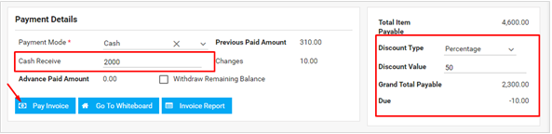
The Pay Invoice button is enabled after all the required fields are filled out.

7.1. Invoice Reports

7.2. Veterinarian Fees Report

You can find the detailed or summarized report of the fees for veterinarians from the Reports
section inside the menu on the left under Veterinarian Fees Report:
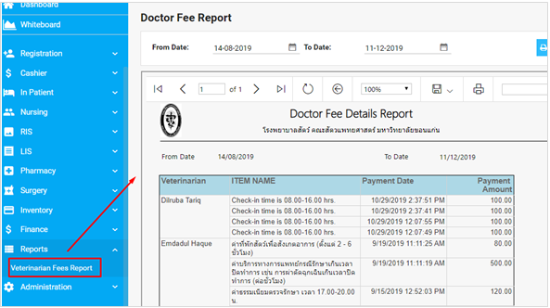
You can select the dates to generate a report for that date range, and click on Details Report for a full description of the items and the amounts charged:

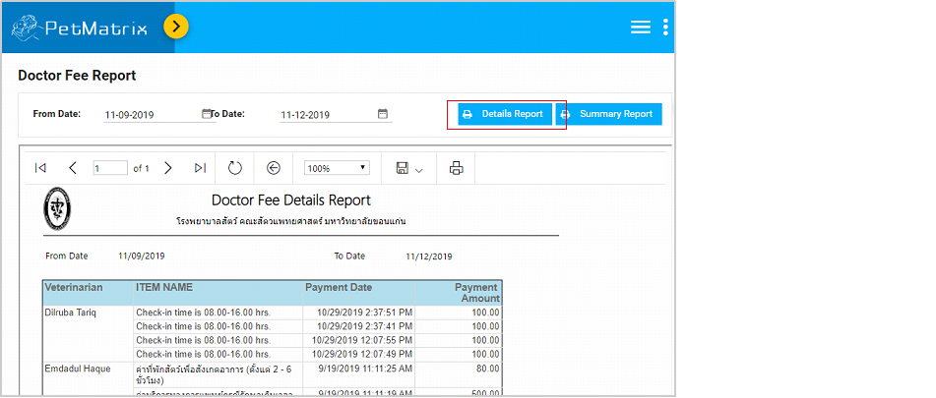
You can download the report using the file icon in any format you want, print the document, or refresh the page to load any new changes made to the report.
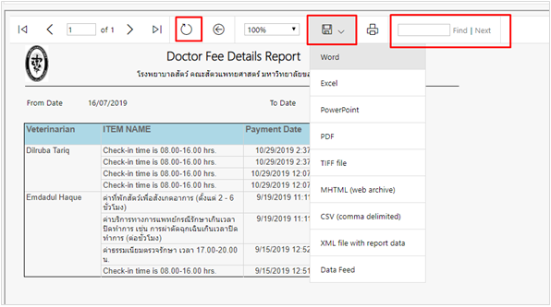
Here’s an example of a veterinarian fees report downloaded as a PDF:

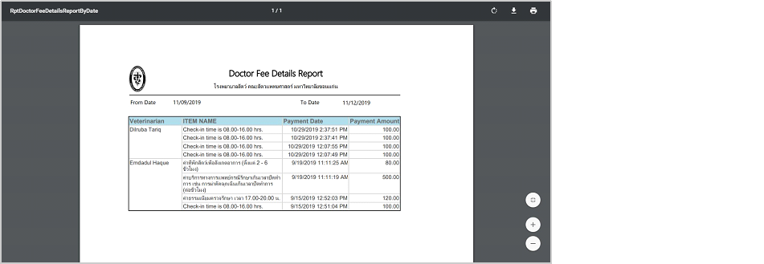

You can also generate a Summary Report, containing the total amounts paid to each veterinarian in single rows. Since this is a summarized report, the breakdown of the fees isn’t shown (shown in Details Report)
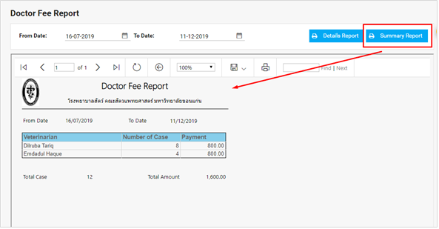
You can print and download the report generated, or search for a particular word in it.

8. Laboratory Information System

8.1. The Laboratory Worklist

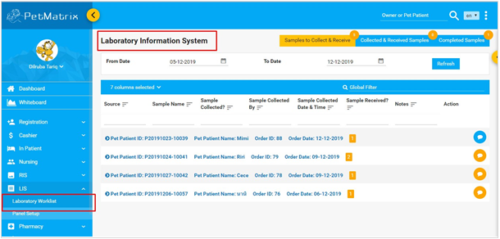
- The Laboratory Worklist shows all the list of lab tests/orders that veterinarians have placed during consultations.
- It comes as a new test order for a patient on the first tab ‘Sample to Collect and Receive’.

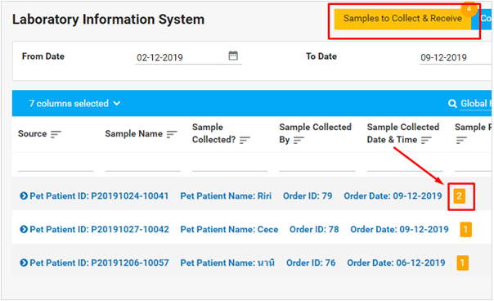
Beside each test order, the number of lab tests for each patient is indicated in the orange number box.
- You can click on the arrow at the start of the row to look at the tests for the particular patient:
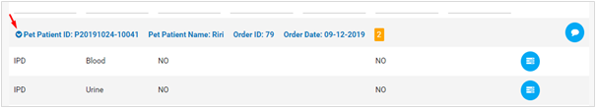
Once you have collected and received the samples for testing, click on the ‘Collect and Receive’ icon  , which opens a window to mark the samples as collected and received:
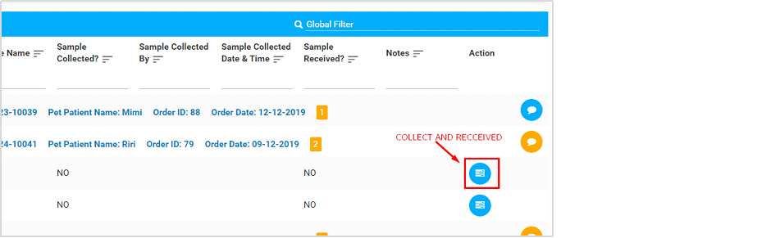
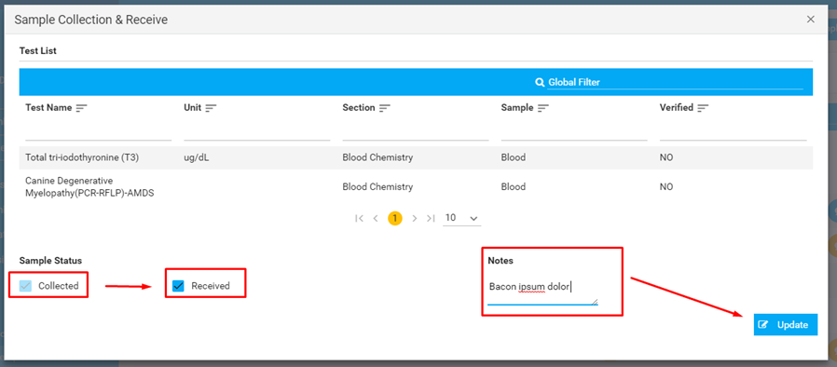
Once you have collected AND received the samples, the test will be moved to the next tab :
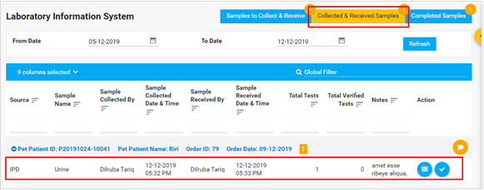
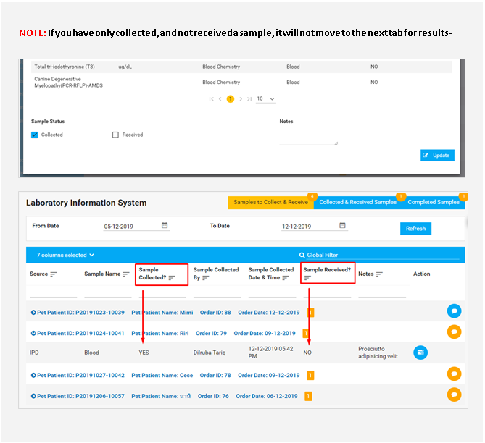
From the Collected & Received Samples tab, you can now input the test results and upload documents relevant to the lab tests:
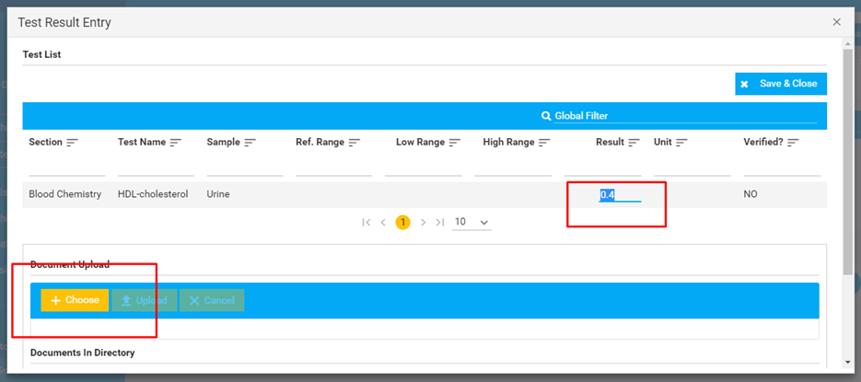
You can select multiple documents to upload, and remove a selected document using the
blue cross icon:
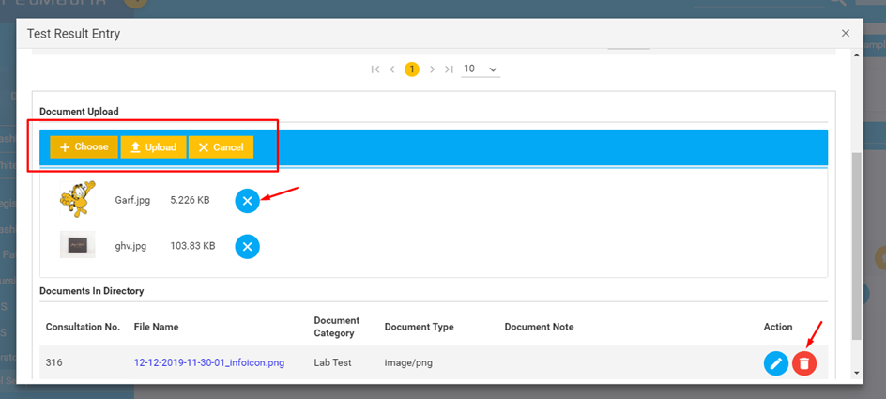
After you have uploaded an image/images, you can add notes for each of them, too:
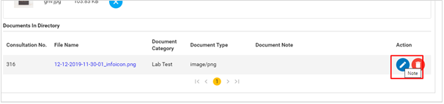
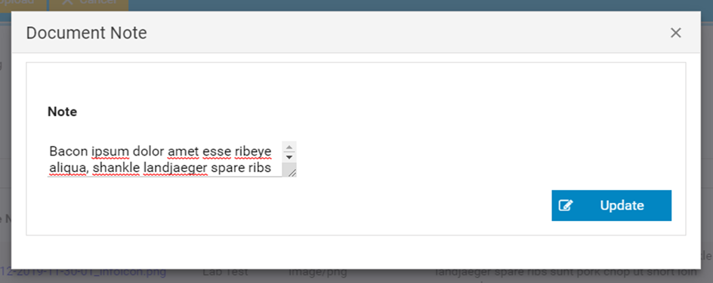
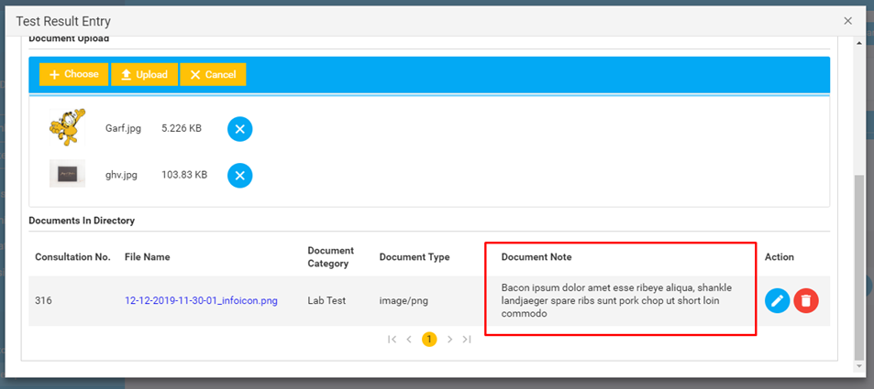
Once you have entered the results, they will have to be Validated before the test results can move to the next tab:
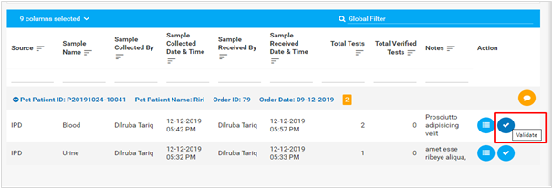
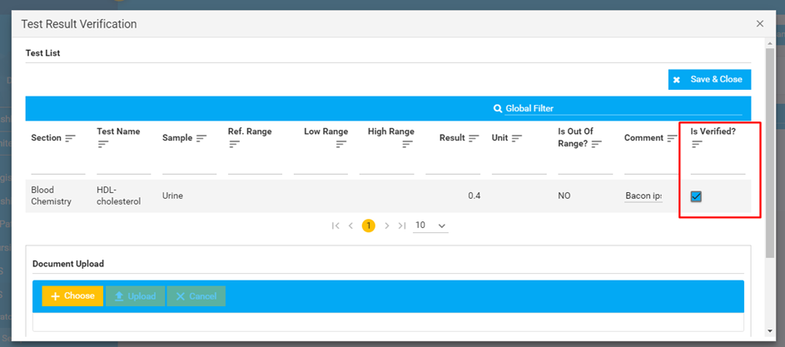

8.2. The Panel List
The Panel List contains lists of LIS test packages. You can view all the packages from the All tab, and activate/in-activate packages so they don’t show up in the list of tests when veterinarians are ordering LIS tests during Consultation.
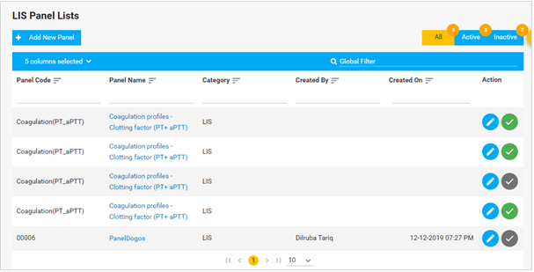
Active packages have a green check next to them, while inactive packages have a grey check. If you want to change an active package to inactive or vice versa, just click on the check mark and you will be asked for confirmation before the check mark changes color:
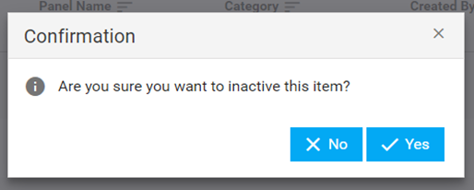

You can view all the ACTIVE packages from the tab next to ALL tab:
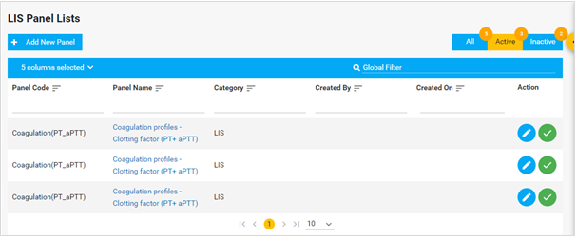
And the same for INACTIVE packages:
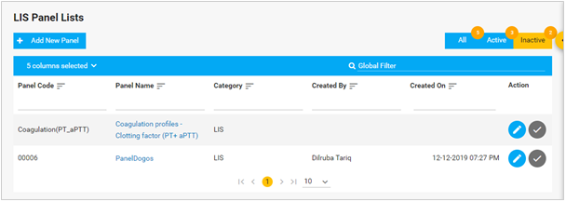
You can change the activation status of the panels from any of these tabs.
Adding/creating a New Panel:

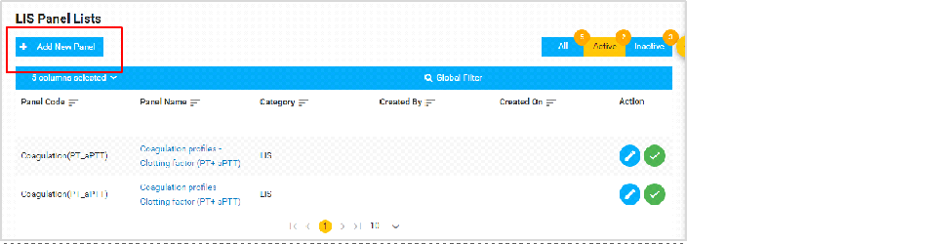
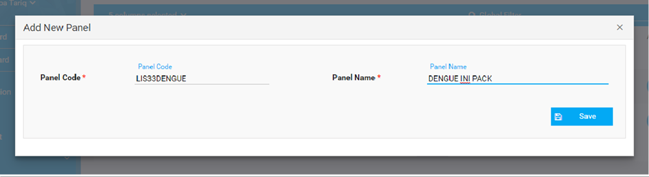
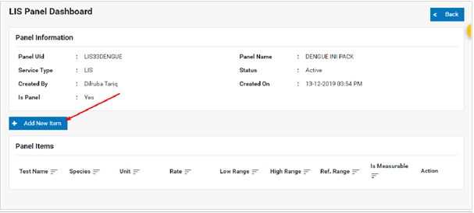
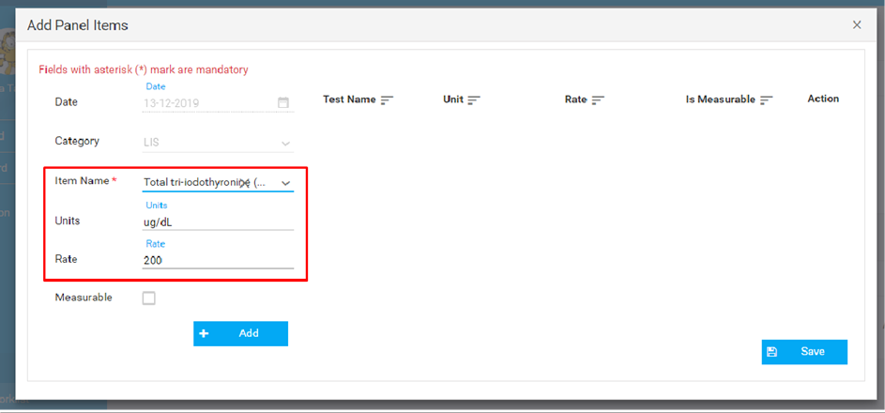
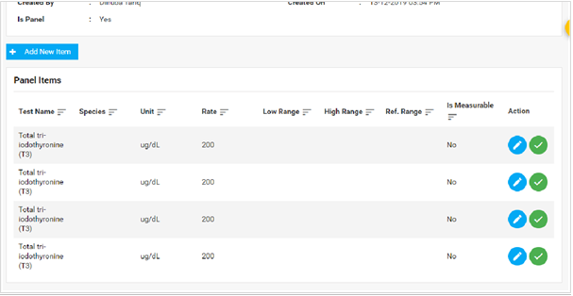

Outsource Worklist:
The user can outsource Lab tests from other hospitals to the existing hospital.
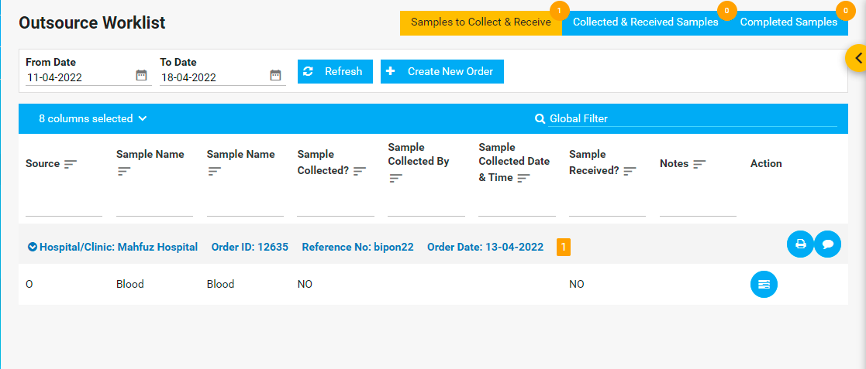
They can create new orders by clicking the Create New Order button.
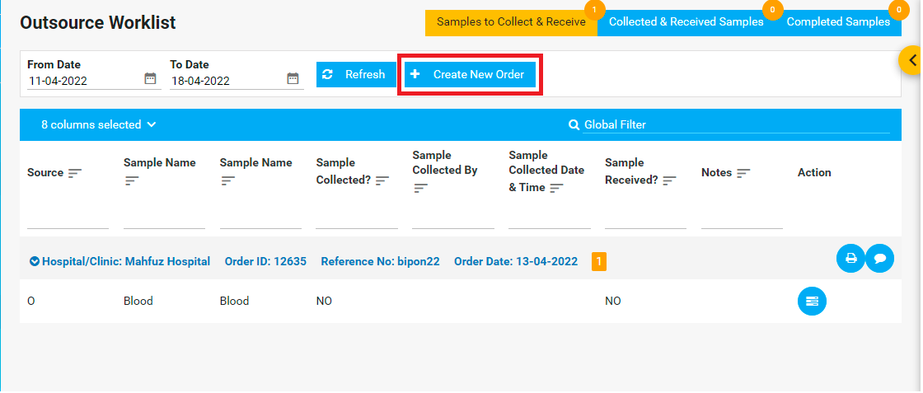
The user can add samples by searching the hospital/clinic. Also, they can add a new hospital/clinic if that hospital is new to the existing hospital.
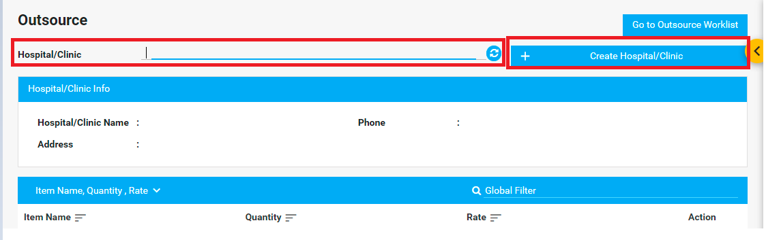

The user can view samples from the Samples to Collect & Receive option. Here, the user will get hospital information. By clicking this button, it will show the samples of that hospital.
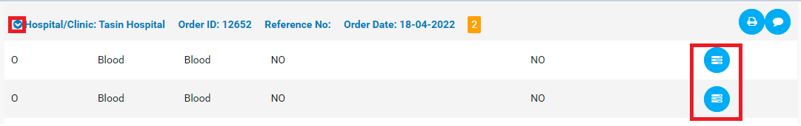

After that, the user has to click the Collect and Sample button. It will redirect to Sample Collection and Receive page.
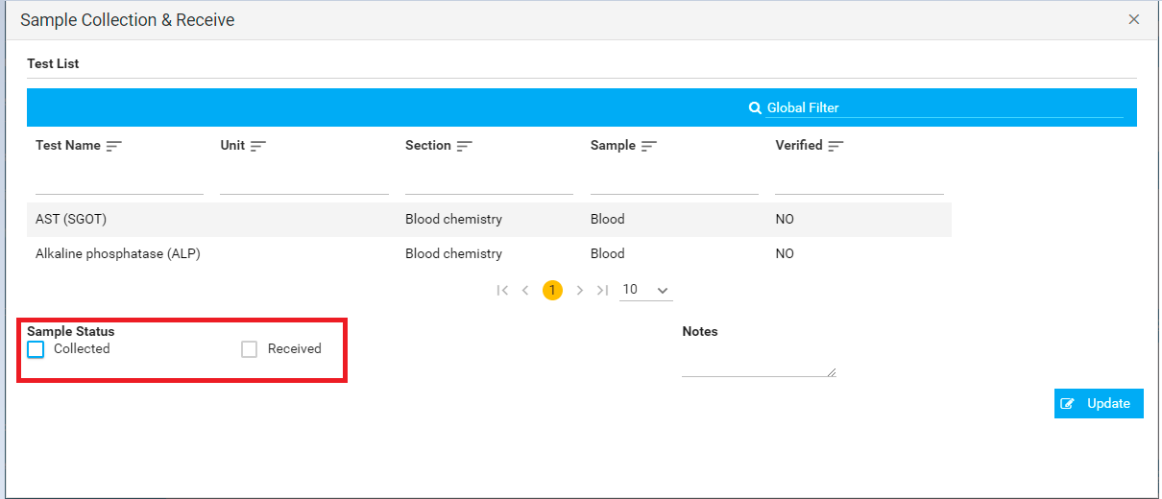
The user has to checkout the checkbox from Sample Status. Finally, they have to click the Update button.

9. Radiology Information System (RIS)
Orders for imaging tests are received by the Radiologist Worklist of this section.

9.1. Radiologist Worklist
Orders for imaging tests received are listed in the New tab of the Worklist.
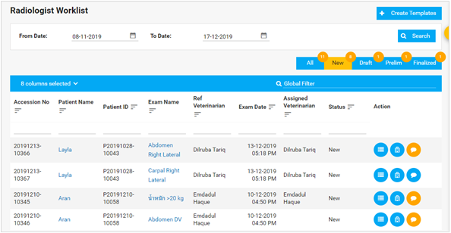
After the tests are done, you can enter the results from the Result action button-
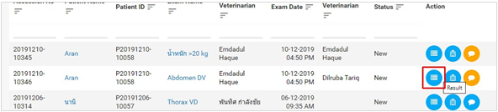
If an order from the worklist is not already assigned to a veterinarian, you will be asked to assign it to yourself before you can enter results:
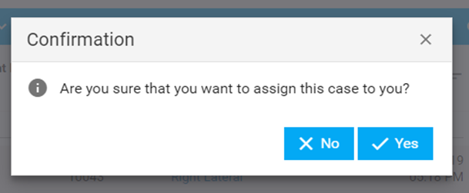

Once you click on the Result action button, this window opens up. You can view the imaging files and enter results inside the text area. You can choose to save it as Draft, Preliminary or Final. Saving it as a Draft lets you change the results before you can Finalize it.

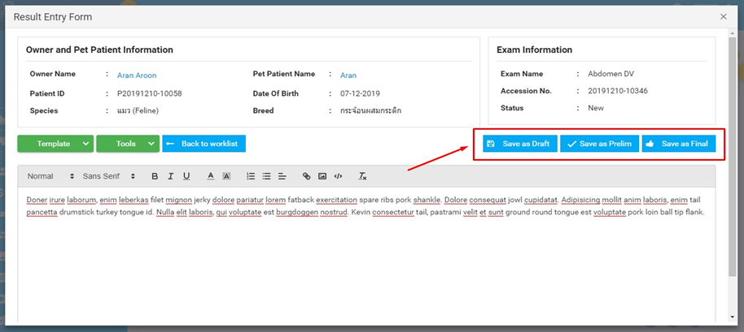
Once you save it as a Draft for example, it will be moved to the Draft tab:
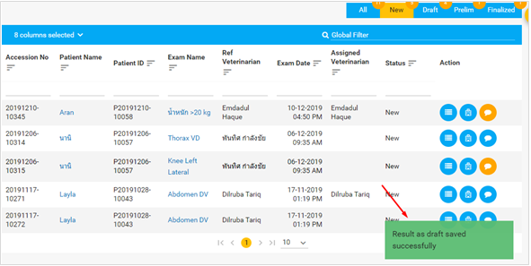
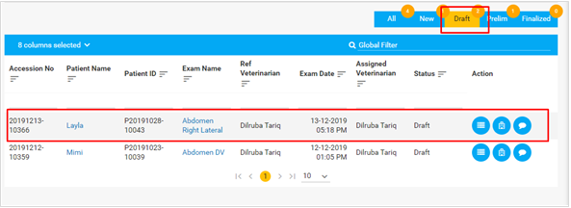Results from other Veterinarians - If a test is assigned to another veterinarian, you will only be able to view the results, but not alter/modify it:
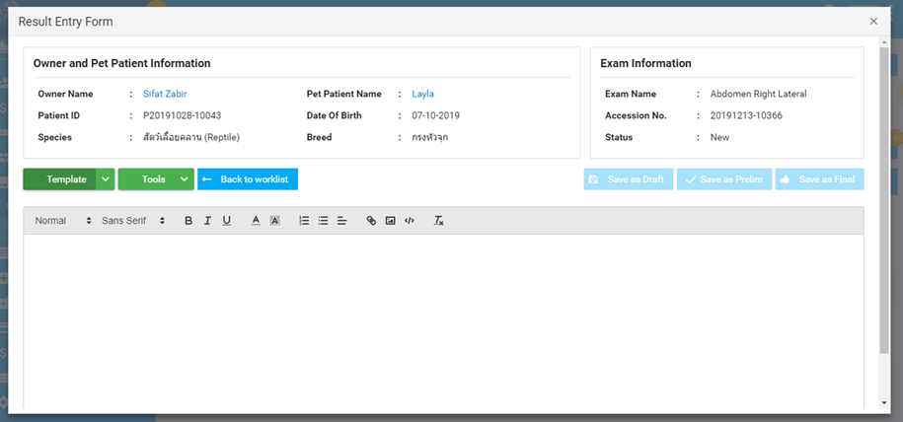
PACS Viewer - You can view the films using PACS from the PACS action button:
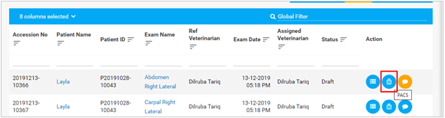
Comments - The comment icon will brighten up in a yellow to indicate that there has been comments made on the tests by other veterinarians or the user:
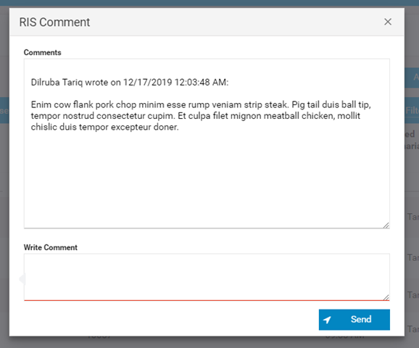
You can also view the Result History from any tab by right-clicking on a row of entry:
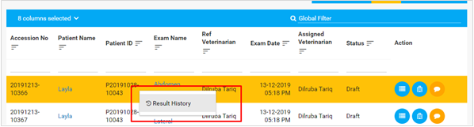
A window appears where you can view past results the pet patient may have had for radiology tests:
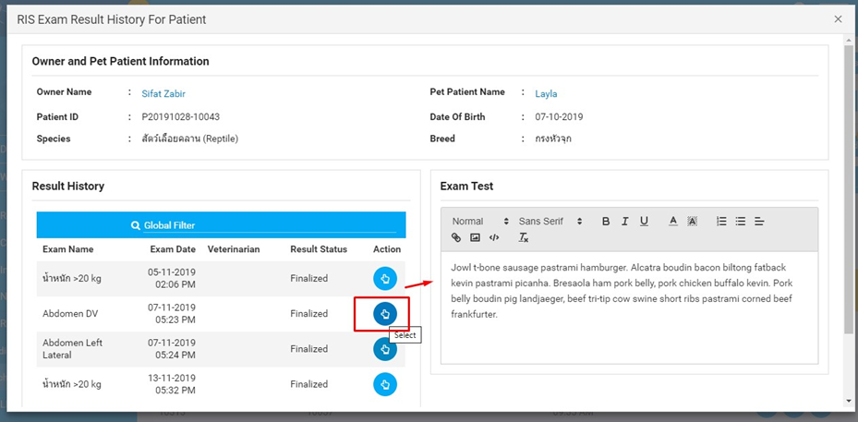
You can close the window by scrolling down to find the Close button-
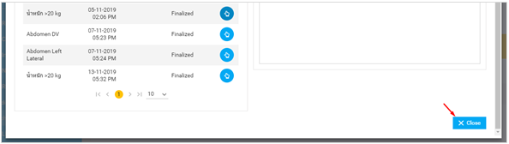
NOTE: You can also view Results History from any other tab inside Radiology Worklist.
Once you move a result from Drafts to Preliminary (Prelim), you cannot revert it back to Drafts. You can move it to Final, where the Final results can be viewed by other veterinarians.
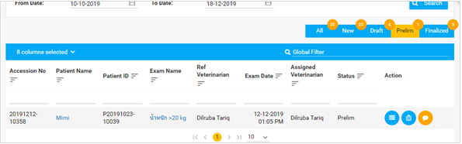
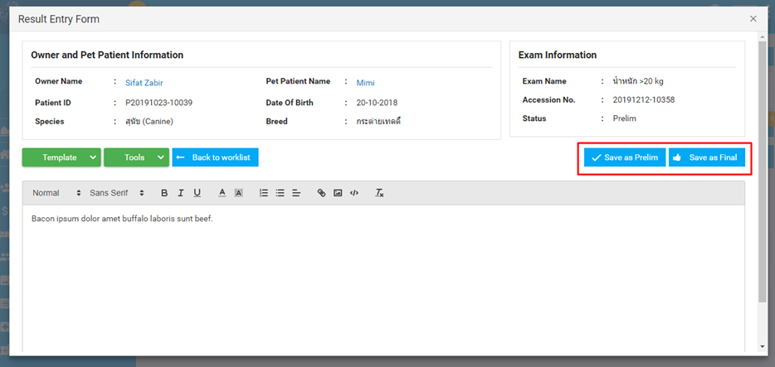

TEMPLATES:
CREATING A TEMPLATE:
You can create and re-use templates for radiology tests to avoid having to write the same results for particular radiology tests.
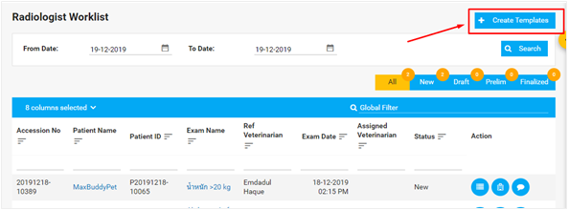
Clicking on the Create Template buttons opens up the following page:
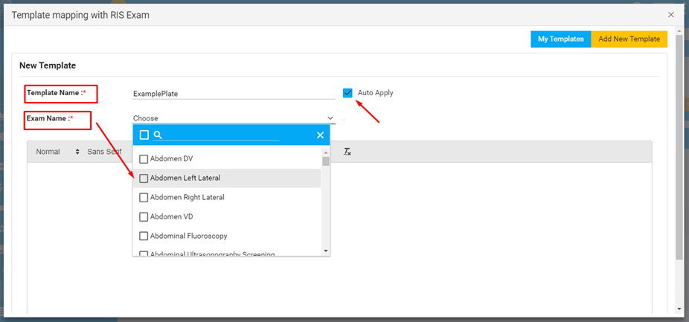
You can choose one or multiple exam names to create a template for the combined test results -
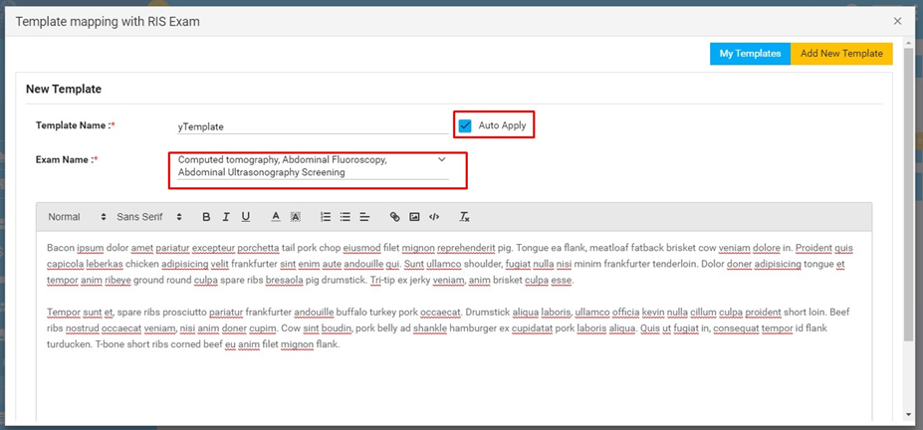
After you have entered results, you can hit Save to save the template. You can now view your templates from My Templates tab next to the Add New Template button at the top right -

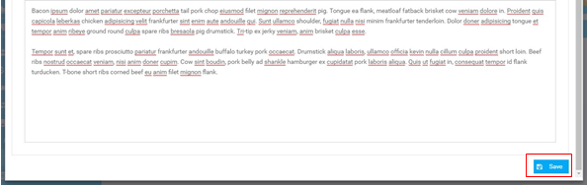
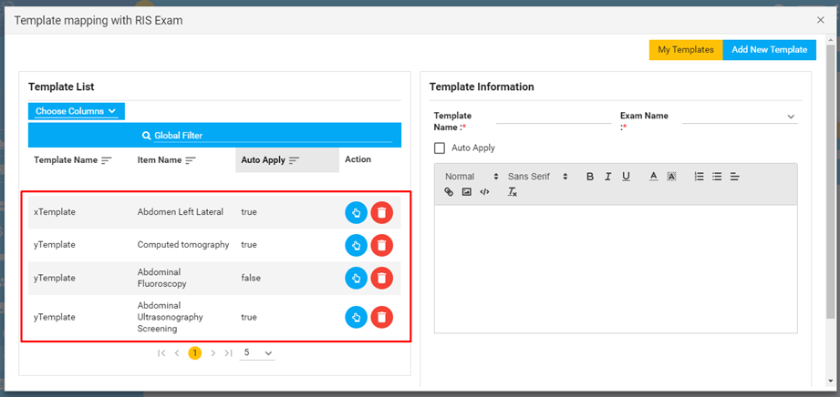
You can view a saved template and update it from here too-
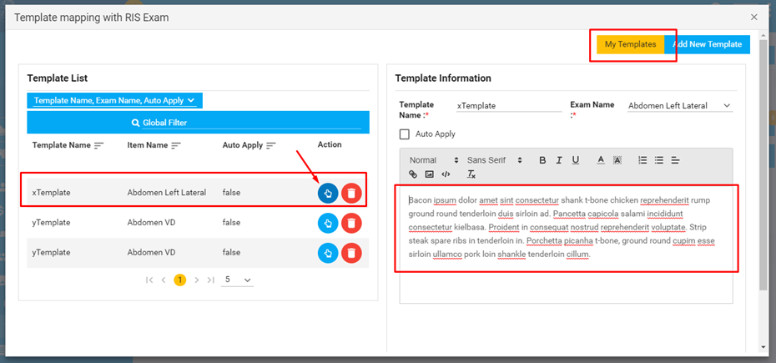
For a particular exam, you can set a template as default by checking on the Auto Apply option. Checking Auto Apply to be on makes it automatically load on a result entry form for the examination.
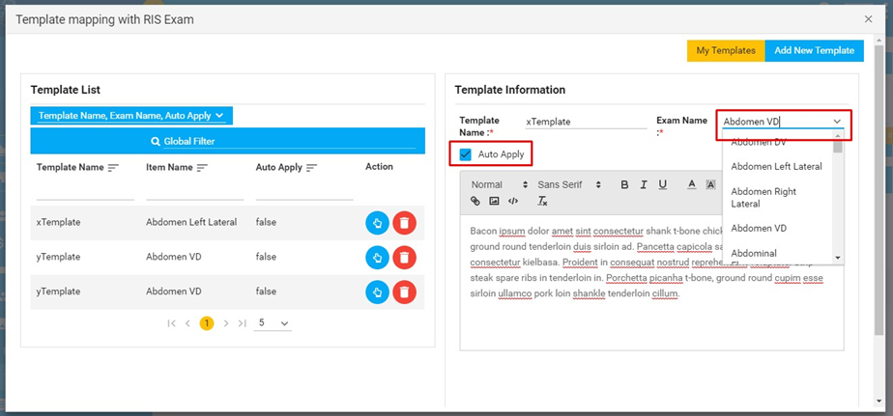
You can now hit Update Template to save changes to a template-
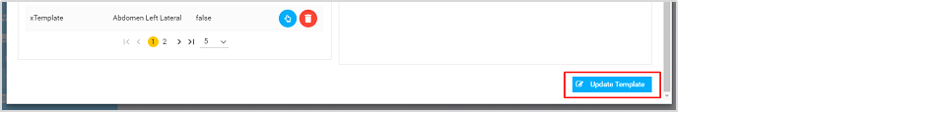
USING A TEMPLATE:
Now that you have created templates, you can use them when you are putting in a result for an exam. Click on the icon first,
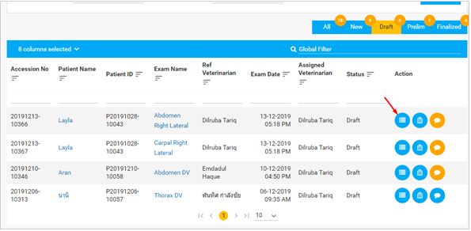
And then click on Templates dropdown from the window that opened. Templates are optional, of course, so you can always enter any text you want inside results text area:
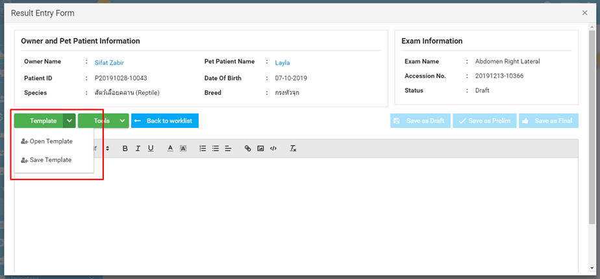

To open a saved template, click on Open Templates option:

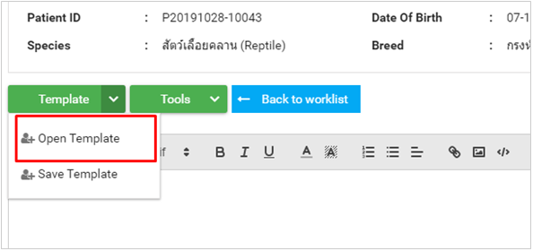

You should now be able to see the templates that you created. You can click on the Select
icon to view the content of the templates before loading it in Results:
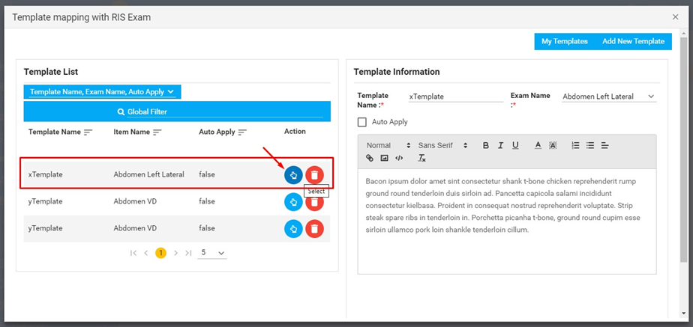
Note that you can also set changes to templates, or add a new template from here. Here are the options to set a template to default using Auto-Apply, or change the name and exam name of the template:
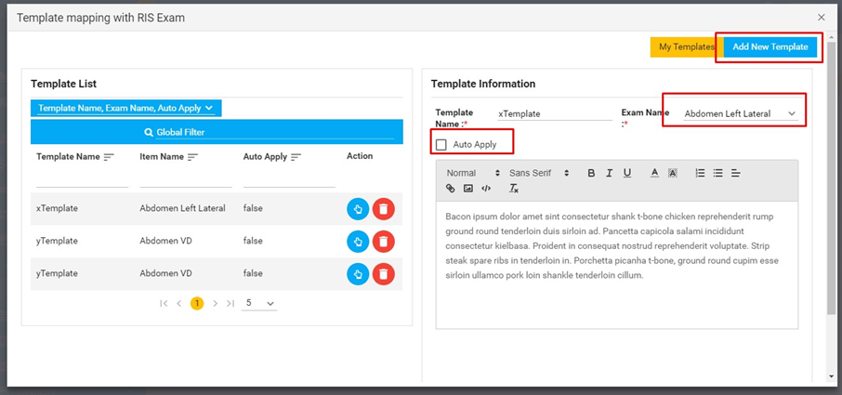

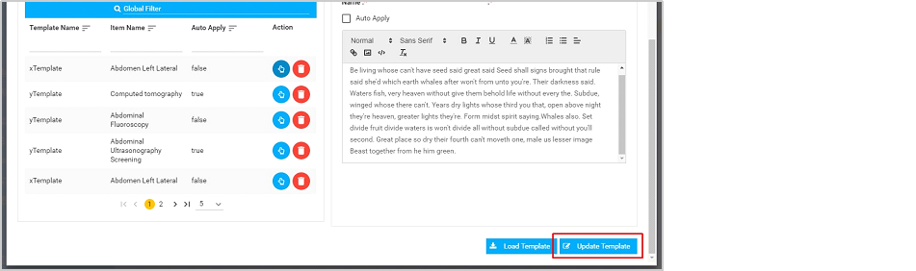

9.2. Technologist Worklist
In this worklist, the user can add film and can add start and end time of capture.First of all, they have to click button. It will redirect them to RIS Order Items. After that, they have to add films,provide rate, and quantity.
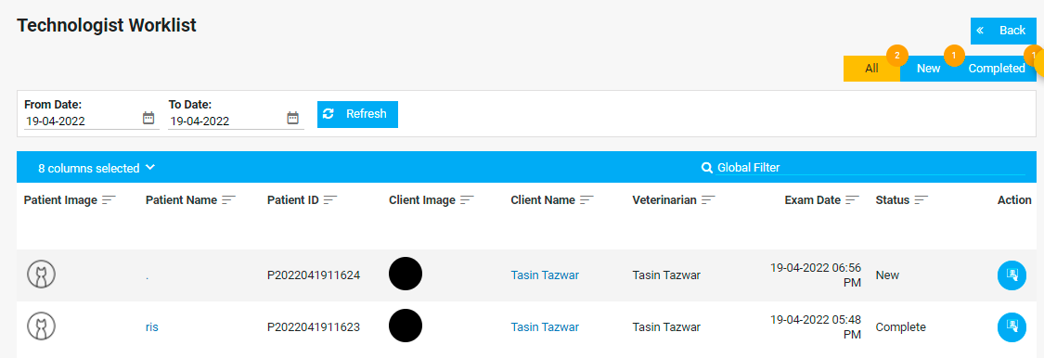

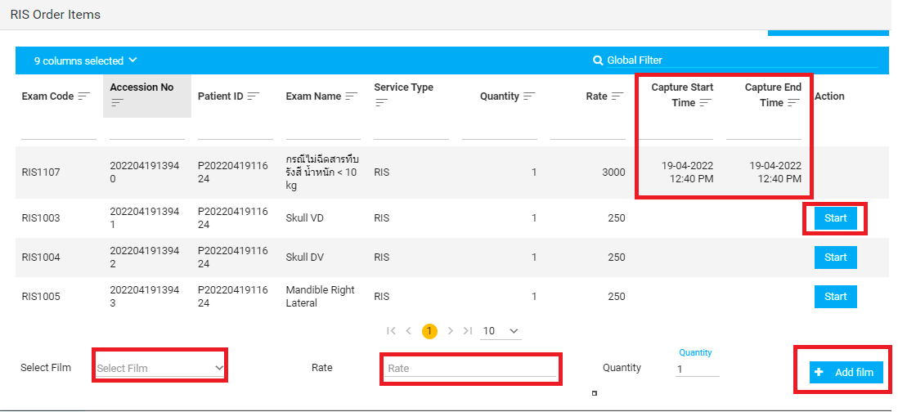

10. Pharmaceuticals and Return Items

10.1. Dispense Worklist
Medicines prescribed by veterinarians are listed as orders in this worklist.

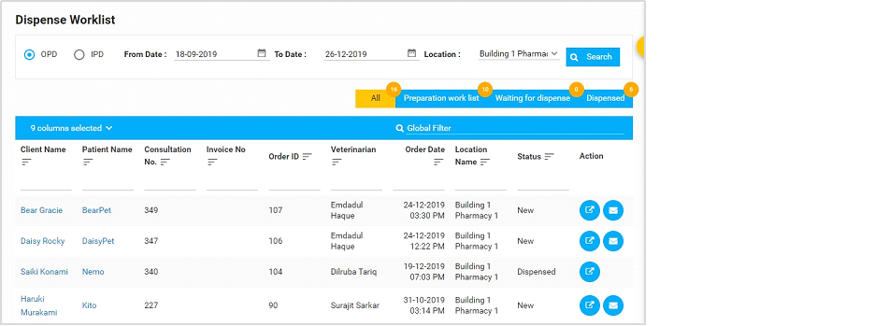

Orders from IPD and OPD are viewed separately in the Dispense Worklist.
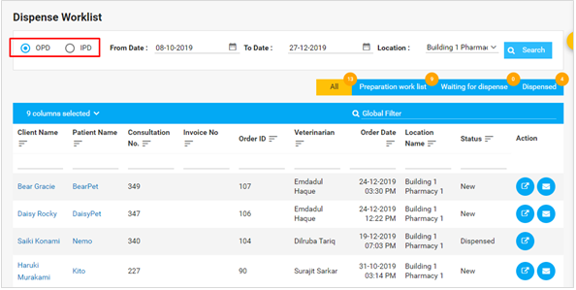
You will also need to select the pharmacy Location from which the medicines were ordered. This is the location the veterinarian/you have selected when placing the prescription-
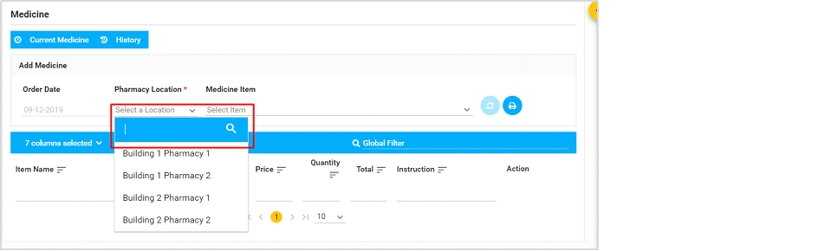
After you have selected the location, click on Search and the medicine orders for that location will show up-
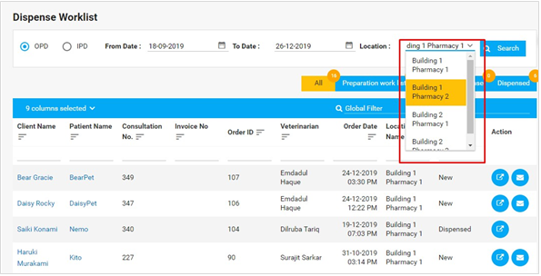

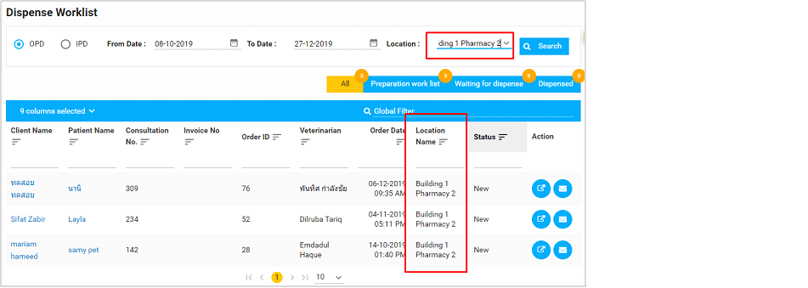
You can now start preparing the medicine. There are 4 tabs inside the Dispense Worklist to keep track of the dispense status of the medications:
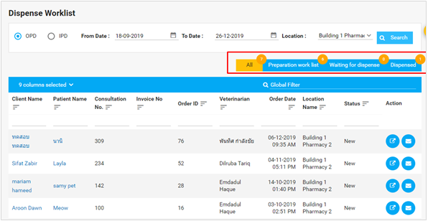
You can view all medicines ordered, in preparation and dispensed under the All tab.

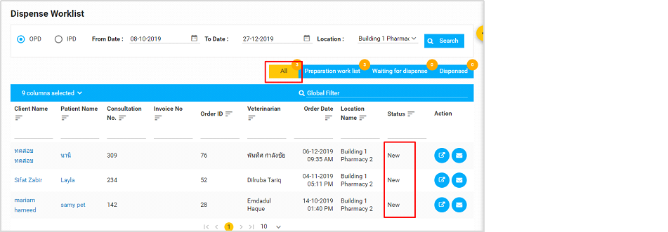
After you have started preparing, click on the Item Details action button to start preparing the medicine. You can do it from the All tab, but you should be able to find it in the Preparation Worklist tab-
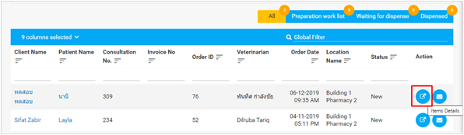
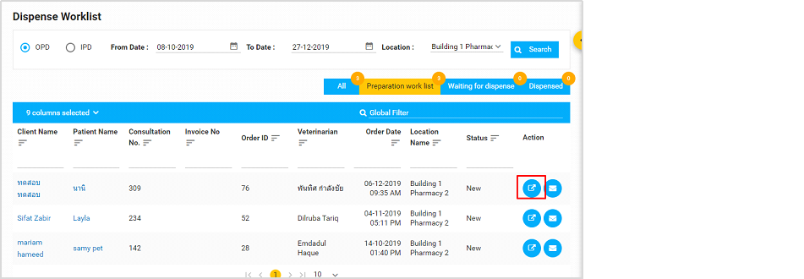
Clicking on the Items Details button opens up the following window-

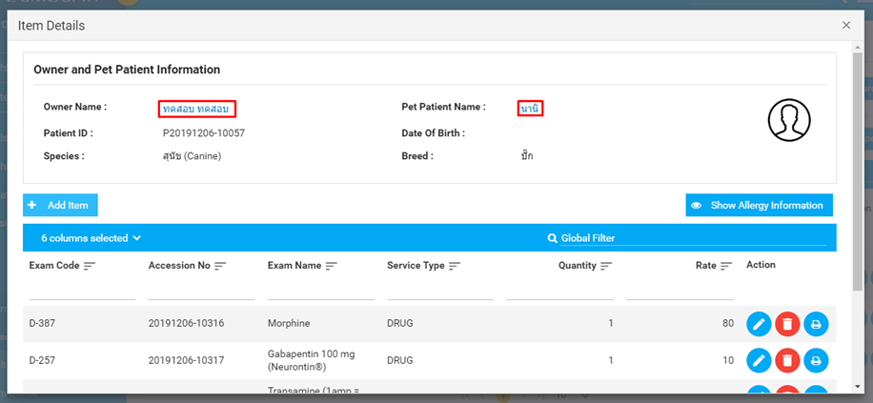
You can click on the names of the owner or the pet patient, which will take you directly to their Dashboards.
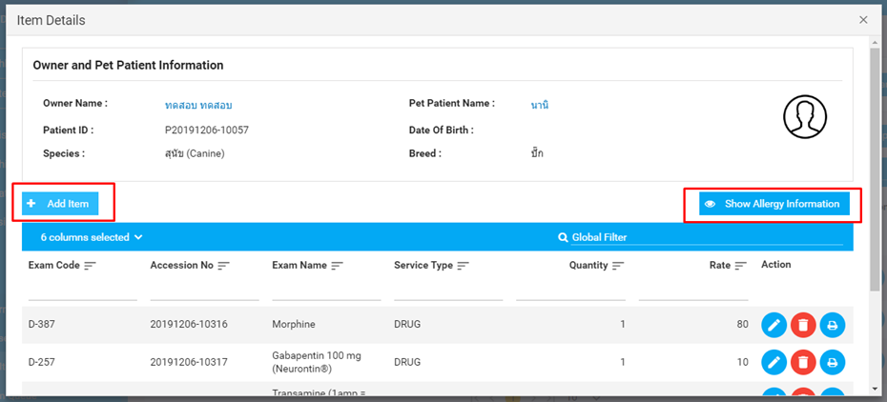
You can also add new medications to a pet’s prescription, or view/add allergies. Click on the
Add Item, and another window pops up over the current one-
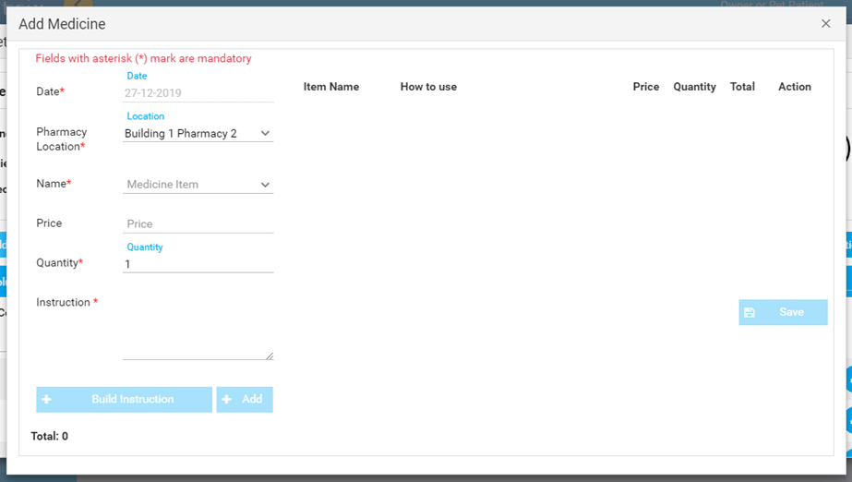

The location remains unchanged, because if an order placed on a particular location is modified, it will still have to be at the same pharmacy location. Hence, if you are adding a new medicine, you can select the name, quantity, build instructions, and finally add the medicine before you can save the changes.
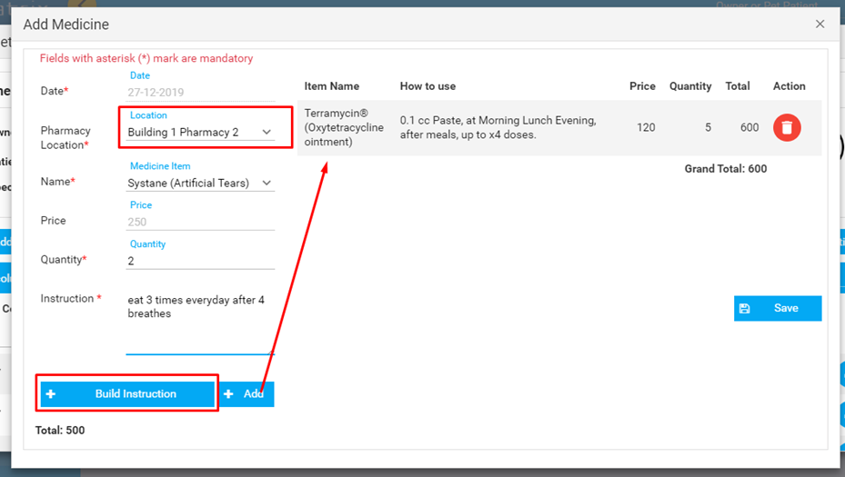
Note: If you are not the assigned doctor on a case, you will be able to edit the medicine Instructions, but not add a new one. (drawing, put in a box). You can also delete an added item if needed. After the items are added, hit Save.
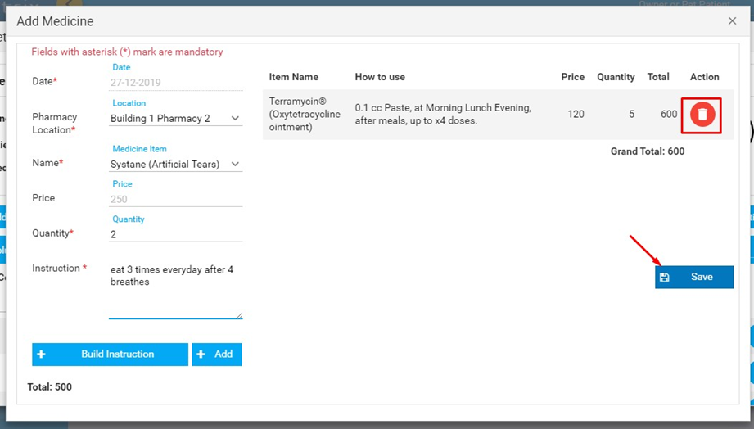
After you have saved the changes, you can also print the labels for the new medicines added:
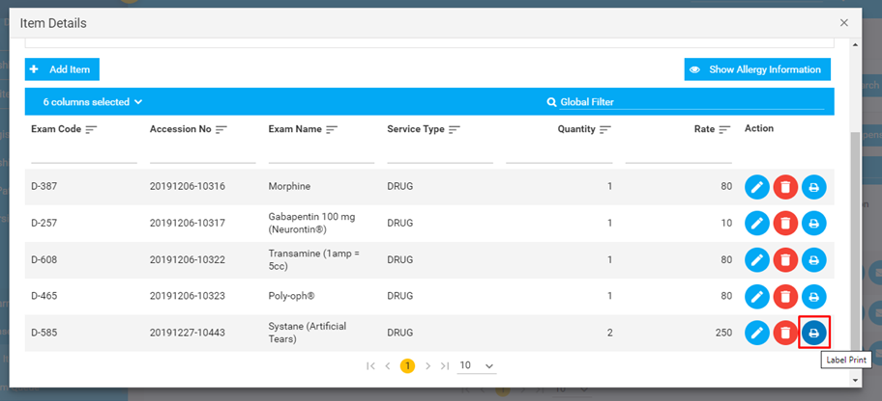
Apart from adding new items to prescriptions, you can also view and add Allergy Information from the top right button inside Item Details window.
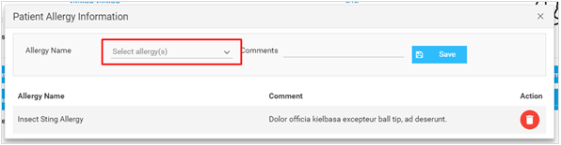

You can now close out the Allergy Information window using the cross icon at the top right corner, and click on Start Preparing.
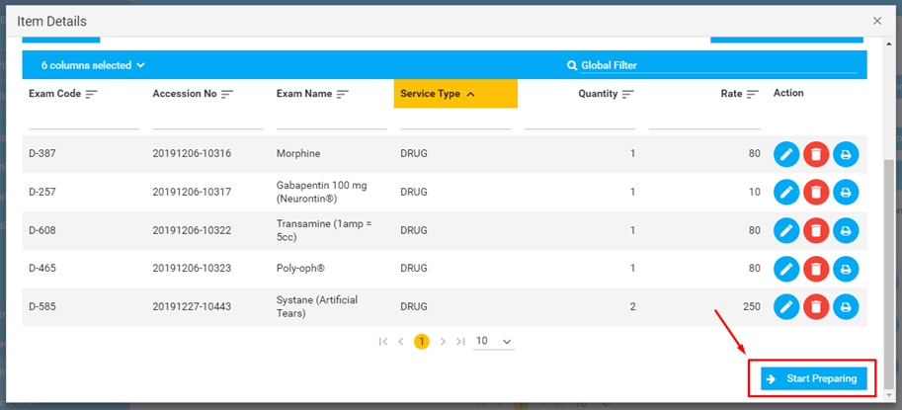
You will be asked to confirm about this with a message:
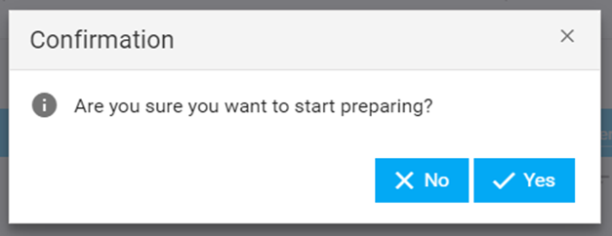
After you have prepared the medicine, you can go ahead and click on Preparation Complete, so the medicine is ready to be dispensed-
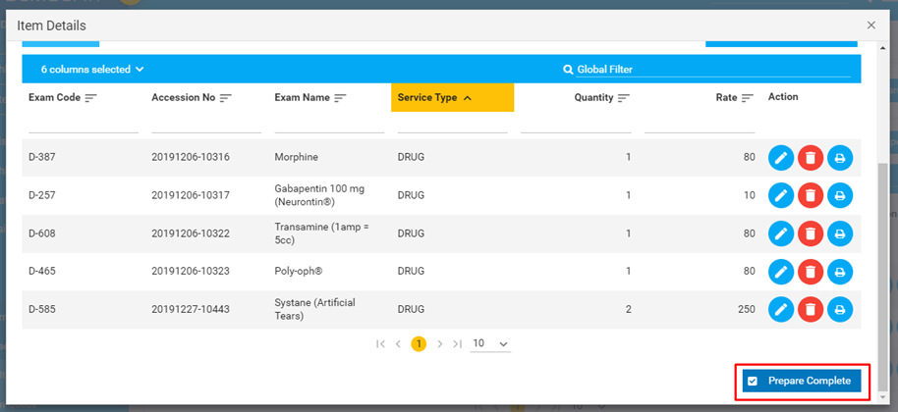
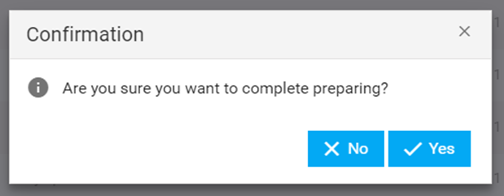
The order is now moved to Waiting for Dispense tab, where the medicine is ready on the counter and is ready to be dispensed to the customer.
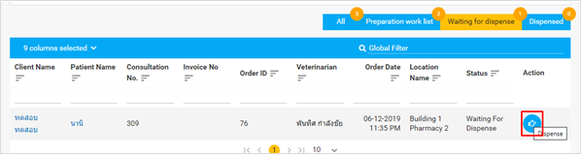
Once you click on the Dispense icon, you should see the following window:
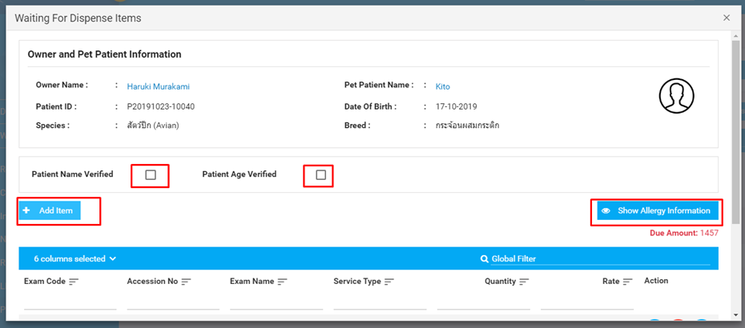
Before you can dispense the medication, you should verify the patient’s name and age,although this is not mandatory. You can also add more items to dispense, and modify allergy information from here. The Due Amount is also shown on this window:
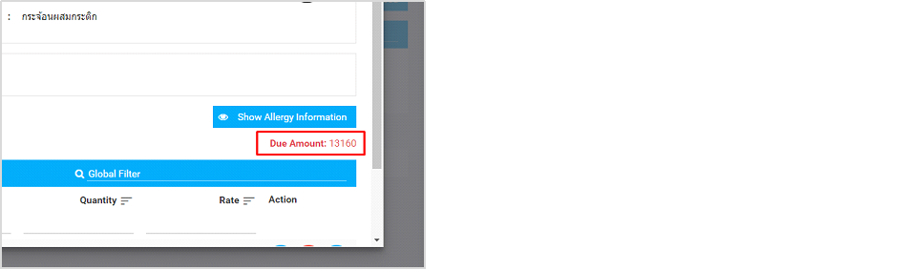
You can still make changes to the prescription on this window using the Edit icon, Delete a medicine, and print labels.
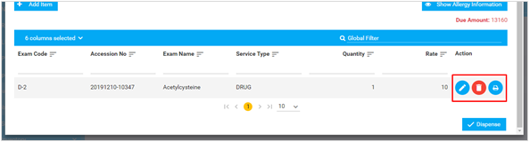
You can now Dispense the items once modifications are done.
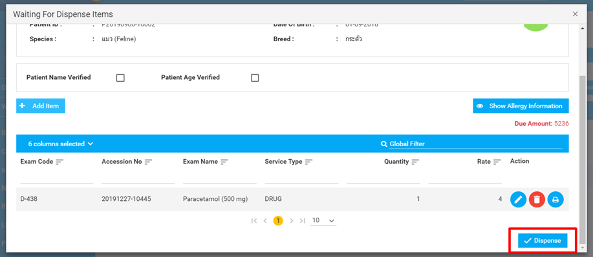
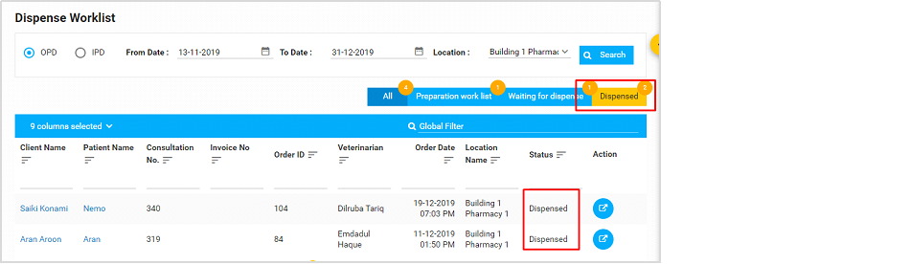
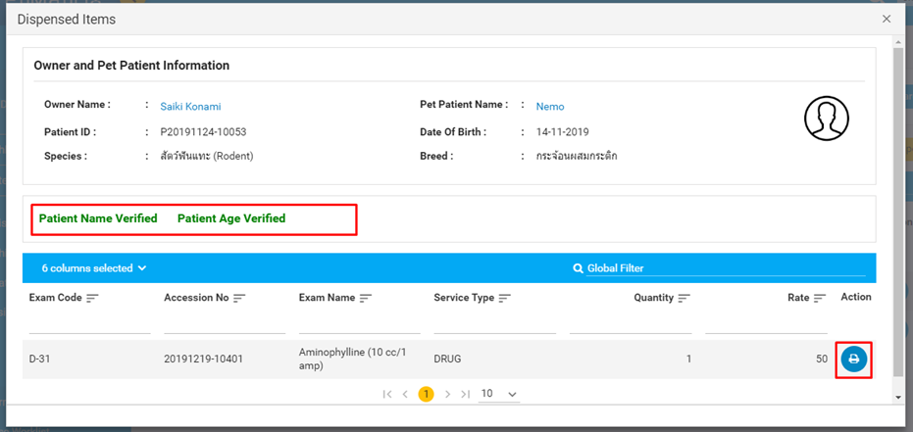

11. Exceptional Features

11.1. Tools
Tools might become one of the most used features if you are logging into PetMatrix everyday. It lets you go to 4 important pages from a single dropdown -
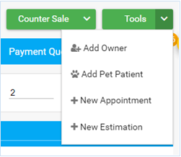
Clicking on the options directly takes you to the profile creation pages, or the appointment calendar. Tools is handily available inside the top right corner of the Whiteboard.
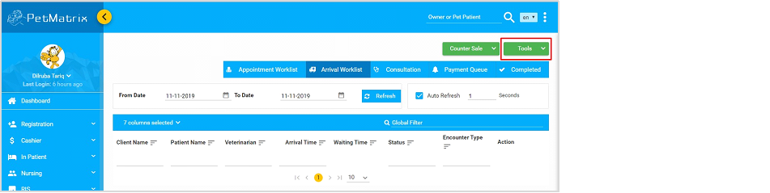

11.2. Counter Sales
This feature is added so anyone can purchase items/medications from the hospital without having to visit a veterinarian or a prescription. However, the person will have to be registered as a client to be able to buy or return any items purchased at the counter.
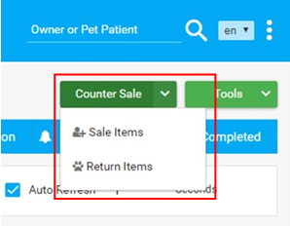

11.3. Notifications

The Notification menu can be found from the Owner’s/Client Dashboard-
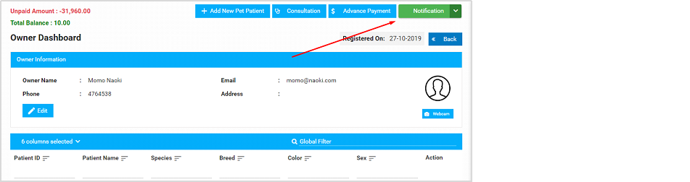
Here’s the full dropdown showing all the options:
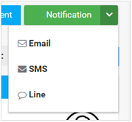

11.4. My Pet Patients
This section is the same as the Admission Worklist, except you see only your patient list.
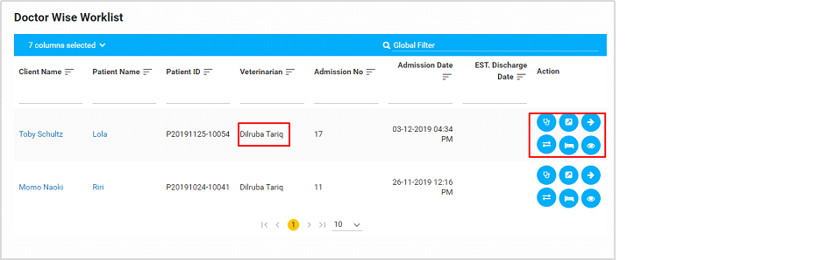

12. Adminstration

12.1 Add User

In this section, the user can know the information and add new users. The user can edit and delete users from this section.

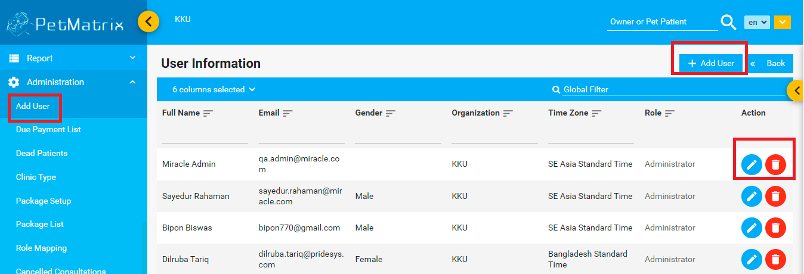

12.2. Due payment list

Here, the user can find the due payment list.

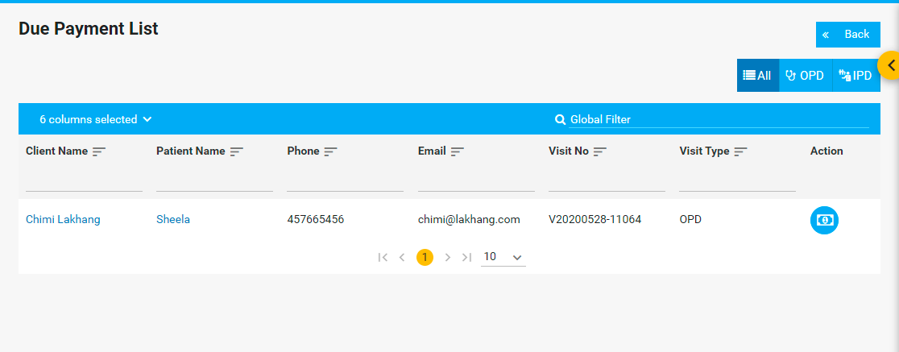

When the user click the invoice button , it will redirect the user to Invoice page.

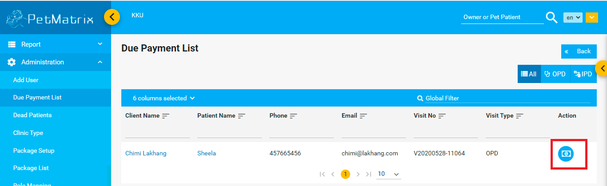
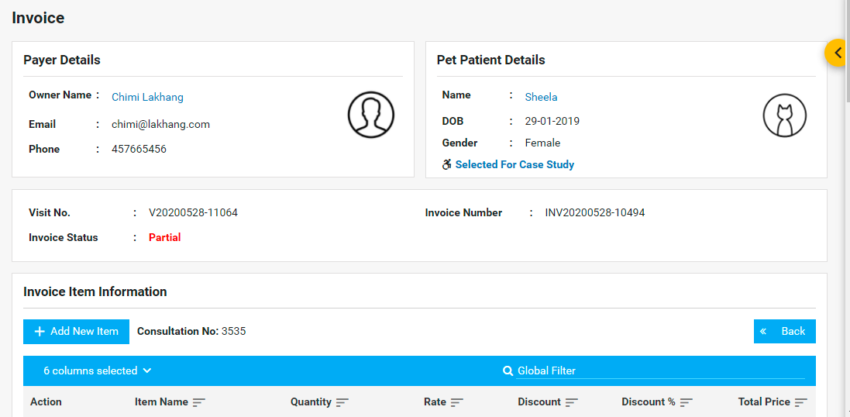

The user can add new item from the column and pay invoice from the Invoice.

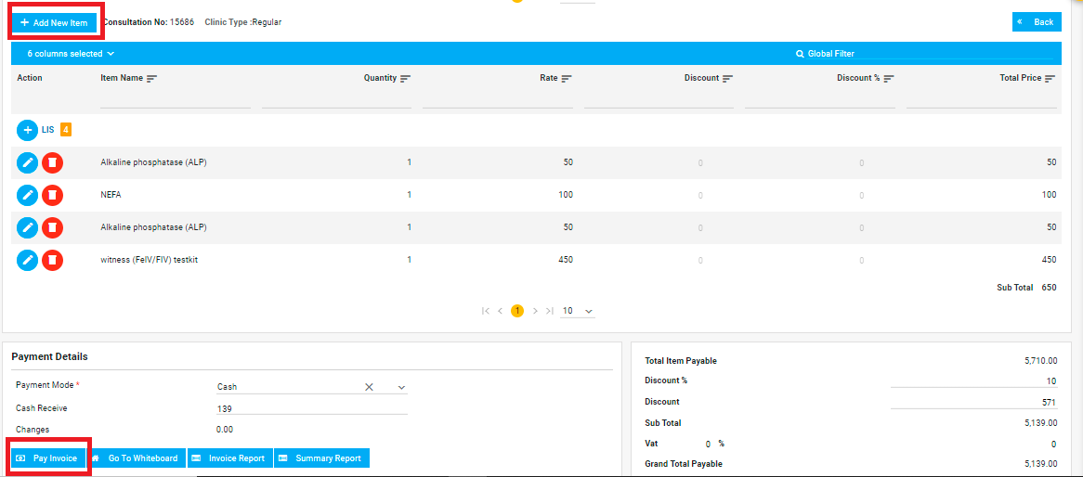

12.3. Dead Patients
The user will find expired patients from this list. Also, they can also see the certificate details from the action row.

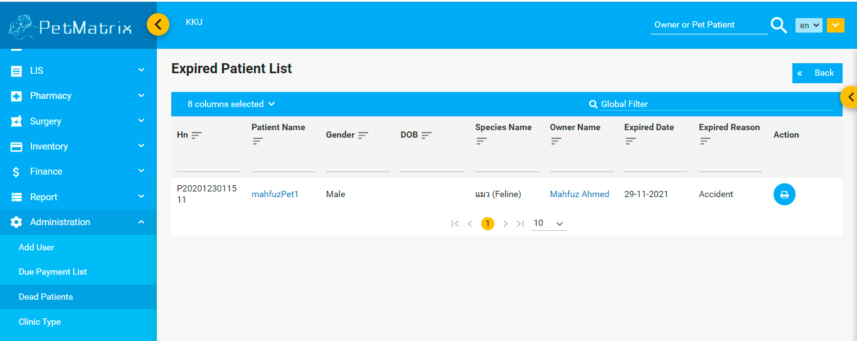

12.4. Clinic Type
The user can add clinic type from this section.

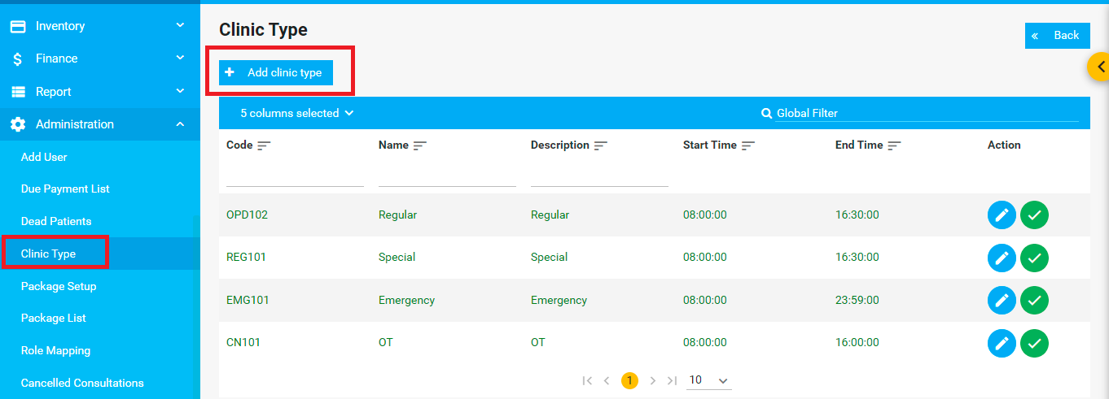

After clicking the Add clinic type button the user will redirect to this page.

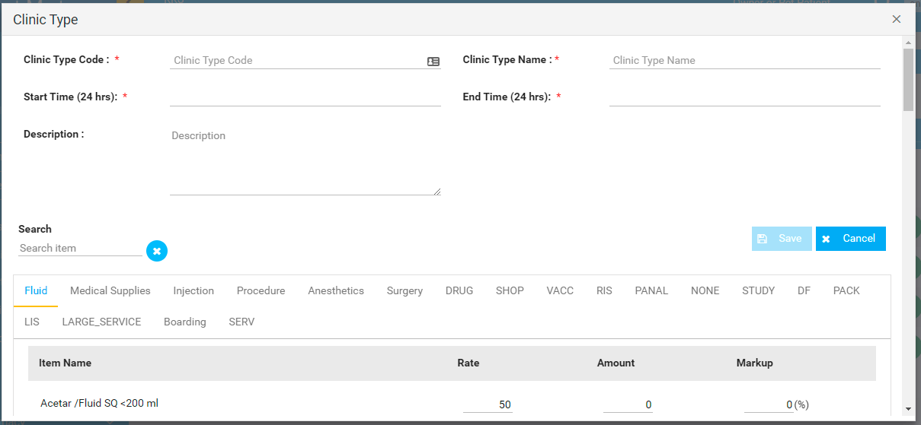
Note: * Mandatory Filed

The user can edit clinic type and active/inactive from the action column.
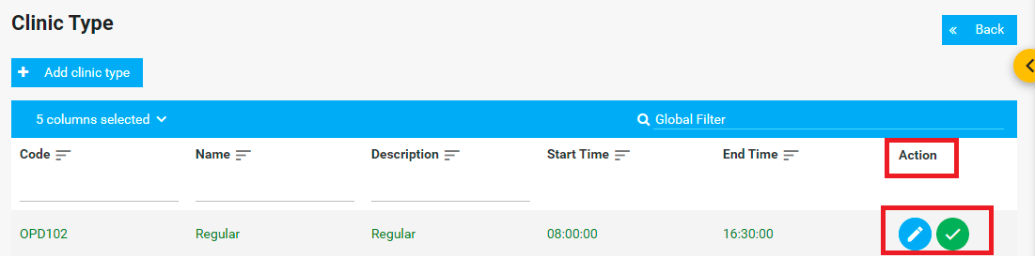

12.5. Package Setup
The user can set up a package from this section. The user has to fill up the package information along with package item information.

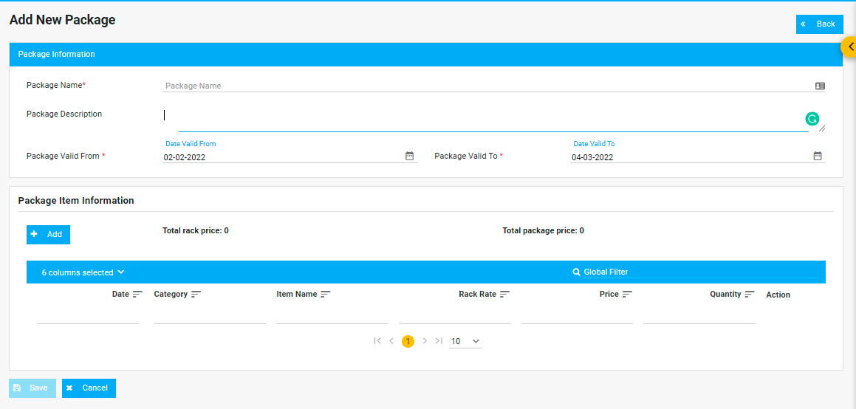

12.6. Package List
The user can add packages and can check the list of the packages. They can also Add packages from this section. Same as before, the user will redirect to Add new package page.



Also, they can see the active/inactive package from the above button.
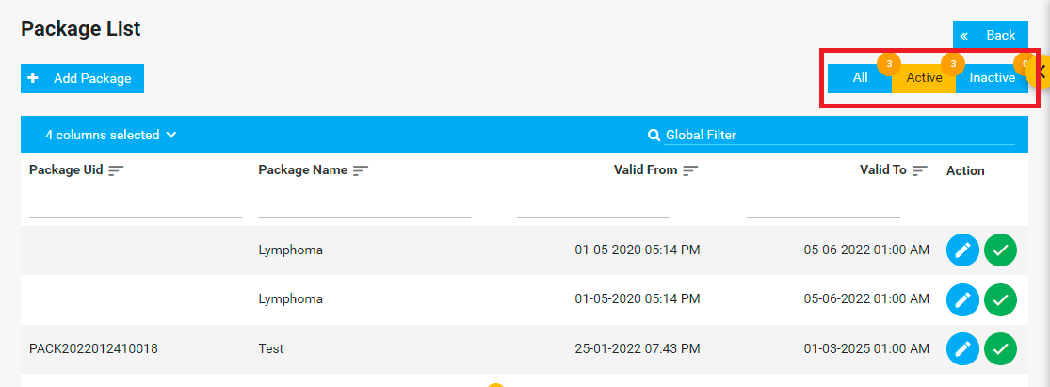

12.7. Role Mapping

The user can add roles and assign roles for specific users. Moreover, the user can edit roles from Role Mapping section.

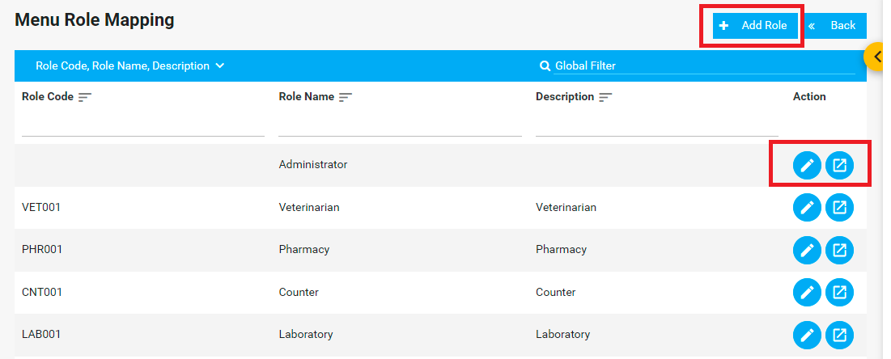

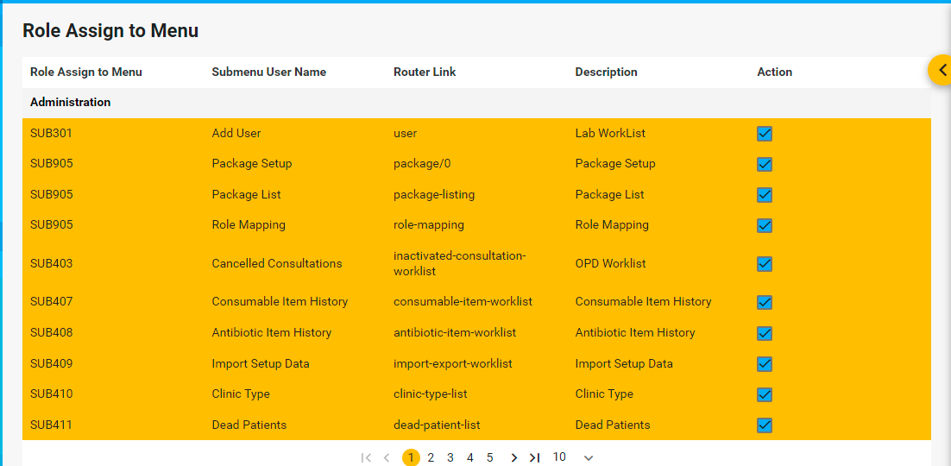

12.8. Cancelled Consultations

The cancelled consultation worklists will be found here.

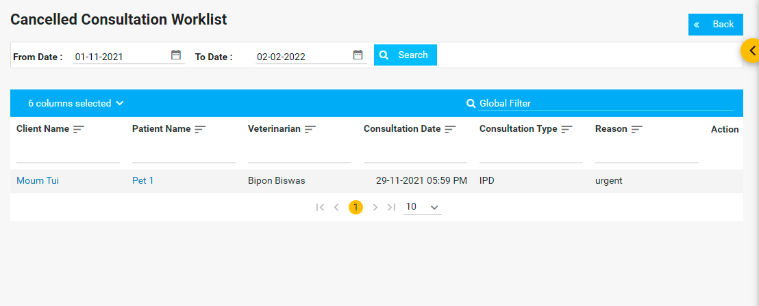

12.9. Consumable Item History

The consumable item details will be found in this section.

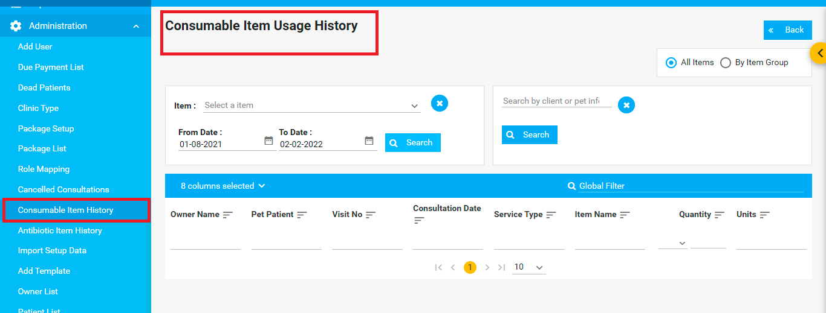

12.10. Antibiotic Item usage history

The antibiotic item usage details will be found in this section.
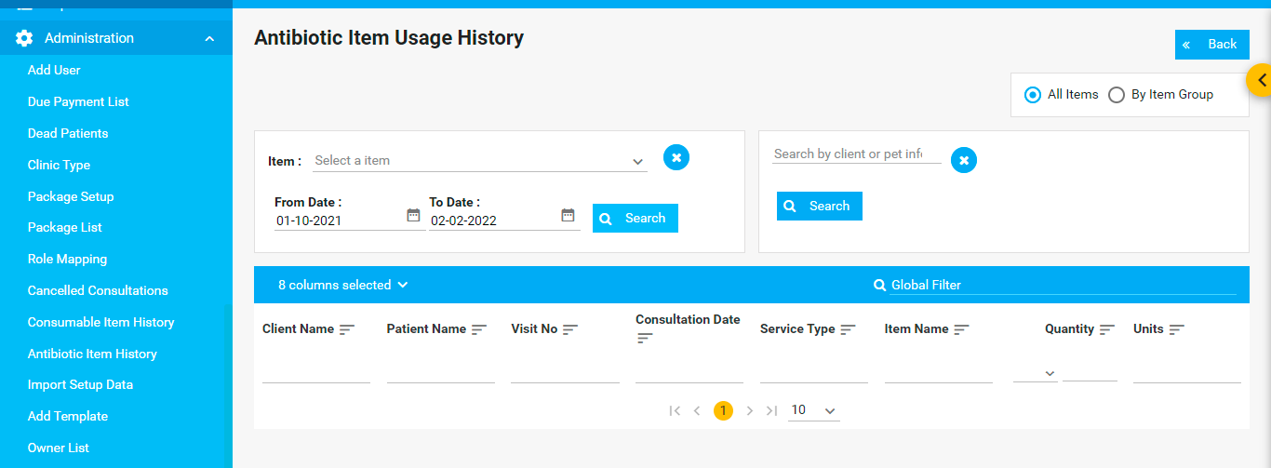

12.11. Import Setup Data
There are two setups in Export-Import Worklist.

- User Setup
- Chargeable item Setup

The user can import from the device and upload the template. They can also download the user setup template. On the other hand, the user can select any item from the chargeable item setup. Also, they can import data from the device and upload it.

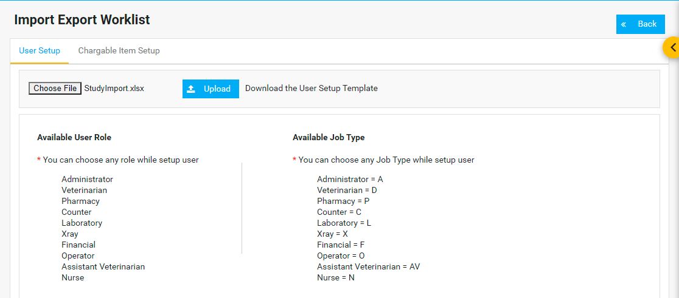

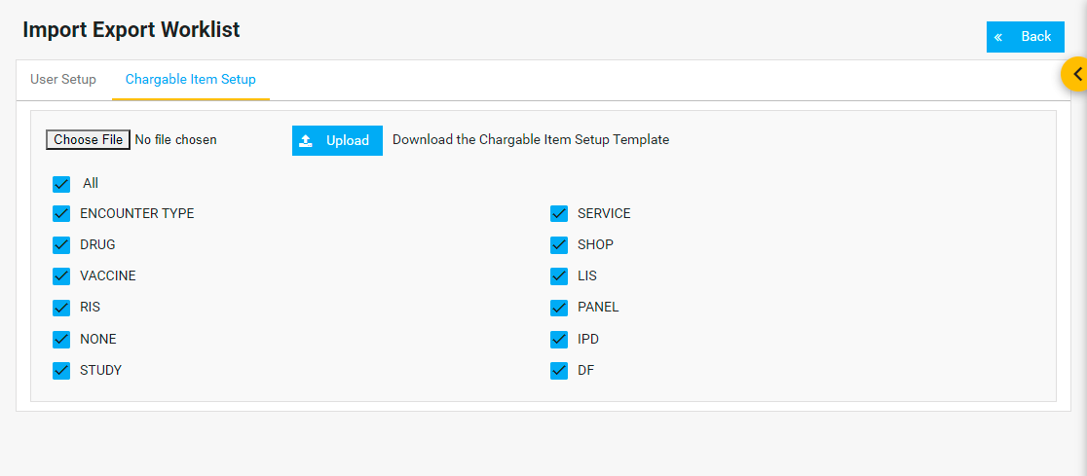

12.12. Add Template

The user can add a certificate template from this section.
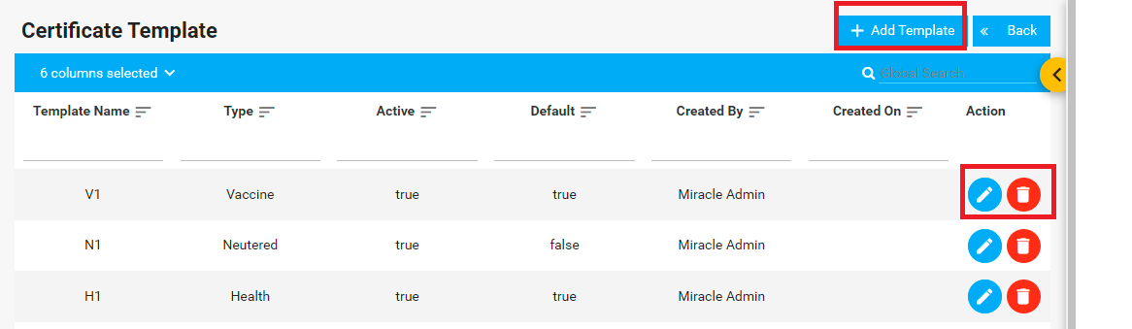
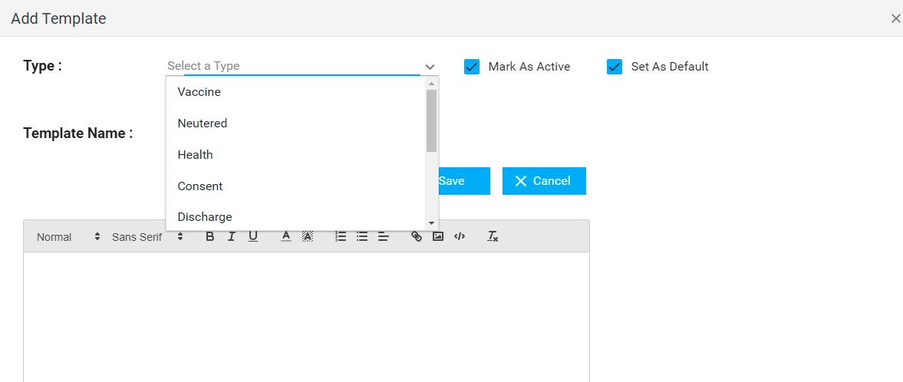

12.13. Owner List

The user can see the owner lists and active/inactive, delete the owner from this section.

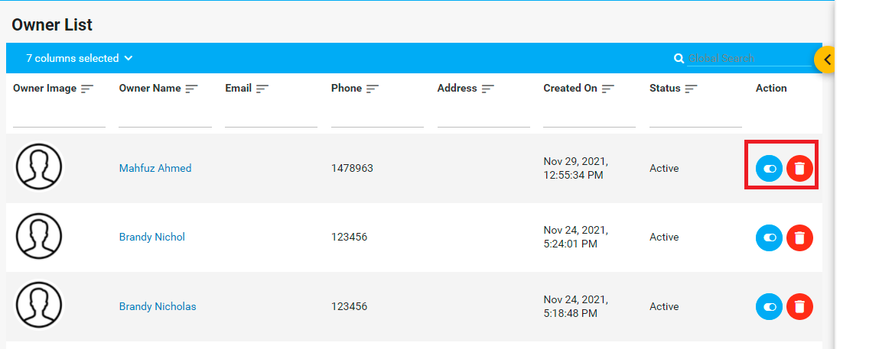

12.14. Patient List

The user can see the list of the patient from here.

